Constructing a Rodent Head-Fixed Lick Rig

# Table of Contents

Table of Contents 1

Introduction 7

Part I: Constructing the rig base 8

Full list of Materials 8

Building Instructions 9

General notes 9

1. Remove the 8-32 setscrews from all the optical posts 9

2. Attach components to the optical breadboard 9

3. Check for protruding setscrews 10

4. Attach the platform 10

Part II: Constructing the head-fixing assemblies 11

Full list of Materials 11

Building Instructions 11

General notes 11

1. Attach the dovetail rails together 11

2. Attach the head-fixing clamp to the rail carrier 12

3. Add the rail carrier onto the dovetail rails 12

4. Connect the support posts 12

5. Insert the head-fixing assembly into the base 12

6. Repeat the above steps reflected to build the right head-fixing assembly 12

7. Check clamp alignment 12

Part III: Constructing the touchposts and mirror mount 14

Full list of Materials 14

Building Instructions 14

General notes 14

1. Connect the capacitive ball electrode to leads 14

2. Insert ball electrode leads into touchposts. 15

3. Create the connecting wires 15

4. Solder the connecting wires to the capacitive ball electrode leads 16

5. Add magnets to the back of the mirror mount 16

Part IV: Constructing the water reservoir 17

Full list of Materials 17

Building Instructions 17

General notes 17

1. Disassemble the bottle 17

2. Install bottom outlet adapter 17

3. Add fill and drain ports 18

4. Add pressure relief hole 18

5. Screw cap back on and test seals 18

Part V: Constructing the lick spout with capacitive lick sensor and solenoid valve 19

Full list of Materials 19

Building Instructions 20

General notes 20

1. Create connector cable between capacitive lick sensor PCB and joystick PCB 20

2. Create the lick spout 20

3. Attach the lick spout tube to the mount 21

4. Create electrode leads for the water spout 21

5. Add wires to solenoid valve 23

6. Add tubes to solenoid valve 23

7. Connect the valve to the lick spout 24

8. Add the connector for the reservoir 24

9. Solder components onto lick sensor board 24

10. Plug the electrode and the connector cable into the PCB 24

11. Mount the lick spout on the rail carrier 25

12. Add rail to mount lick spout 25

Part VI: Constructing alternate positionable spout mount for double-step experiments 26

Full list of Materials 26

Building Instructions 27

General notes 27

1. Create the lick spout 27

2. Attach the lick spout tube to the mount 27

3. Attach the optical post to the linear motor mount 27

4. Mount the guide rail onto the motor mount 27

5. Mount the linear motor on the motor mount 28

6. Attach the spout mount onto the guide rail carriage 28

7. Install the carriage onto the guide rail and motor shaft 28

8. Connect the motor controller to the motor 28

9. Connect the motor controller to power and signal source 29

10. Complete the rest of the steps to build and attach the lick sensor and solenoid valve. 29

Part VII: Assembling the underside viewing mirror 30

Full list of Materials 30

Building Instructions 30

General notes 30

1. Prepare the magnetic backing 30

2. Install mirror 30

Part VIII: Building the masking light 31

Full list of Materials 31

Building Instructions 31

General notes 31

1. Cut one LED unit off of the strip 31

2. Solder wires onto the LED 32

3. Add receptacle 32

Part IX: Constructing the audio cue system 33

Full list of Materials 33

Building Instructions 34

General notes 34

1. Solder the resistor, transistor, and jumper wire 34

2. Create a connector cable 34

3. Solder the tone generator leads onto the breadboard 34

4. Plug in the speaker 35

Part X: Building a joystick board 36

Full list of Materials 36

Building Instructions 38

General notes 38

1. Soldering the SMT components 38

2. Soldering the through-hole components 38

3. Add heatsink 39

Part XI: Building an adapter for the joystick board 40

Full list of Materials 40

Building Instructions 40

General notes 40

1. Prepare the leads 41

2. Connect the header 41

3. Connect the DB9 41

Part XII: Building restraint walls and back support 42

Full list of Materials 42

Building Instructions 42

General notes 42

4. Attach brackets to the side walls 42

5. Construct the back support 42

Part XIII: Final assembly of the rig 44

Full list of Materials 44

Building Instructions 44

General notes 44

11. Mount restraint walls 44

12. Mount touchposts and mirror mount on platform 45

13. Mount water reservoir 45

14. Install and connect lick spout assembly 45

15. Add audio system 46

16. Connect lick spout to water reservoir and joystick board 46

17. Connect the masking light 46

Part XIV: Building the optogenetic system 47

Full list of Materials 47

Building Instructions 47

General notes 47

1. Screw commutator into mounting bracket 47

2. Bolt bracket to custom mounting plate 47

3. Connect the fiber optic cables. 48

4. Use tape to hold excess cable in place 48

Part XV: Building the RIO breakout board 49

Full list of Materials 49

Building Instructions 49

General notes 49

1. Solder the SMT components 49

2. Solder the through-hole components 49

3. Cut and strip power wires 49

Part XVI: Building the data acquisition system (DAQ) 50

Full list of Materials 50

Building Instructions 51

General notes 51

1. Assemble base and sides of enclosure 52

2. Mount power supplies on enclosure base 52

3. Mount sbRIOs on enclosure base 52

4. Mount RIO breakout boards on enclosure faceplate 53

5. Cut and strip power wires 53

6. Solder wires onto power receptacles, and mount on faceplate 53

7. Connect power wires to power supplies. 54

8. Connect sbRIO and RIO breakout board power cables 54

9. Mount Ethernet jacks in enclosure, and connect to sbRIO boards 54

10. Optional: close enclosure with lid. 54

11. Connect to sbRIO using LabVIEW, and compile software onto FPGA. 54

Part XVII: Building the camera trigger adapter 55

Full list of Materials 55

Building Instructions 55

General notes 55

1. Cut and strip wire leads 56

2. Solder wires into connectors 56

3. Solder components onto protoboard 56

Part XVIII: Constructing the high speed camera box 58

Full list of Materials 58

Building Instructions 59

General notes 59

Part 1 – Modifying the box 60

1. Cut rectangular slot in box for breadboard 60

2. Cut side hole for camera view 60

3. Add anchor holes for breadboard 60

4. Cut top hole for optogenetics and strobe cables 60

5. Drill side hole for anchoring acoustic foam (optional) 60

6. Cut acoustic foam panels (optional) 61

Part II – Building and installing camera mount 62

1. Add positioning rails 62

2. Add rail carriers 62

3. Add camera platform 62

4. Add camera mounting feet receptacles 62

5. Insert camera mount into box 63

Part XIX: Assembling entire system 65

Full list of Materials 65

Building Instructions 66

General notes 66

1. Assemble camera mounting feet 66

2. Mounting the camera 67

3. Install head-fixed rig 67

4. Install strobe light 67

5. Install optogenetic system 67

6. Install camera trigger adapter circuit 67

7. Set up control/storage server 68

8. Make RIO connections 68

Table of Figures 69

# Introduction

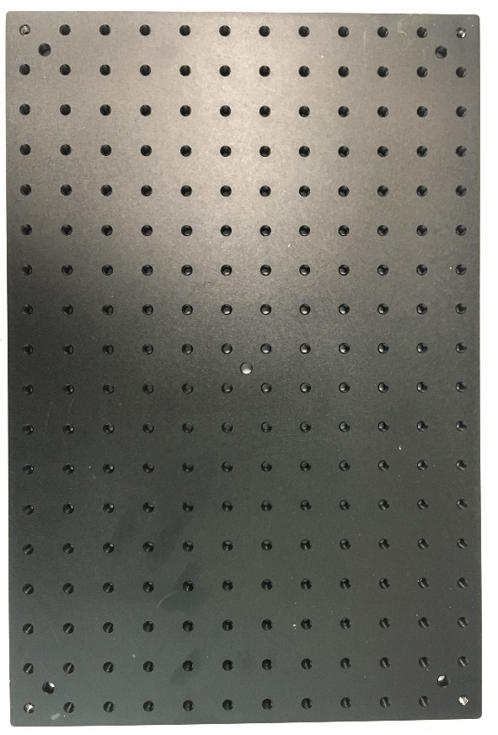

(0, 0)

(2, 4)

Front

Back

Left

Right

Figure The coordinate system used throughout the documentation

This guide describes in detail the process for building a mouse head-fixed lick rig for studying mouse neurobiology via lingual kinematics. This rig is capable of collecting millisecond resolution lick and paw touch data, and lick-triggered high speed (1 kHz) video of simultaneous side and bottom views of the tongue as it licks within a flexible experimental paradigm that can include optogenetic inactivation. See Figure 1 for a diagram of the coordinate system used throughout the documentation. See Figure 2 for an overall diagram of the system. Some have been custom machined or 3D printed – the specs for these components are made available at the following URL: <https://github.com/GoldbergLab>. We built a single setup for taking high speed video (a “video box”), and several for simply training the mice without video. The instructions for creating a training box are a subset of the instructions for creating the video box.

Note that the StroboLED II IR strobe light that we obtained from AOS Technologies has been discontinued, so alternate high speed IR illumination will be needed for high speed video recording.

Note that while individual fasteners are detailed in each materials section, we recommend the Thorlabs 1/4"-20 Cap Screw and Hardware Kit (<https://www.thorlabs.com/thorproduct.cfm?partnumber=HW-KIT2>), as it is an easy way to get most of the fasteners you will need in one purchase.

Throughout this guide, a basic knowledge of soldering (including surface-mount soldering) is assumed, as are the required tools for soldering.

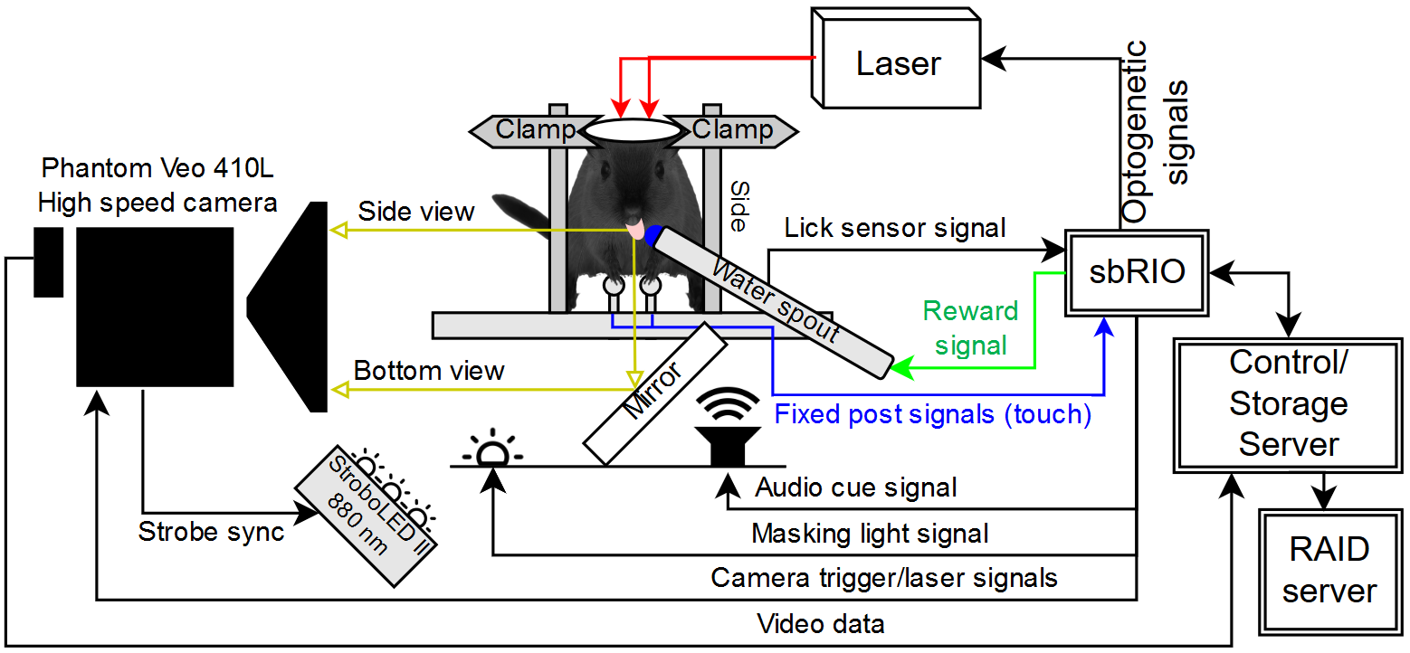

Figure Overall system diagram

# Constructing the rig base

## Full list of Materials

| **#** | **Part Description** | **Manufacturer/**  **Supplier** | **Manufacturer/Supplier Part Number** | **Datasheet/Drawing/Modification** |
| --- | --- | --- | --- | --- |
|  | Aluminum Breadboard 12" x 18" x 1/2", 1/4"-20 Taps | Thorlabs | MB1218 | <https://www.thorlabs.com/thorproduct.cfm?partnumber=MB1218> |
|  | 1/2" Post Holder, Spring-Loaded Hex-Locking Thumbscrew, L = 1" | Thorlabs | PH1 | <https://www.thorlabs.com/thorproduct.cfm?partnumber=PH1> |
|  | 1/2" Post Holder, Spring-Loaded Hex-Locking Thumbscrew, L = 3" x3 | Thorlabs | PH3 | <https://www.thorlabs.com/thorproduct.cfm?partnumber=PH3> |
|  | 1/2" Post Holder, Spring-Loaded Hex-Locking Thumbscrew, L = 4" x4 | Thorlabs | PH4 | <https://www.thorlabs.com/thorproduct.cfm?partnumber=PH4> |
|  | 1/2" Optical Post, SS, 8-32 Setscrew, 1/4"-20 Tap, L = 4" x4 | Thorlabs | TR4 | <https://www.thorlabs.com/thorproduct.cfm?partnumber=TR4> |
|  | 15" Long Construction Rail | Thorlabs | XE25L15 | <https://www.thorlabs.com/thorproduct.cfm?partnumber=XE25L15> |
|  | Dovetail Optical Rail, 3", Imperial | Thorlabs | RLA0300 | <https://www.thorlabs.com/thorproduct.cfm?partnumber=RLA0300> |
|  | 2" Manual Rotation Stage | Thorlabs | RP01 | <https://www.thorlabs.com/thorproduct.cfm?partnumber=RP01> |
|  | Cap screw, 1/4”-20, 3/4” long x2 | Thorlabs | SH25S075 | <https://www.thorlabs.com/thorproduct.cfm?partnumber=SH25S075> |
|  | Cap screw, 1/4”-20, 5/8” long x2 | Thorlabs | SH25S038 | <https://www.thorlabs.com/thorproduct.cfm?partnumber=SH25S038> |
|  | Setscrew, 1/4”-20, ¾” long x11 | Thorlabs | SS25S075 | <https://www.thorlabs.com/thorproduct.cfm?partnumber=SS25S075> |
|  | Pan head screw, 8-32, 3/8” long x2 |  |  |  |
|  | Acrylic platform | Custom made |  |  |

## Building Instructions

### General notes

The base of the rig consists of a Thorlabs optical breadboard with various posts attached to support the other components.

Recommended tools: 5/64” hex wrench, 3/16” hex wrench

### Remove the 8-32 setscrews from all the optical posts

* Use a 5/64” hex wrench to remove the 8-32 setscrews from the ends of the optical posts. They will not be needed.

### Attach components to the optical breadboard

Figure Materials for head-fixed rig base. Clockwise from top left: Construction rail, setscrews, 1/4"-20 screws (3/4” and 5/8”), 8-32 screws, PH4, PH3, PH1, acrylic platform, TR4, RP01. The components are sitting on the optical breadboard.

* Throughout the next steps, ensure that no screws are poking through the bottom of the optical breadboard – this will tilt the rig and interfere with alignment when the head-fixed rig is secured to the camera mount later.

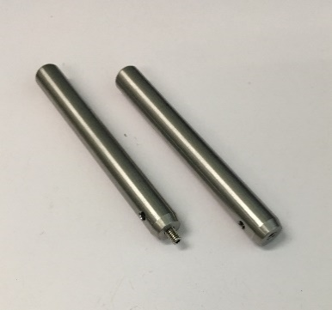

Figure Removing the 8-32 setscrews from the optical posts

* See Figure 1 for an explanation of the coordinate system used here.
* Screw setscrews all the way into the bottom of four 4” posts (TR4), then screw the post/setscrew assemblies in at (11, 5), (13, 5), (11, 10), and (13, 8).
* Screw ¼”-20x3/4” bolts partially in at (3, 0) and (17, 2). These will be used later to secure the head-fixed rig to the camera mount
* Screw a setscrew half in at (5, 0), and screw the 1” post holder (PH1) onto it. This will be used to mount the strobe light.

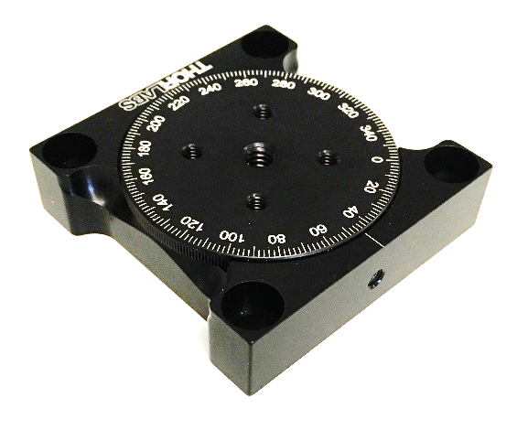

Figure RP01 rotation stage.

* Screw setscrews half in at (8, 7) and (16, 7), then screw a 4” post holder (PH4) onto each.
* Remove the thumbscrews from the sides of two 3” post holders (PH3) – we won’t need them, and they’ll get in the way in the next step.
* Screw setscrews half in at (7, 7) and (17, 7), then screw the two 3” post holders (sans thumb screws) onto them.

Locking setscrew hole

* *For centered spout:* Place the rotation stage (RP01) so it is centered at (12, 1), with the locking setscrew hole facing the front of the rig (see Figure 5), and screw it down using two 1/4"-20x5/8” screws. The RP01 can be shifted to the right or left to produce non-centered spout positions.
* Screw a setscrew half in to the center of the RP01 rotation stage, then screw a 3” post holder (PH3) onto the setscrew.
* Screw a setscrew half in at (2, 9), and screw the 15” construction rail onto the setscrew.

### Check for protruding setscrews

* Lift up the rig so you can see the underside of the breadboard. Check for any setscrews protruding out the bottom of the breadboard.
* Use a hex wrench as necessary to adjust the position of setscrews so the bottom of the breadboard has no protrusions.

### Attach the platform

* Place the acrylic platform on the four optical posts so the rectangular cutout is facing forwards.
* Screw the platform down onto the back two optical posts, at (11, 10), and (13, 8) using two 8-32x3/8” screws.
* See Figure 6 for the completed head-fixed rig base.

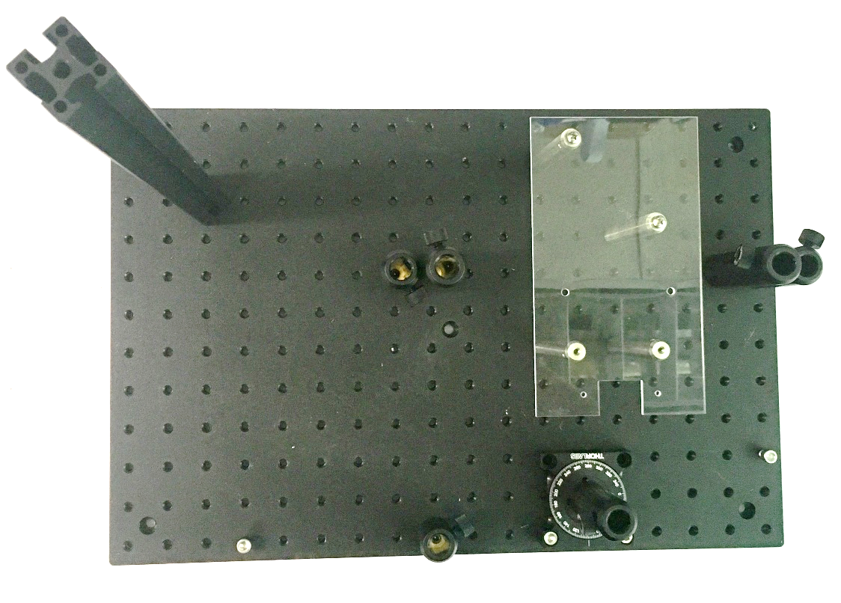

Figure Completed head-fixed rig base

# Constructing the head-fixing assemblies

## Full list of Materials

| **#** | **Part Description** | **Manufacturer/**  **Supplier** | **Manufacturer/Supplier Part Number** | **Datasheet/Drawing/Modification** |
| --- | --- | --- | --- | --- |
|  | Head-plate clamp x2 | N/A | Custom made |  |
|  | 1/2" Optical Post, SS, 8-32 Setscrew, 1/4"-20 Tap, L = 4" x2 | Thorlabs | TR4 | <https://www.thorlabs.com/thorproduct.cfm?partnumber=TR4> |
|  | 1/2" Graduated Optical Post, SS, 8-32 Setscrew, 1/4"-20 Tap, L = 3" x2 | Thorlabs | TR3E | <https://www.thorlabs.com/thorproduct.cfm?partnumber=TR3E> |
|  | Dovetail Rail Carrier, 2.00" x 1.00", 1/4" Counterbore, 8-32 Taps x2 | Thorlabs | RC2 | <https://www.thorlabs.com/thorproduct.cfm?partnumber=RC2> |
|  | Dovetail Optical Rail, 6", Imperial x6 | Thorlabs | RLA0600 | <https://www.thorlabs.com/thorproduct.cfm?partnumber=RLA0600> |
|  | Dovetail Optical Rail, 3", Imperial x2 | Thorlabs | RLA0300 | <https://www.thorlabs.com/thorproduct.cfm?partnumber=RLA0300> |
|  | Pan head screw, 8-32, 3/8” long x4 |  |  |  |

## Building Instructions

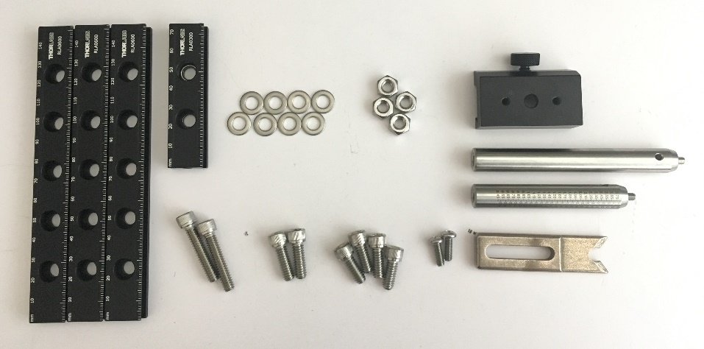

Figure Head-fixing assembly materials (one side only - another set is needed for the other side)

### General notes

The head-fixing assemblies consist of two separate mirror-symmetric sides that fit into the pairs of post holders on the rig base. The instructions below describe building the left side. The right side is a reflection of the left side.

Recommended tools: 3/16” hex wrench, 1/4" or adjustable crescent wrench, screwdriver, bench-top vise (optional)

### Attach the dovetail rails together

* Lay two 6” rails beside each other, markings up.
* Lay a 3” rail across the two 6” rails, markings up. Line up the two holes on the 3” rail with the back two holes on the 6” rails.
* Insert a 1/4"-20x3/4” screw into each of the two 3” rail holes, and through the 6” rail holes. Add a washer and a nut to the other side of each screw, and loosely tighten them.
* Lay a 6” rail across the two connected 6” rails, markings **down**. For the left head-fixing assembly, align the new 6” rail so the second and third holes from the left align with the front two holes in the two 6” rails.
* Add a washer to two 1/4"-20x1 1/4" screws, then insert them into each of the two overlapping 6” rail holes. Add a washer and a nut to the other side of each screw, and loosely tighten them.
* Adjust the rails so they are all perpendicular to each other, forming a rectangle, rather than a general parallelogram, and tighten the screws/nuts. A vise can be useful to hold the rails in position while you tighten the screws. See Figure 8 for the results of this step.

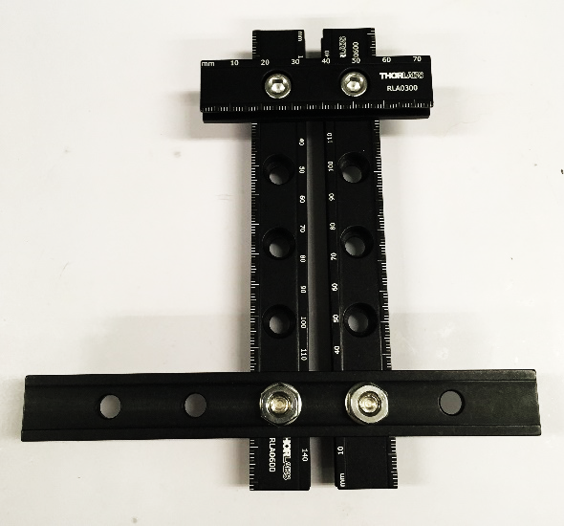

Figure Head-fixing assembly dovetail rails connected together

### Attach the head-fixing clamp to the rail carrier

* Lay the head-fixing clamp on top of the rail carrier so the slot in the clamp overlaps the two 8-32 holes in the carrier. For the left-hand head-fixing assembly, when viewed from the top of the rail carrier with the rail carrier thumbscrew facing away from you, the clamp should stick out to the right.
* Add washer to two 8-32x3/8” screws, and insert them through the clamp slot and into each of the two 8-32 holes in the carrier.
* Straighten the clamp so it is centered on and parallel to the edges of the rail carrier, and tighten the two 8-32 screws. See Figure 9 for the results of this step.

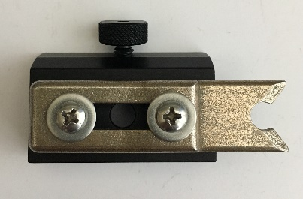

Figure Rail carrier with clamp

### Add the rail carrier onto the dovetail rails

* Slide the rail carrier onto the underside of the 6” rail that crosses the other two 6” rails. For the left head-fixing assembly, the carrier should slide onto the longer overhanging part of the 6” rail that protrudes to the right. The clamp should be facing to the right, and the thumbscrew should be facing forwards. See Figure 10 for the results of this step.

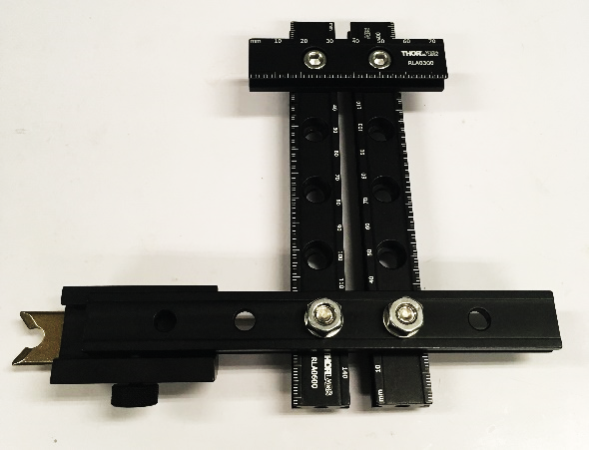

Figure Dovetail rails with carrier installed

### Connect the support posts

* Use a 5/64” hex wrench to remove the 8-32 setscrews from the ends of all the optical posts. They will not be needed.
* Attach the bottom (the end with the 1/4"-20 hole) of the 4” optical post to the left 6” rail using the hole closest to the 3” rail with a 1/4"-20x3/8” screw.
* Attach the bottom (the end with the 1/4"-20 hole) of the 3” graduated optical post to the right 6” rail using the hole closest to the 3” rail with a 1/4"-20x3/8” screw. See Figure 12 for the results of this step.

### Insert the head-fixing assembly into the base

* Insert the two optical posts into the left-hand 3” and 4” post holders with the clamp side facing forwards. The thumbscrew on the 4” post holder can be used to set the height of the head-fixing assembly. See Figure 11 for the results of this step.

### Repeat the above steps reflected to build the right head-fixing assembly

* Repeat the above steps in mirror-image to create the right head-fixing assembly.

### Check clamp alignment

* Using the thumbscrews on the post holders, adjust the height of the left and right head-fixing assemblies so the left and right clamps are level with each other.
* Check that the left and right clamps are parallel and pointing directly at each other. If they aren’t, adjust the alignment of the dovetail rails and/or the clamp/carrier connection.

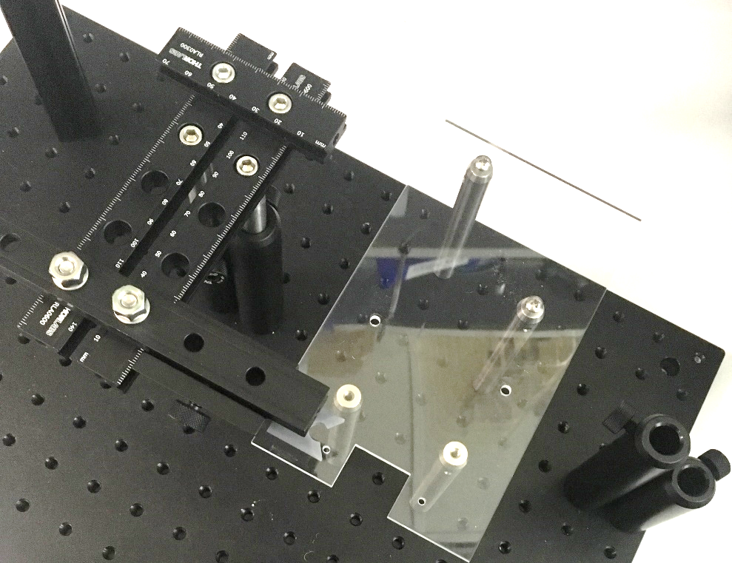

Right head-fixing assembly will fit here

Left head-fixing assembly

Figure Base with left head-fixing assembly complete and installed

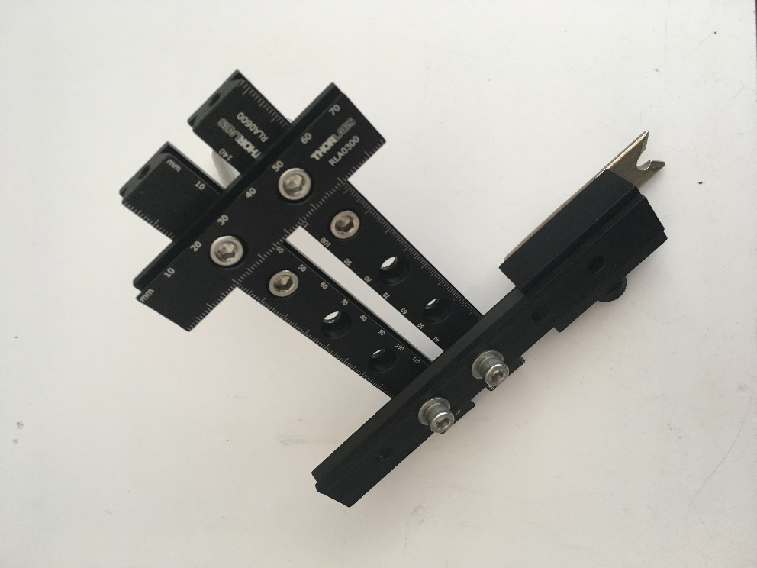

Attachment for 4” optical post

Attachment for 3” optical post

Figure Head-fixing assembly with optical posts attached

# Constructing the touchposts and mirror mount

## Full list of Materials

| **#** | **Part Description** | **Manufacturer/**  **Supplier** | **Manufacturer/Supplier Part Number** | **Datasheet/Drawing/Modification** |
| --- | --- | --- | --- | --- |
|  | Touchpost panel | Custom made |  |  |
|  | Ball bearing with machined hole |  |  |  |
|  | 2-pin receptacle x2 | Hirose/Digikey | DF3-2S-2C | <https://www.digikey.com/product-detail/en/DF3-2S-2C/H2083-ND/141479> |
|  | Stranded, insulated wire, approximately 26 AWG, two different colors |  |  |  |
|  | 24 AWG Wire Wrap | Digikey | K517 | https://www.digikey.com/product-detail/en/jonard-tools/R24R-0100/K517-ND/806200 |
|  | 5-minute epoxy (HARDMAN® Extra-Fast Setting Epoxy) | Hardman | 04001 | <http://www.royaladhesives.com/Files/Hardman-Structural/DOUBLE-BUBBLE_04001_RED_TDS.PDF> |
|  | Dental Acrylic (Flow-It ALC Flowable Composite) | Pentron | N11H | <http://www.pentron.com/products/product_detail/flow_it_alc_flowable_composite> |
|  | Heatshrink wrap |  |  |  |

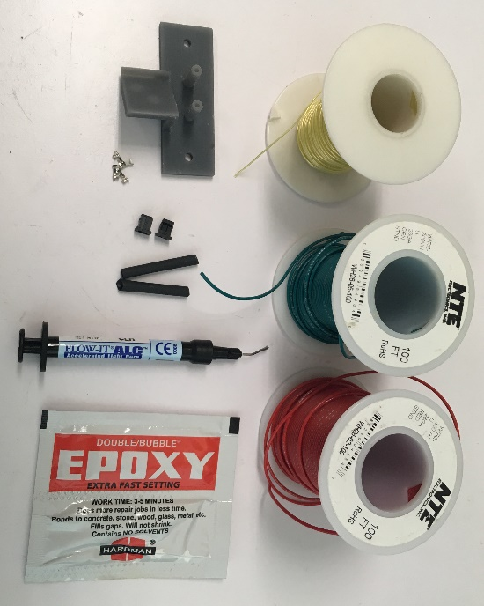

Figure Materials for constructing the touchposts and mirror mount. Clockwise from top left: Solid wire, two colors of stranded wire, epoxy, dental acrylic, heatshrink tubing, receptacles, crimp terminals, touchpost & mirror mount. Not pictured: magnets

## Building Instructions

### General notes

The touchposts and mirror mount are 3D printed as one piece to ensure that they are aligned precisely, and, for multiple rigs, identically. The two touchposts allow detection of paw touches, and the 45° mirror mount allows a side-mounted camera to simultaneously view the side view of the head/tongue and the view from below.

Recommended tools: Soldering microscope, soldering iron, wire strippers, needle-nose pliers UV curing light, tweezers, clips/helping hands, power drill, Form 2 3D printer

### Connect the capacitive ball electrode to leads

* Cut a 2.5” piece of wire wrap wire
* Strip last 1/16” of insulation from one end of the wire
* Clamp the capacitive ball in place under a microscope with the machined hole facing in an easily accessible direction
* Dab a little flux in the machined hole on the capacitive ball. Avoid getting flux elsewhere on the ball.
* Insert the solder wire into the machined hole
* Heat the capacitive ball by touching the soldering iron to the back until the solder melts into the hole. A small amount in the hole is ideal. Too much solder will lead to inconvenient bulges of solder out of the hole.
* Heat the ball again to re-melt the solder as you insert the stripped end of the wire into the capacitive ball hole. Remove the soldering iron heat while holding the wire in place, until the solder cools and solidifies
* Clean off any excess flux and solder
* Tug on the wire gently to confirm that the ball is firmly soldered in the hole.
* Strip about 1/4" of insulation off the other end of the wire.
* See Figure 14 for an illustration of this process.
* Repeat the above steps for the other electrode. See Figure 15 for the results of this step.

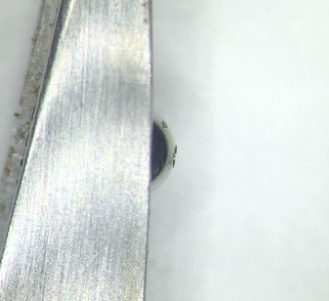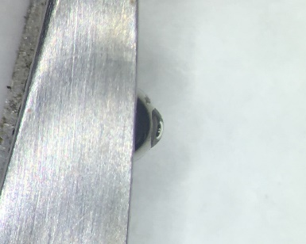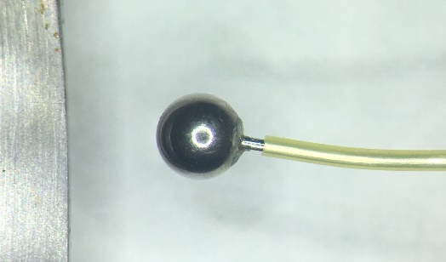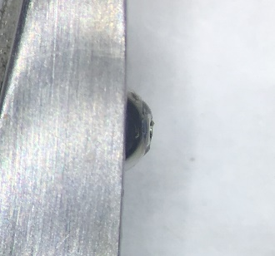

a

b

c

d

flux in hole

Figure Steps for connecting a wire lead to the ball electrode: a) clamp the ball in place with hole accessible b) add a dab of flux onto the hole in the ball c) melt solder into the hole in the ball d) remelt solder and insert wire

solder in hole

clamp

### Insert ball electrode leads into touchposts.

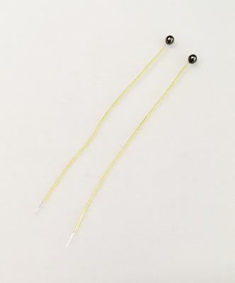

Figure Completed ball electrodes with wire leads

* Insert each ball electrode lead into one of the 3D printed touchposts. Ensure that each ball can sit centered on top of its post.
* Lift the ball up and spread a thin layer of epoxy below it on the wire lead, then push the ball back down. Carefully remove any excess epoxy that squishes out around the ball – ensure that no epoxy gets on the upper hemisphere of the ball.
* Liberally epoxy the area on the other side where the wire leads come out to protect the ball/wire joint from strain.
* Suspend the touchposts in their proper orientation so the epoxy doesn’t drip off to the side as it cures (5 min).

### Create the connecting wires

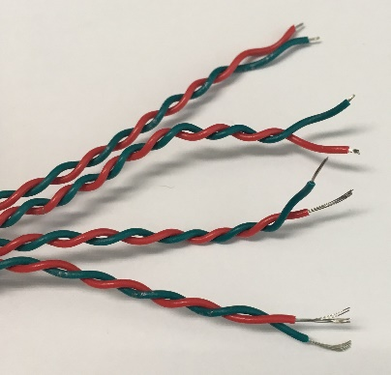

Figure Four connecting wires in two twisted pairs, showing the eight ends appropriately stripped

* Cut four lengths of wire approximately 2 feet long each
* Twist them into two twisted pairs of wire
* Strip one end of each wire to about 1/4", and the other end of each wire to about 1/16”. See Figure 16 for the results of this step.
* Using needle-nose pliers, crimp the tabs of a crimp terminal onto the 1/16” stripped side of each wire, so the middle tabs hold the bare metal of the wire, and the back tabs hold the insulation. *Note: If the back tabs are flattened too much or too little, they may not fit in the receptacle, and adjustment will be necessary.*
* Insert the crimp terminals at the ends of each pair of wires into the 2-pin receptacles. See Figure 17 for an illustration of this process.
* Add some dental acrylic to the back of the receptacles to ensure the wires don’t pop out under stress.
* Slip on a piece of heatshrink tubing onto the other end of each pair of wires in preparation for the next step.

Figure Process for attaching wires to receptacles: a) crimp middle tabs onto stripped wire, back tabs onto insulation b) repeat for other wire c) insert into receptacle in the orientation shown d) push in until catch pokes out into hole

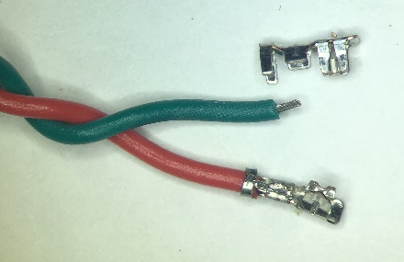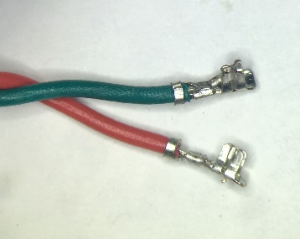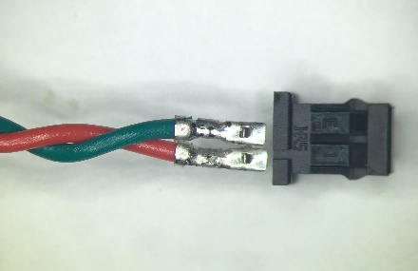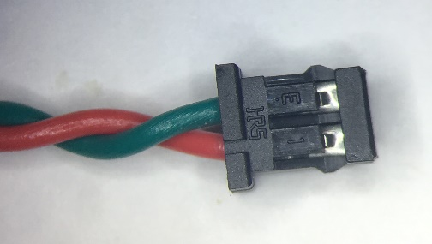

a

b

c

d

Back tabs hold

insulation

Middle tabs hold bare wire

Both catches need to poke through to hold terminals in

### Solder the connecting wires to the capacitive ball electrode leads

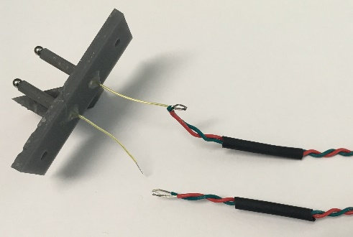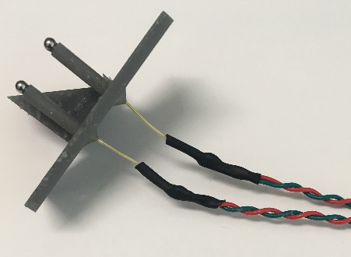

Figure Soldering connecting wires to the electrode leads. Left, one pair of connecting wires is soldered on. Right, both pairs soldered with heatshrink tubing applied.

* Solder each pair of wires together to one of the ball leads.
* Slide the heatshrink tubing over the solder joint and use a heat gun to shrink it onto the joint. See Figure 18 for the results of this step.

### Add magnets to the back of the mirror mount

* Take two pairs of magnets and insert them into the two holes in the back of the mirror mount – make sure their “north” sides are facing the same way. These magnets will hold the mirror in place during camera recording.

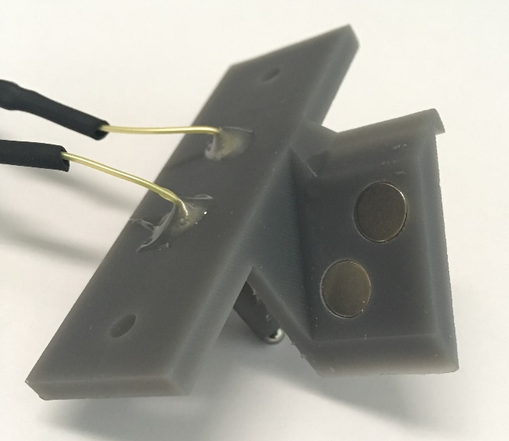

Figure Two pairs of magnets inserted into magnet holes

* Careful use of a vise or clamp can help to pop the magnets into place if the fit is tight.
* Add a small amount of superglue to secure them in place.

# Constructing the water reservoir

## Full list of Materials

| **#** | **Part Description** | **Manufacturer/**  **Supplier** | **Manufacturer/Supplier Part Number** | **Datasheet/Drawing/Modification** |
| --- | --- | --- | --- | --- |
|  | Lixit Flat sided water bottle | Lixit | QLCSA-5 | <http://www.lixit.com/node/653> |
|  | Plastic Quick-Turn Cap | McMaster-Carr | 51525K311 | <https://www.mcmaster.com/51525k311> |
|  | Luer lock female x female connector x3 | Cole-Parmer | EW-45502-22 | <https://www.coleparmer.com/i/cole-parmer-female-luer-x-female-luer-adapter-nylon-25-pk/4550222> |
|  | 5-minute epoxy (HARDMAN® Extra-Fast Setting Epoxy) | Hardman | 04001 | <http://www.royaladhesives.com/Files/Hardman-Structural/DOUBLE-BUBBLE_04001_RED_TDS.PDF> |

## Building Instructions

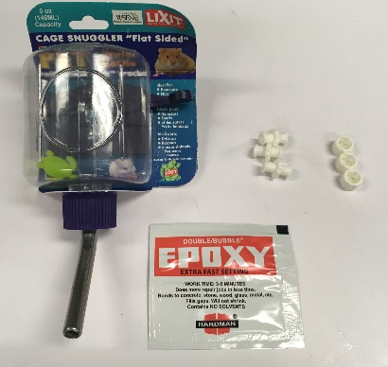

Figure Reservoir materials. Clockwise from top left: Water bottle, FxF Luer lock connectors x3, Luer lock caps x3, epoxy

### General notes

The water reservoir is a modified consumer rodent water bottle. The reservoir has a Luer lock port at the bottom to connect to the lick spout intake tube. It also has two Luer lock ports – one for filling on top, and one optional one for draining to a pre-set level for use with an automatic watering system. These can be filled manually or connected to an automatic water system to easily maintain the appropriate water height in each bottle, and therefore maintain a constant dispense volume at the lick spout. The constant dispense volume can be calibrated by adjusting the duration of solenoid valve opening.

### Disassemble the bottle

* Remove the bottle from its packaging
* Unscrew the cap, separate the rubber seal and the metal spout. Discard the spout.

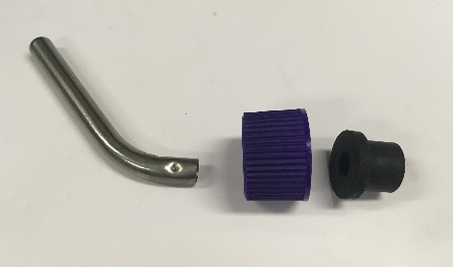

Figure Reservoir cap disassembled. The metal spout can be discarded.

### Install bottom outlet adapter

* Apply liberal amounts of epoxy around the outside of a one end of a female x female Luer lock connector to ensure water doesn’t leak between the cap and the adapter.
* Quickly insert the epoxied end of the connector into the wide end of the rubber seal up to the middle connector flange.
* Using a swab, clean off excess epoxy that comes out of the rubber seal.
* Allow epoxy to harden (5+ minutes)
* Slightly widen the hole in the bottle cap to approximately 7/16 inches, to allow the Luer lock flange to fit.
* See Figure 22 for a depiction of this process.

### Add fill and drain ports

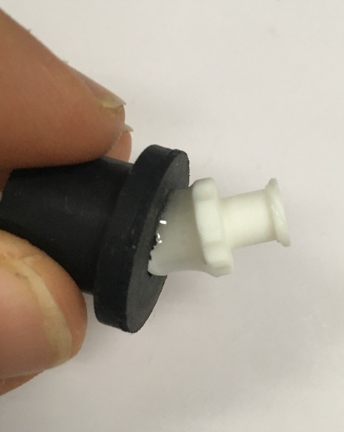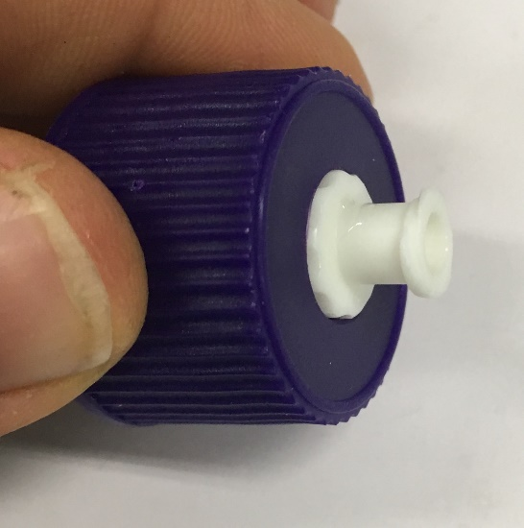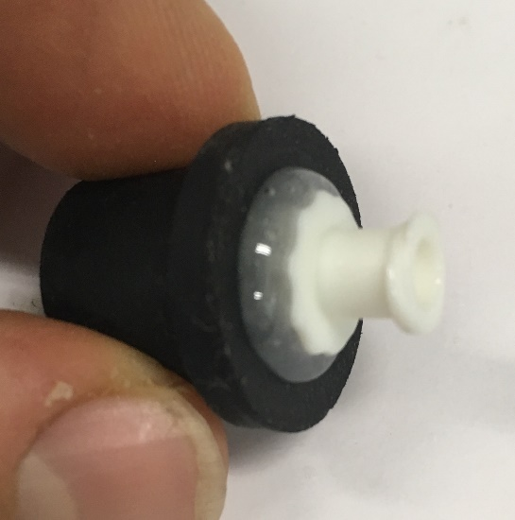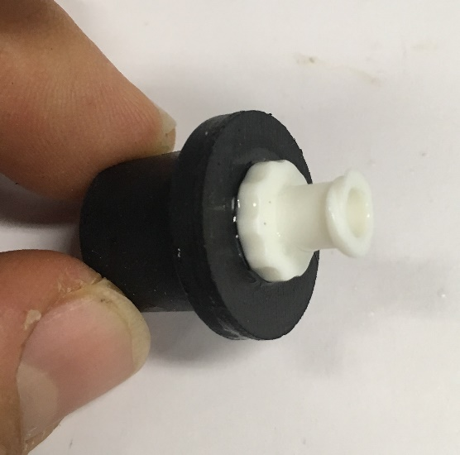

A

B

C

D

Figure Process of making bottom water outlet. A) Mix epoxy and slather generous amounts on one side of male adapter B) Insert male adapter into the wide end of the rubber seal up to the flange C) Wipe excess epoxy away D) allow to harden, and insert in cap

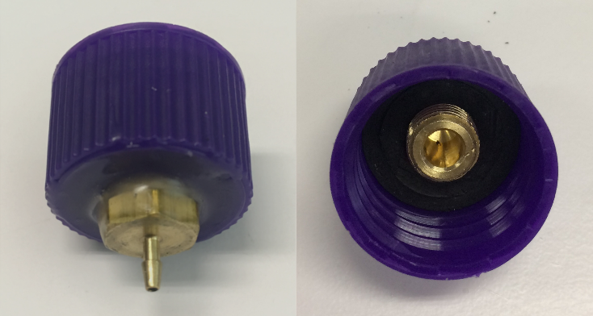

Figure Adapter and seal installed in cap. Outside view, left, inside view, right.

* Drill a 1/4” hole in the top and flat side of the bottle. The optional side drain hole should be approximately 1 cm below the top surface of the bottle.
* Insert female x female Luer lock connectors into the two holes.
* Use a generous amount of epoxy between the bottle and the Luer lock connectors and around the lip of the connectors to make a watertight seal.
* See Figure 25 for this process

### Add pressure relief hole

* Drill a 1/16” hole somewhere on the top surface of the reservoir to relieve pressure during operation.

### Screw cap back on and test seals

* Screw the cap back on
* Test to make sure the three ports are watertight by filling the bottle with water, capping the ports, and check for drips after a while
* Make sure there are no plastic fragments left in the reservoir that could clog up the ports or tubing.
* See Figure 24 for the completed water reservoir.

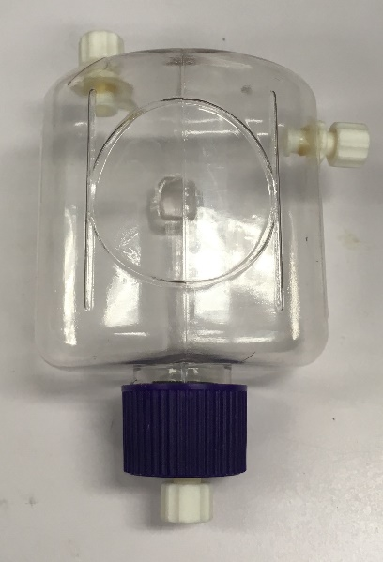

Figure Completed water reservoir

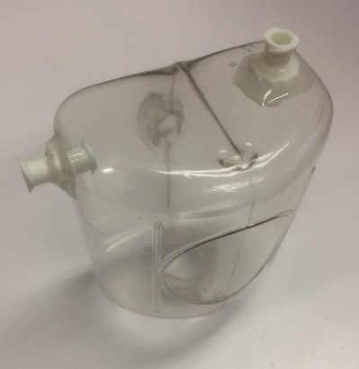

Figure Luer lock fill and drain ports inserted and epoxied

# Constructing the lick spout with capacitive lick sensor and solenoid valve

## Full list of Materials

| **#** | **Part Description** | **Manufacturer/**  **Supplier** | **Manufacturer/Supplier Part Number** | **Datasheet/Drawing/Modification** |
| --- | --- | --- | --- | --- |
|  | Stainless Steel 304 Hypodermic Tubing, 15 Gauge, 0.072" OD, 0.0625" ID, 0.00475" Wall, 36" Long | Amazon | B004WPQJHC | <https://www.amazon.com/gp/product/B004WPQJHC> |
|  | Lick spout mount | Custom made |  |  |
|  | Tygon PVC Tubing for Food, Beverage, and Dairy, 1/16" ID | McMaster-Carr | 6546T33 | <https://www.mcmaster.com/#6546t33> |
|  | 1/16” barbed plug | VWR | P0-1NK | <https://us.vwr.com/store/product/14459897/barbed-plugs-eldon-james> |
|  | Male Luer x 1/16” hose barb | Cole-Parmer | EW-45518-00 | <https://www.coleparmer.com/i/cole-parmer-male-luer-with-lock-ring-x-1-16-hose-barb-pp-25-pk/4551800> |
|  | Solenoid valve | The Lee Company | LHDA2433215H | <http://www.theleeco.com/electro-fluidic-systems/solenoid-valves/lhd/3-port-ported-style.cfm> |
|  | Crimp terminals | Hirose/Digikey | DF3-2428SC | <https://www.digikey.com/product-detail/en/DF3-2428SC/H1500-ND/141644> |
|  | Stranded, insulated wire, ~26 AWG, four colors |  |  |  |
|  | 2-pin receptacle | Hirose/Digikey | DF3-2S-2C | <https://www.digikey.com/product-detail/en/DF3-2S-2C/H2083-ND/141479> |
|  | 3-pin receptacle x3 | Hirose/Digikey | DF3-3S-2C | <http://www.digikey.com/product-detail/en/DF3-3S-2C/H2084-ND/141482> |
|  | Heatshrink tubing |  |  |  |
|  | Capacitive lick sensor board |  |  |  |
|  | 2-pin header | Hirose/Digikey | DF3A-2P-2DSA | <http://www.digikey.com/product-detail/en/DF3A-2P-2DSA/H2094-ND/141512> |
|  | 3-pin header | Hirose/Digikey | DF3A-3P-2DSA | <http://www.digikey.com/product-detail/en/DF3A-3P-2DSA/H2095-ND/141515> |
|  | R1 = 1 kΩ resistor, SMT | For example, Yageo AC0603JR-071KL |  | <https://www.digikey.com/product-detail/en/yageo/AC0603JR-071KL/YAG3646TR-ND/5896388> |
|  | C1 = 3.3 nF capacitor (value may vary by application), SMT | Samsung CL21B332KBANNNC |  | [https://www.digikey.com/product-detail/en/samsung-electro-mechanics/CL21B332KBANNNC/1276-1260-1-ND/3889346](https://www.digikey.com/product-detail/en/samsung-electro-mechanics/CL21B332KBANNNC/1276-1260-1-ND/3889346?utm_adgroup=Capacitors&gclid=EAIaIQobChMInsjixO7N2AIVCLjACh04uATsEAAYASAAEgJ6_vD_BwE) |
|  | C2 = 0.47 uF capacitor, SMT | For example, Samsung CL10B474KO8NNNC |  | <https://www.digikey.com/product-detail/en/samsung-electro-mechanics/CL10B474KO8NNNC/1276-1062-2-ND/3886720> |
|  | C3 = 10 pF capacitor, SMT | For example, Samsung CL10C100JB8NNNC |  | <https://www.digikey.com/product-detail/en/samsung-electro-mechanics/CL10C100JB8NNNC/1276-1027-2-ND/3886685> |
|  | U1 = Atmel Touch sensor IC, SMT | AT42QT1011 |  | <http://ww1.microchip.com/downloads/en/DeviceDoc/40001947A.pdf> |
|  | Translucent scotch tape |  |  |  |
|  | Dovetail Rail Carrier, 1.00" x 1.00", 1/4" Counterbore | Thorlabs | RC1 | <https://www.thorlabs.com/thorproduct.cfm?partnumber=RC1> |
|  | 1/4"-20x5/8” screw | Thorlabs | SH25S063 | <https://www.thorlabs.com/thorproduct.cfm?partnumber=SH25S063> |
|  | 1/4"-20 washer | Thorlabs | W25S050 | <https://www.thorlabs.com/thorproduct.cfm?partnumber=W25S050> |
|  | 1/4"-20 nut | Thorlabs | N25S044 | <https://www.thorlabs.com/thorproduct.cfm?partnumber=N25S044> |
|  | 1/2" Graduated Optical Post, SS, 8-32 Setscrew, 1/4"-20 Tap, L = 3" | Thorlabs | TR3E | <https://www.thorlabs.com/thorproduct.cfm?partnumber=TR3E> |
|  | Dovetail Optical Rail, 3", Imperial | Thorlabs | RLA0300 | <https://www.thorlabs.com/thorproduct.cfm?partnumber=RLA0300> |

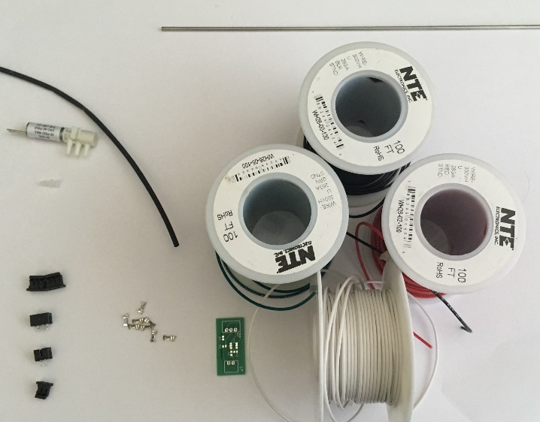

Figure Materials for lick spout. Clockwise from top left: heatshrink tubing, steel tube, wire, lick sensor PCB, crimp terminals, headers and receptacles, 1/16" plug, solenoid valve. Not pictured: lick spout mount, rail carrier, screw, nut, and washer.

## Building Instructions

### General notes

The lick port consists of a water spout, which both dispenses water and serves as a capacitive touch sensor electrode to detect licks, a solenoid valve, a capacitive touch sensor PCB, and connecting wires.

Recommended tools: Soldering iron, wire strippers, needlenose pliers, Dremel with cutting wheel, fine small file, heat gun

### Create connector cable between capacitive lick sensor PCB and joystick PCB

* Cut three electrode wires, a ground wire (black), a 5V wire (red), and a lick signal wire (white), about 1 foot long. Color coding is recommended.
* Braid the wires together
* Strip the both ends of the wires to about 1/16”, and add crimp terminals to both ends.

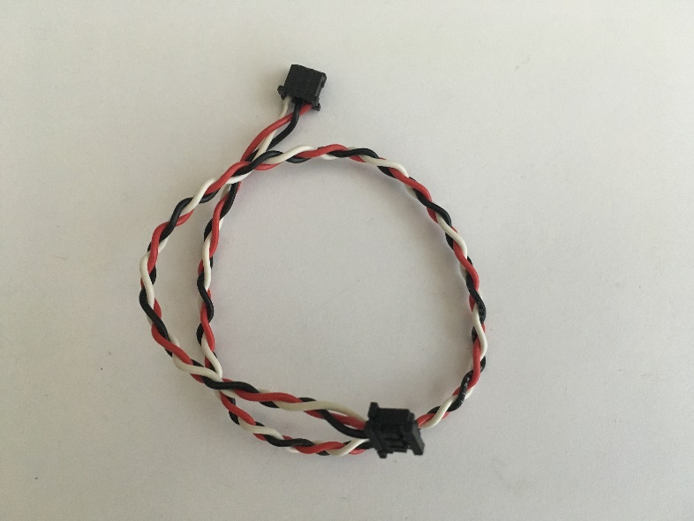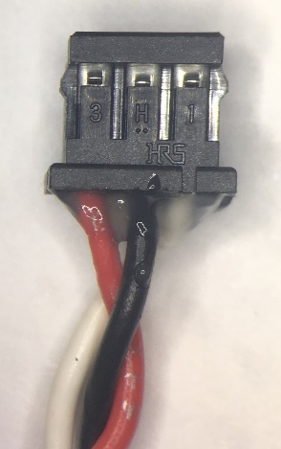

Figure Lick spout PCB connector cable. Left: Completed cable. Right: close-up of receptacle wire order (same for both ends)

* Insert the three crimp terminals on each end into 3-pin receptacles in the order shown in Figure 27.
* Add dental acrylic to the back side of the receptacle to secure the wires, and cure.

### Create the lick spout

* Use a Dremel with a cutting wheel or a hacksaw to cut the steel tubing to 2 1/16” long. It’s easier to cut it accurately if you leave a little extra, then grind it down to the right length with a Dremel or other tool. Note: The ends of the tube need to be flat (perpendicular to the tube), rather than angled/pointed.

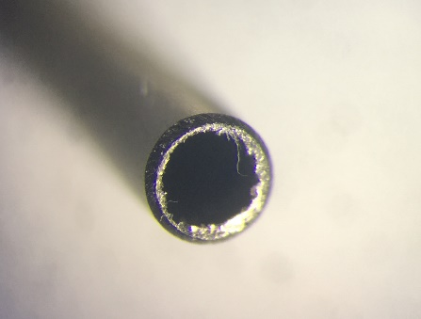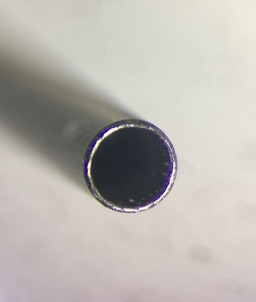

Figure Lick spout end under a microscope. Left: before filing off burs and sharp edges. Right: After filing

* Use a fine file to smooth the ends of the tube. Any burrs or sharp edges may cut the mouse’s tongue. Checking the end for sharp parts under a microscope is recommended. See Figure 28 for the results of this step.

### Attach the lick spout tube to the mount

* Mark the spout tube 1.5” from one end with a fine marker.
* Use the mark to position the spout tube on the mount so 1.5” of the tube stick out from the mount.
* Fill the space between the tube and the mount with dental acrylic **only** along the triangular recess, **not** in the deeper cylindrical recess (the tubing will need to fit in that space).
* Position the spout precisely, and use scotch tape to hold it firmly in place.
* Cure the dental acrylic through the scotch tape, then remove the tape.
* Add extra dental acrylic to increase the strength of the joint, being careful not to add any in the cylindrical recess, and cure.
* See Figure 29 for a depiction of this process.

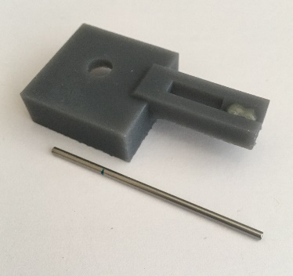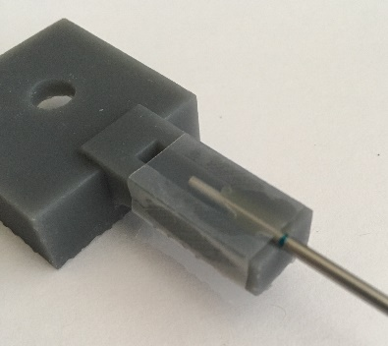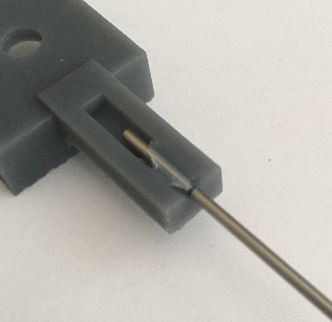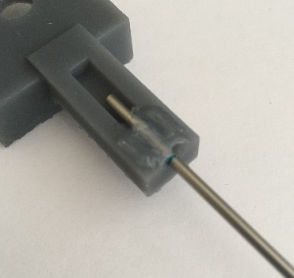

Figure Attaching the spout tube to the mount. a) mark tube at 1.5" b) fill triangular area with dental acrylic, insert tube at 1.5", and cover with tape c) cure and remove tape d) add extra dental acrylic and cure

a

b

c

d

no acrylic

acrylic

### Create electrode leads for the water spout

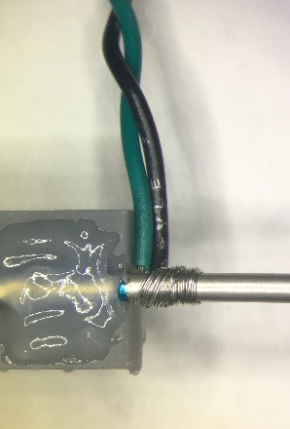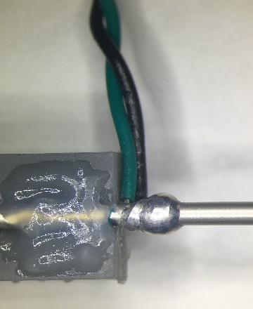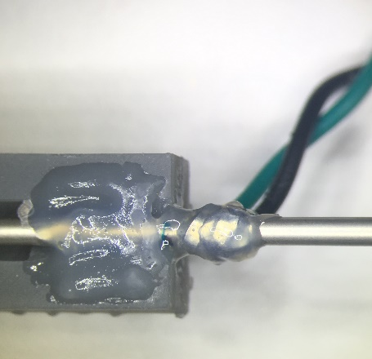

a

b

c

Figure Attaching the electrode leads to the water spout. a) twist stripped ends of leads around spout b) using flux, solder wires onto spout c) add dental acrylic to solder joint

* The water spout, which also serves as the touch sensitive electrode, will be connected to two wires, which will lead to the PCB.
* Cut two wires, about 1 foot long each
* Twist the two wires together.
* Strip the wires so one end of the wires is stripped to about 1/16”, and the other end is stripped to about 1/2".
* Wrap the bare wire ends of the 1/2" stripped side of the twisted pair around the lick spout tube right next to where it emerges from the mount.

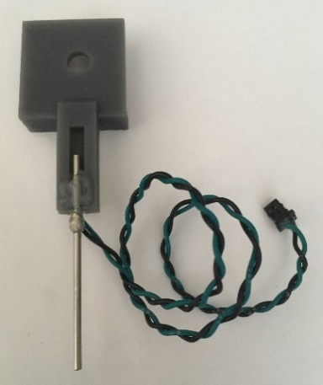

Figure Finished mounted water spout

* Paint some liquid flux over the area where the wires are wrapped around the tube.
* Apply a generous amount of solder to connect the twisted wire pair to the tube.
* Cover the wire/spout solder joint with dental acrylic or other adhesive to mechanically reinforce the connection.
* See Figure 30 for an illustration of this process.
* Add crimp terminals to the other ends of the twisted pair of electrode wires.
* Insert the crimped ends of the wires into the 2-pin receptacle (in any order).
* Add dental acrylic to the area where the wires enter the receptacle to provide extra mechanical strength.
* See Figure 17 for a depiction of the crimp terminal process.
* See Figure 31 for the finished water spout.

### Add wires to solenoid valve

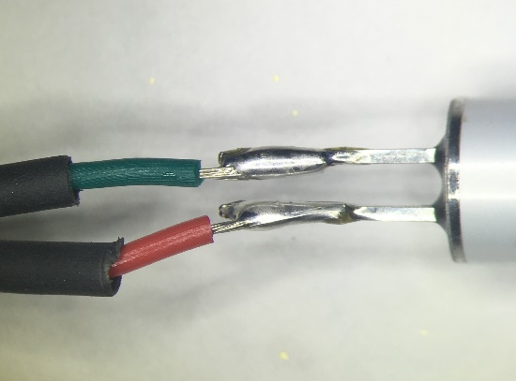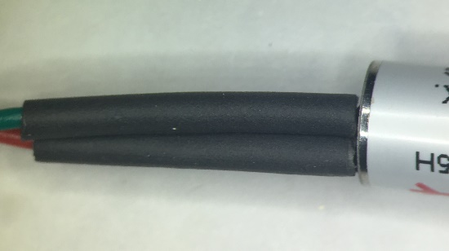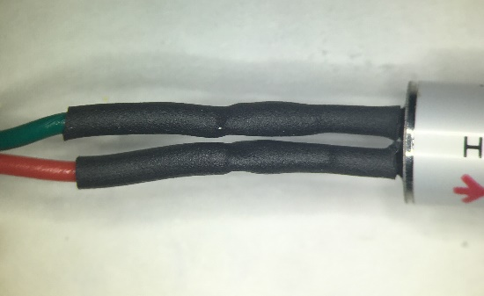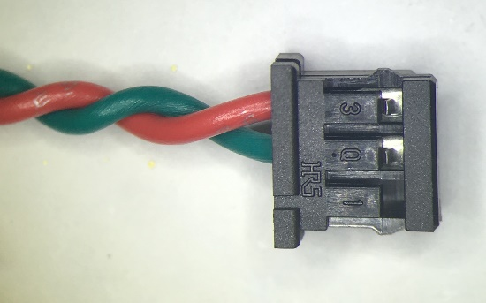

a

b

c

d

Figure Adding leads to solenoid valve. a) solder b) slide on heatshrink c) shrink heatshrink d) insert receptacle - note which receptacle slot is empty

* Cut two wires to a length of approximately 1 foot each.
* Twist the wires together.
* Strip one side of the wires to about 1/4", and the other to about 1/16”
* Add a piece of heatshrink tubing to the 1/4" stripped end of each wire
* Solder the 1/4" stripped wires onto the solenoid valve. The solenoid valve is nonpolar, so the order of the wires is not important.
* Slide the heatshrink tubing over the solder joint, and shrink with a heat gun.
* See Figure 32 for an illustration of this process.
* Add crimp terminals to the other ends of the wire, and insert into the 3-pin receptacle as shown in Figure 32d. Note which receptacle slot is left empty (due to historical changes in design).

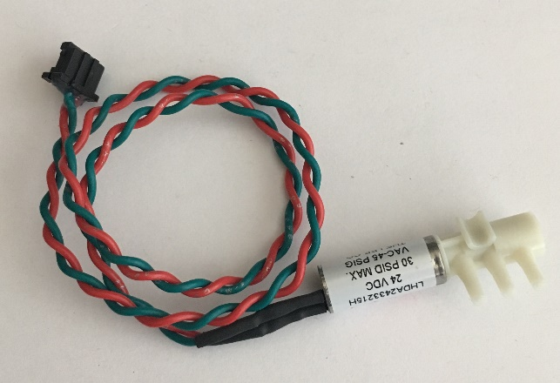

Figure Solenoid valve with completed leads

* See Figure 17 for a depiction of the crimp terminal process.
* See Figure 33 Solenoid valve with completed leads for the results of this step.

### Add tubes to solenoid valve

* Cut an approximately 1” section of 1/16” tubing.
* Push the 1” piece of tubing onto the valve outlet closest to the wire terminals, then add a 1/16” plug to seal that outlet
* Cut two more lengths of tubing, one approximately 1 foot, the other approximately 2 feet.
* Push the two lengths of tubing onto the other two valve outlets (order doesn’t matter).
* To see the tubing connected to the solenoid valve, see Figure 36.

### Connect the valve to the lick spout

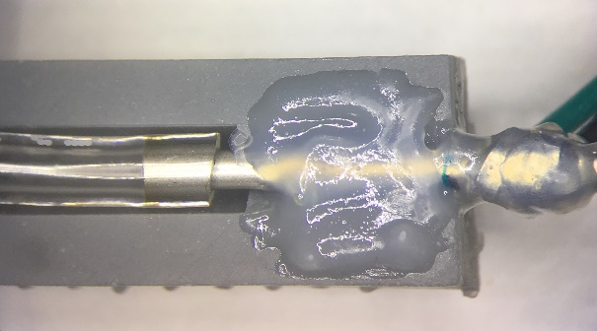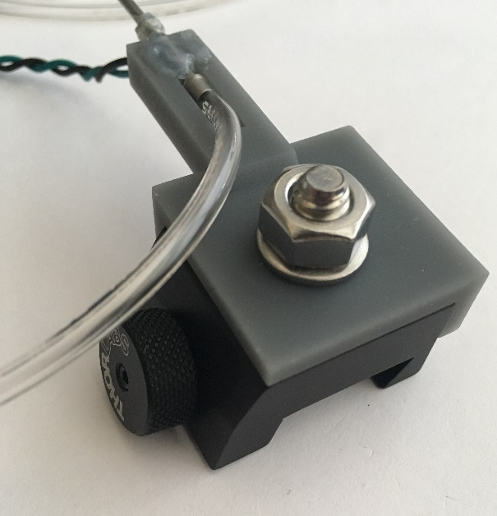

Figure Tube connecting solenoid valve and lick spout. Top: Close-up of tube/spout connection

* Push the free end of the 1-foot section of tubing from the valve onto the lick spout tube. Push the tubing as far on as possible.
* See Figure 34 for the results of this step

### Add the connector for the reservoir

* Push the last free tube onto the female Luer x 1/16” hose barb adapter. This will connect to the bottom port on the water reservoir.

### Solder components onto lick sensor board

* Solder the resistor, capacitors, IC chip, and headers onto the PCB
* See the parts list for the value of each labeled component on the PCB
* Note that the capacitor labeled C1 (referred to as the “sense capacitor” in the Atmel datasheet) controls the sensitivity of the lick sensor. We’ve found that 3.3 nF works well to accurately discriminate mouse tongue contact on the spout. If your application changes, C1 will need to be adjusted to fit the circumstances and desired sensor behavior. Higher values of C1 will result in a more sensitive electrode. With higher values of sensitivity, you may find the lick sensor registering a lick when the tongue passes nearby the electrode, even if it isn’t actually licking. With lower values of sensitivity, some licks may fail to register. It is fairly easy to desolder surface mount capacitors, so this value can be varied during calibration without remaking the entire PCB.

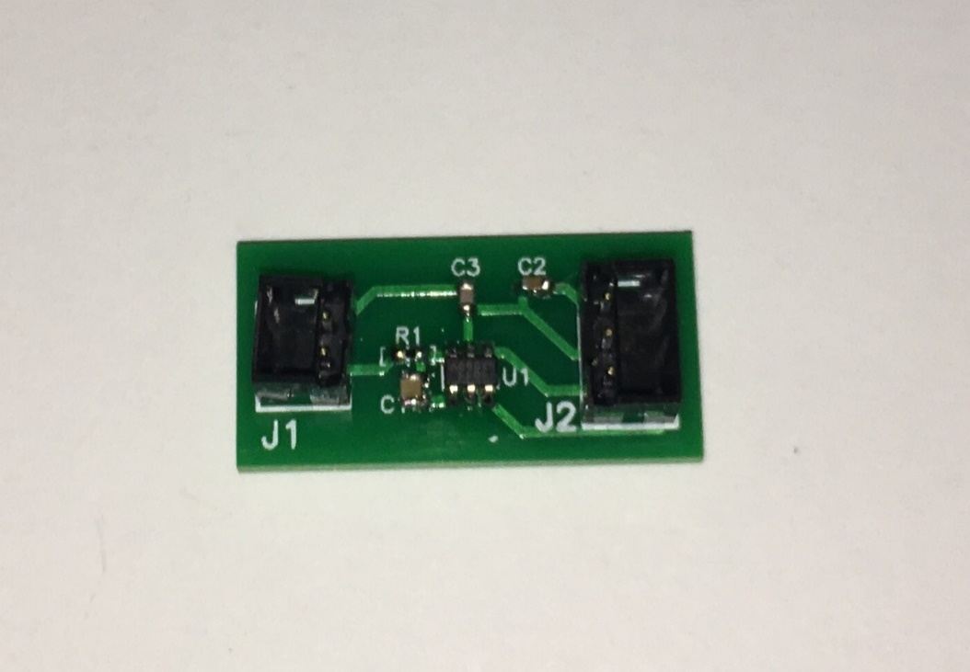

Figure Lick sensor PCB with components soldered on.

* See Figure 35 for the completed capacitive lick PCB.

### Plug the electrode and the connector cable into the PCB

* Insert the electrode 2-pin receptacle into the 2-pin header on the PCB.
* Insert the 3-pin connector cable receptacle into the 3-pun header on the PCB.

### Mount the lick spout on the rail carrier

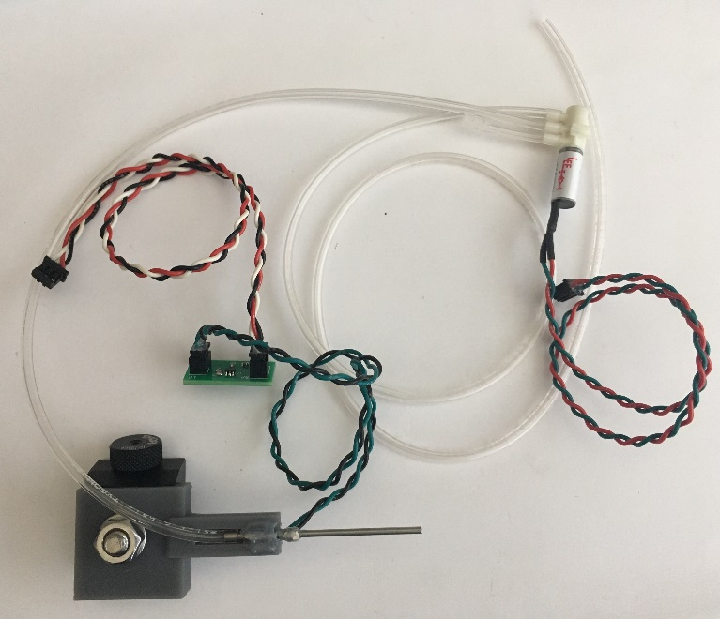

Figure Completed lick spout, capacitive lick sensor, and solenoid valve, all connected. (male Luer x 1/16” hose barb not shown)

* Place the lick spout mount on the rail carrier so the rail carrier is snug in the corner of the underside of the mount.
* Insert the 1/4"-20x5/8” screw into the underside of the rail carrier and through the hole in the mount, and secure with a washer and a nut.
* See Figure 36 for the finished lick spout, capacitive lick sensor, and solenoid valve.

### Add rail to mount lick spout

* Connect the bottom of the 3” graduated optical post to the 3” dovetail rail with a 1/4"-20x3/8” screw.
* See Figure 37 Lick spout mounting rail for the results of this step.
* Slide the lick spout rail carrier onto the 3” rail. Use the carrier thumbscrew to hold it in place.

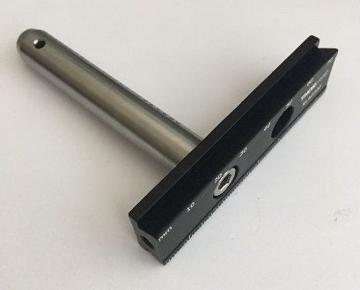

Figure Lick spout mounting rail

# Constructing alternate positionable spout mount for double-step experiments

## Full list of Materials

| **#** | **Part Description** | **Manufacturer/**  **Supplier** | **Manufacturer/Supplier Part Number** | **Datasheet/Drawing/Modification** |
| --- | --- | --- | --- | --- |
|  | Linear motor mount | 3D printed | N/A (Custom made) |  |
|  | Positionable lick spout mount | 3D printed | N/A (Custom made) |  |
|  | 1/2" Graduated Optical Post, SS, 8-32 Setscrew, 1/4"-20 Tap, L = 3" | Thorlabs | TR3E | <https://www.thorlabs.com/thorproduct.cfm?partnumber=TR3E> |
|  | 8-32x3/8” screw |  |  |  |
|  | Linear DC Servomotor | Faulhaber / Micromo | LM0830-015-01 | <https://www.faulhaber.com/en/products/series/lm-083001/> |
|  | Linear Motor Controller | Faulhaber / Micromo | MCLM3006 S RS | <https://www.faulhaber.com/en/products/series/mclm-3006-s/> |
|  | LM0830 flexboard adapter | Micromo | 6501.00117 |  |
|  | LM0830 flexboard adapter cable | Micromo | 6501.00118 |  |
|  | DC power supply (12V – 30V, 5+ A) |  |  |  |
|  | M1.2 x 3mm screw, non-magnetic recommended x4 |  |  |  |
|  | M1.6 x 5mm screw, non-magnetic recommended |  |  |  |
|  | M1.6 x 3mm screw, non-magnetic recommended |  |  |  |
|  | Small washer, non-magnetic (approximately M1.6) |  |  |  |
|  | M3 x 5mm screw x4 |  |  |  |
|  | Guide rail (with included fasteners) | McMaster-Carr | 6725K43 | <https://www.mcmaster.com/6725K43-6725K31/> |
|  | Guide rail carriage | McMaster-Carr | 8438K3 | <https://www.mcmaster.com/8438K3/> |
|  | M3 hex nut |  |  |  |
|  | M3 x 10 mm screw (optional) |  |  |  |
|  | Stranded, insulated wire, approximately 26 AWG, two different colors |  |  |  |
|  | BNC female x solder cup connector | Amphenol / Digikey | ARFX1905 | <https://www.digikey.com/product-detail/en/amphenol-rf-division/031-10-RFXG1/ARFX1905-ND/2643384> |
|  | BNC male x male connector | Amphenol / Digikey | ARFX1070 | <https://www.digikey.com/product-detail/en/amphenol-rf-division/31-218-RFX/ARFX1070-ND/160252> |
|  | Heatshrink tubing |  |  |  |

## Building Instructions

### General notes

This section describes the construction of an alternate motorized linear positioning spout mounting system for double-step experiments. This section replaces parts of “Part V: Constructing the lick spout with capacitive lick sensor and solenoid valve” if a linearly positionable spout is needed instead of a static one. This section does not describe how to construct or connect the solenoid valve or lick sensor, as the process is essentially identical. Refer to the other section for that information.

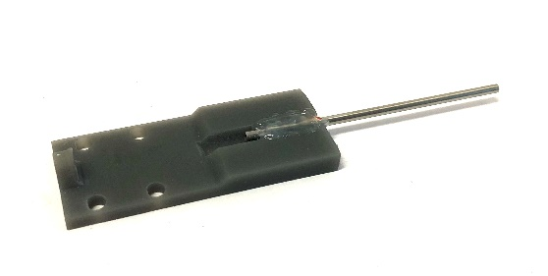

Figure Spout mount with spout attached

Caution: Never allow the actuator shaft to come out of the linear motor housing – doing so may release the bearings and destroy the motor. Never allow the carriage to come off of the guide rail – doing so likewise may release the bearings.

Recommended tools: Very fine flathead screw driver (~1.4mm)

### Create the lick spout

* Refer to the procedure in “Part V: 2. Create the lick spout”

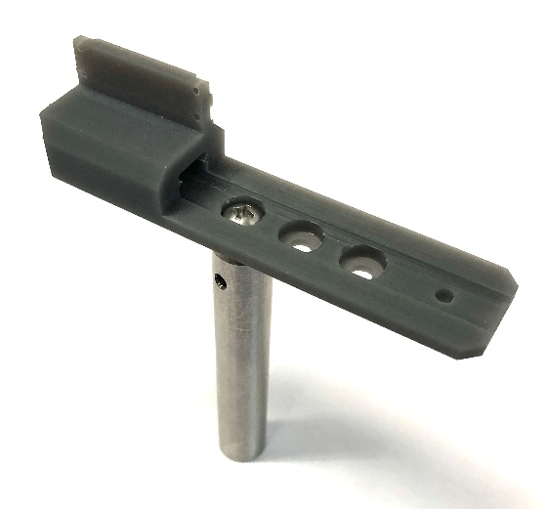

Figure Motor mount with optical post attached

### Attach the lick spout to the mount

* Refer to the procedure in “Part V: 3. Attach the lick spout tube to the mount”, using the positionable spout mount instead of the regular spout mount.
* See Figure 38 for the results of this step.

### Attach the optical post to the linear motor mount

* Insert the 8-32 screw into one of the motor mount mounting holes.
* Screw the optical post onto the threaded end of the screw protruding below the motor mount.
* See Figure 39 for the results of this step.

### Mount the guide rail onto the motor mount

* Slide the guide rail into the slot in the motor mount until the end mounting hole lines up with the small hole on the motor mount. You may need to clear 3D printing blemishes from the motor mount using a file or flush cutters. Make an effort to keep the guide rail clean and clear of dust and debris.

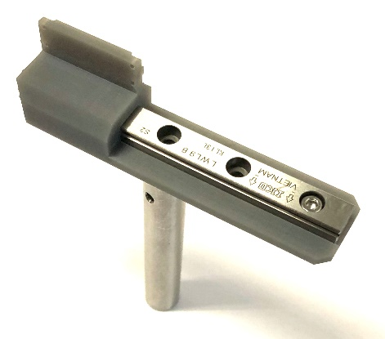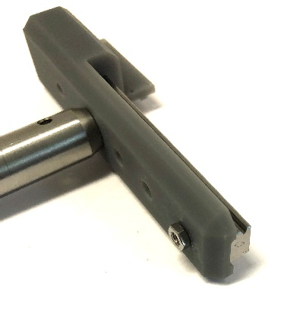

Figure Motor mount with guide rail installed. Left: Top view. Right: Bottom view.

* Insert one of the included guide rail screws into the end hole in the guide rail, so it protrudes through the small hole on the motor mount, and screw on the M3 hex nut onto the protruding end and tighten. Note that the included guide rail fasteners are just barely long enough – it may be helpful, though not necessary, to purchase a slightly longer M3 x 10 mm screw.
* See Figure 40 for the results of this step.

### Mount the linear motor on the motor mount

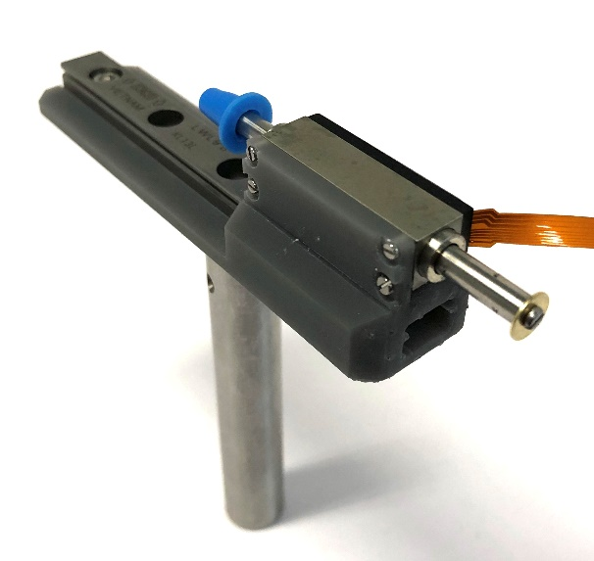

Figure Motor mount with motor installed.

* Hold the flat side of the linear motor up to the mounting panel on the motor mount, so the four mounting holes line up, and the flex cable is pointing backwards (away from the motor mount).
* Screw the four M1.2 screws through the four mounting holes on the mounting panel into the linear motor and tighten.
* Carefully remove the plastic cap on the back side of the linear motor shaft – DO NOT ALLOW THE SHAFT TO COME OUT OF THE MOTOR HOUSING.
* Insert the M1.6 x 3mm screw into the small washer, then screw it into the back of the linear motor shaft. This will prevent the shaft from accidentally exiting the motor housing in one direction.
* See Figure 41 for the results of this step.

### Attach the spout mount onto the guide rail carriage

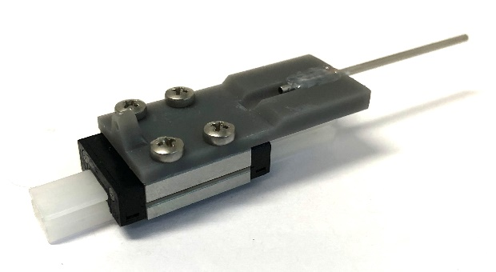

Figure Spout mount attached to guide rail carriage

* Unwrap the carriage, but DO NOT remove the plastic guide rail – doing so may release the bearings from the carriage.
* Hold the spout mount onto the carriage so the four mounting holes line up.
* Screw at least two M3 x 5mm into the mounting holes and tighten.
* See Figure 42 for the results of this step.

### Install the carriage onto the guide rail and motor shaft

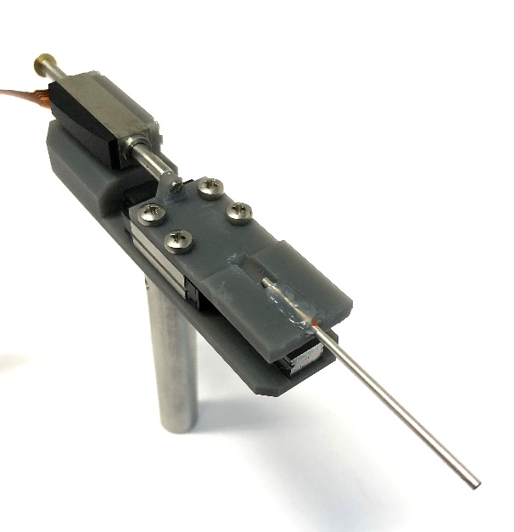

Figure Carriage installed on guide rail and attached to motor shaft

* Match the end of the plastic placeholder rail (which the carriage is packaged on) up to the guide rail on the motor mount, so the two guide rails are collinear.
* Carefully slide the carriage off the plastic guide rail and onto the metal guide rail with the spout pointing away from the motor – make sure not to allow the bearings to escape the carriage while transferring it from the plastic guide rail to the metal guide rail.
* Insert the M1.6 x 5mm screw into the shaft mounting hole on the spout mount, and screw it firmly into the end of the motor shaft, securing the carriage to the motor shaft.
* See Figure 43 for the results of this step.

### Connect the motor controller to the motor

* Gently insert the “flexboard” (the orange flat flexible connector on the motor) into the flexboard adapter by pulling the compression collar out, inserting the end of the flexboard into the collar, and pushing the compression collar back in. Make sure the bare metal contacts on the flexboard are facing down towards the green PCB when inserting.
* Plug the black receptacle on one end of the flexboard adapter cable onto the pins on the adapter board. Make sure the small key on the black receptacle is facing away from the green PCB (compare the colored wire positions in Figure 44 to confirm correct orientation)

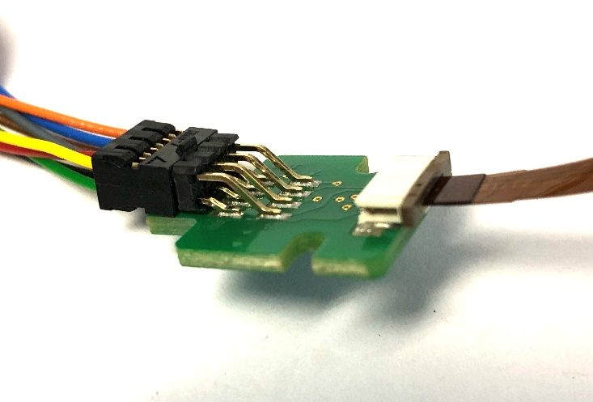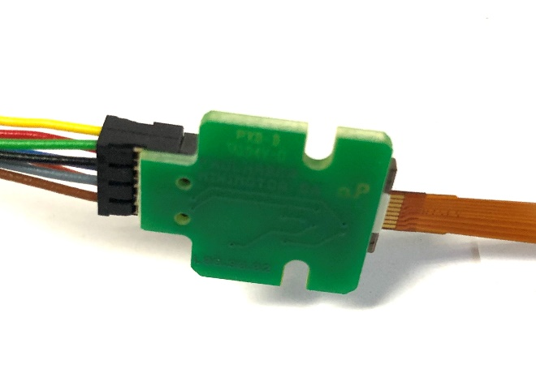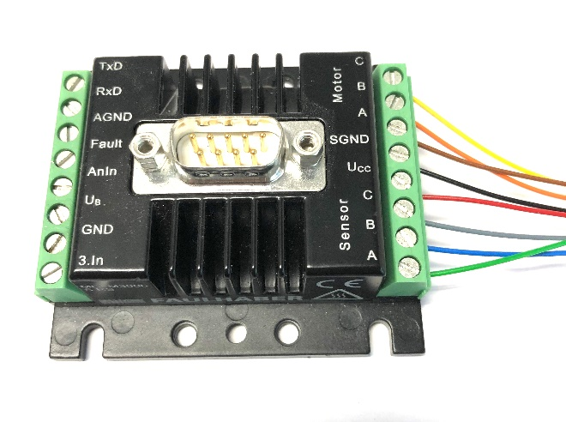

Figure Top to bottom: Flexboard adapter top view, bottom view, and motor controller connections

* Insert the free ends of the colored wires of the flexboard adapter cable into the screw terminals on the motor controller. It is very important that the correct color wires go into the correct screw terminals on the motor controller. Connecting them incorrectly may damage the motor or controller. See Figure 44 for the correct order.
* See Figure 44 for the results of this step.

### Connect the motor controller to power and signal source

* The motor controller has screw terminals labeled “GND” and “UB”. Connect these to the ground and positive connections respectively on an appropriate power supply (as per the MCLM 3006 technical manual, 12V – 30V, 5A or higher)
* The motor controller has screw terminals labeled “GND” and “AnIn”. When assembling the entire system, connect the FPGA analog output (the BNC output) to the GND and AnIn screw terminals on the motor controller to allow the FPGA to send an analog control signal to the motor controller.
* Use the BNC solder cup, the BNC M x M connector, stranded insulated wire, and heatshrink tubing to make a cable that can connect from the FPGA BNC output to the motor controller screw terminals.

### Complete the rest of the steps to build and attach the lick sensor and solenoid valve.

* See “Part V: Constructing the lick spout with capacitive lick sensor and solenoid valve”, steps 1, 4, 5, 6, 7, 8, 9, and 10.

# Assembling the underside viewing mirror

## Full list of Materials

| **#** | **Part Description** | **Manufacturer/**  **Supplier** | **Manufacturer/Supplier Part Number** | **Datasheet/Drawing/Modification** |
| --- | --- | --- | --- | --- |
|  | High-Permeability Magnetic Shielding Foil | Thorlabs | MSFHP | <https://www.thorlabs.com/thorproduct.cfm?partnumber=MSFHP> |
|  | 1" x 1" Protected Silver Mirror | Thorlabs | PFSQ10-03-P01 | <https://www.thorlabs.com/thorproduct.cfm?partnumber=PFSQ10-03-P01> |

## Building Instructions

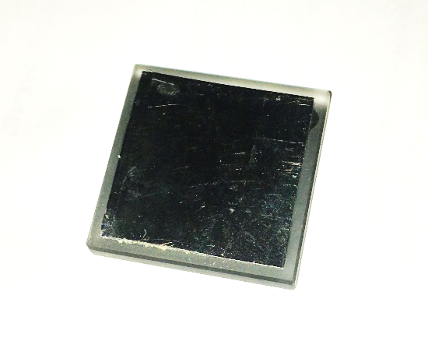

Figure Completed mirror, showing the back side with the magnetic foil applied.

### General notes

The underside viewing mirror is a mirror that can be placed on the mirror mount to allow a side-mounted camera to see both the side view of the mouse’s head and tongue and, simultaneously, the view from underneath. Because typically only one rig can be in the camera at a time, but many rigs can be training mice at the same time, the mirror was designed to be detachable. The mirror easily attaches to the rig with magnets when recording video.

Recommended tools: Scissors, bench-top vise

### Prepare the magnetic backing

* Cut an approximately 0.75” x 0.75” square of magnetic shielding foil.

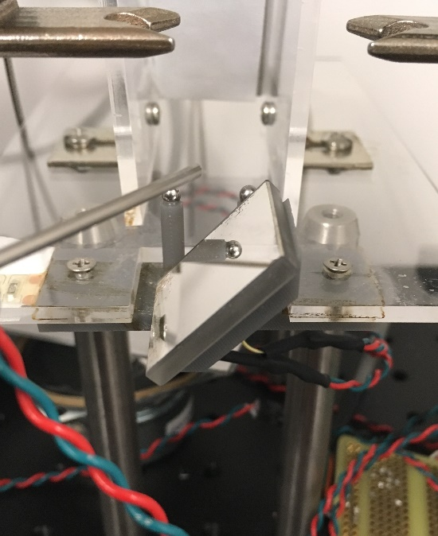

Figure Mirror placed on mirror mount on head-fixed rig

* Sandwich the foil between two flat pieces of metal, and press in a vise to completely flatten it. *Note: any bumps or bends in the foil will cause the mirror angle to differ from 45°, changing the underside view angle.*
* Peel off the backing – avoid bending the foil.
* Stick the backing onto the non-reflective back of the mirror. The foil should not stick out on any edge of the mirror.
* See Figure 45 for the results of this step.

### Install mirror

* When recording video, the mirror can by placed and positioned by simply putting it on the mirror mount. The magnets embedded in the mirror mount will hold the foil in place.

# Building the masking light

## Full list of Materials

| **#** | **Part Description** | **Manufacturer/Supplier** | **Manufacturer/Supplier Part Number** | **Datasheet/Drawing/Modification** |
| --- | --- | --- | --- | --- |
|  | LED light strip | Amazon | B01980IN56 | <https://www.amazon.com/KAPATA-Waterproof-Superbright-100cm-Strip/dp/B01980IN56/> |
|  | 2-pin receptacle | Hirose/Digikey | DF3-2S-2C | <https://www.digikey.com/product-detail/en/DF3-2S-2C/H2083-ND/141479> |
|  | Crimp terminals | Hirose/Digikey | DF3-2428SC | <https://www.digikey.com/product-detail/en/DF3-2428SC/H1500-ND/141644> |
|  | 5-minute epoxy (HARDMAN® Extra-Fast Setting Epoxy) | Hardman | 04001 | <http://www.royaladhesives.com/Files/Hardman-Structural/DOUBLE-BUBBLE_04001_RED_TDS.PDF> |
|  | Stranded, insulated wire, ~26 AWG |  |  |  |

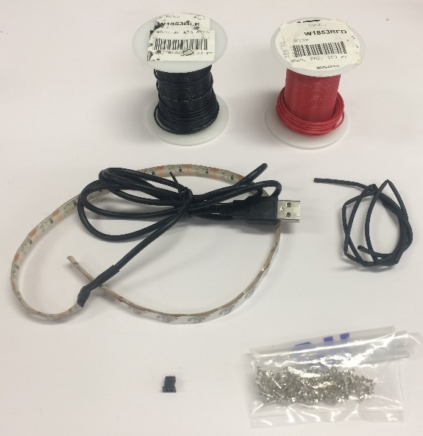

Figure Materials for masking light. Clockwise from top left: wire, heatshrink tubing, crimp terminals, 2-pin receptacle, LED light strip

## Building Instructions

### General notes

The masking light is an LED with wires and a 2-pin connector. It plugs into the joystick board and will be attached to the homecage above the lick port. Its purpose is to prevent mice from visually discriminating between trials when the optogenetic laser is on or off due to laser light leaking from the cannula.

Recommended tools: soldering iron, wire strippers, needlenose pliers, knife

### Cut one LED unit off of the strip

* Cut one of the LED units off of the strip along the printed divider lines.
* Peel and cut away the tiny bit of the plastic coating on the edge of the LED unit that covers the copper terminals marked “+” and “-“.
* See Figure 49 for the results of this step.

### Solder wires onto the LED

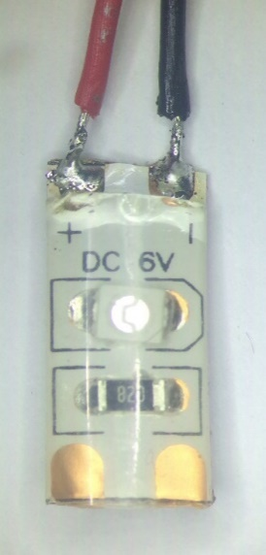

Figure LED with wires soldered onto terminals. Note that the terminals are marked "+" and "-" to indicate 5V and GND.

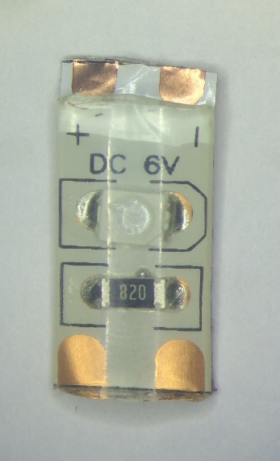

Figure LED unit cut from strip, with terminals exposed

* Cut, twist together, and strip two wires approximately 18” long each
* Solder one end of each wire onto the exposed terminals on the LED unit marked “+” and “-”. Color coding is recommended. See Figure 50.

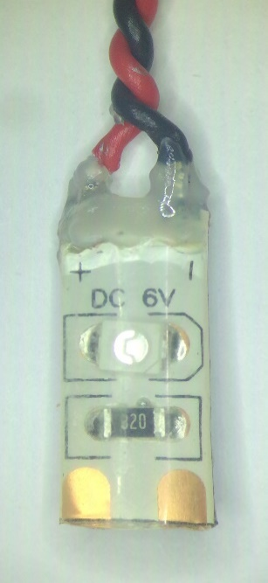

Figure LED with terminals coated

* Coat the exposed junction with epoxy or dental acrylic to insulate and strengthen the joint.
* See Figure 50 for the results of this step.

### Add receptacle

* Add crimp terminals to the two stripped ends of the wires
* Insert the crimped ends of the wires into the 2-pin receptacle in the order shown in Figure 51.

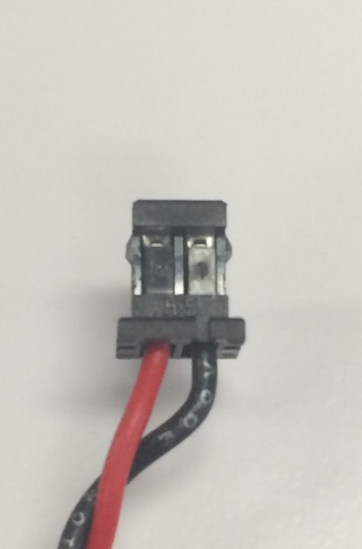

Figure Receptacle for LED

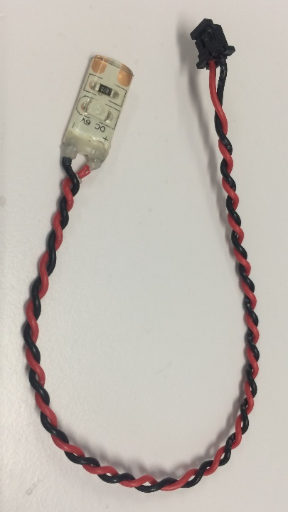

Figure Completed masking light

# Constructing the audio cue system

## Full list of Materials

| **#** | **Part Description** | **Manufacturer/**  **Supplier** | **Manufacturer/Supplier Part Number** | **Datasheet/Drawing/Modification** |
| --- | --- | --- | --- | --- |
|  | Speaker for Classic Mouse Chamber | Med Associates Inc. | ENV-324M | <https://www.med-associates.com/product/cage-speaker-for-classic-mouse-chamber/> |
|  | Multiple Tone Generator | Med Associates Inc. | ENV-223 | <https://www.med-associates.com/product/multiple-tone-generator/> |
|  | 1/4 Sized Perma-Proto Breadboard | Adafruit | 1608 | <https://www.adafruit.com/product/1608> |
|  | NPN Transistor | Micro Commercial Co/Digikey | 2N3904 | <https://www.digikey.com/product-detail/en/micro-commercial-co/2N3904-AP/2N3904-APCT-ND/950591?utm_adgroup=Semiconductor%20Modules&gclid=EAIaIQobChMIpO3hideR2gIVFFcNCh0mPwH6EAAYASAAEgIVBvD_BwE> |
|  | 2 kΩ resistor, axial lead | Stackpole Electronics Inc./Digikey | CF14JT2K00TR | <https://www.digikey.com/product-detail/en/stackpole-electronics-inc/CF14JT2K00/CF14JT2K00TR-ND/1741368> |
|  | 3-pin receptacle | Hirose/Digikey | DF3-3S-2C | <http://www.digikey.com/product-detail/en/DF3-3S-2C/H2084-ND/141482> |
|  | Small jumper wire |  |  |  |

## Building Instructions

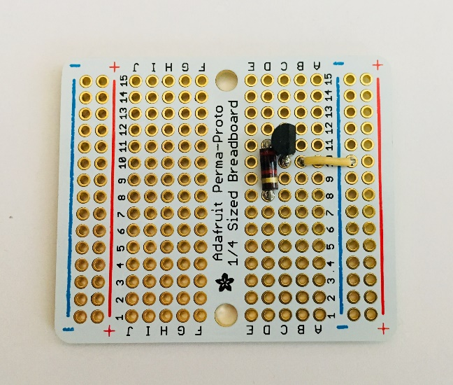

Figure Breadboard with resistor, transistor, and jumper wire soldered

### General notes

The audio cue system provides an audible tone to cue the mouse that the lick spout is active. A simple transistor circuit allows the DAQ to switch the audio tone on and off. See Figure 56 for a schematic of this circuit.

Recommended tools: Wire stripper, soldering iron, needlenose pliers

### Solder the resistor, transistor, and jumper wire

* Solder the jumper wire into the negative bus and row 11
* On the breadboard, solder the transistor emitter (left pin if the flat side faces you) into row 10, the base (center pin) into row 11, and the collector (right pin) into row 12.
* Solder the resistor into pins 8 and 12
* Trim the excess wire from the underside. See Figure 53 for the results of this step.

### Create a connector cable

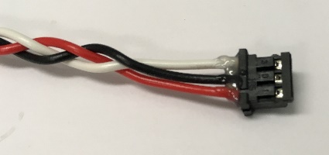

Figure Connector cable end. Note the order of the wires in the receptacle.

* Cut three wires about 6” long. Color coding is recommended – red=5V, black=ground, white=signal.
* Braid three wires together
* Strip one end of each wire to about 1/4", and the other end to about 1/16”
* Solder the longer stripped side of the cables into the breadboard, red wire onto the positive bus row, black wire onto the negative bus row, and white wire onto row 8

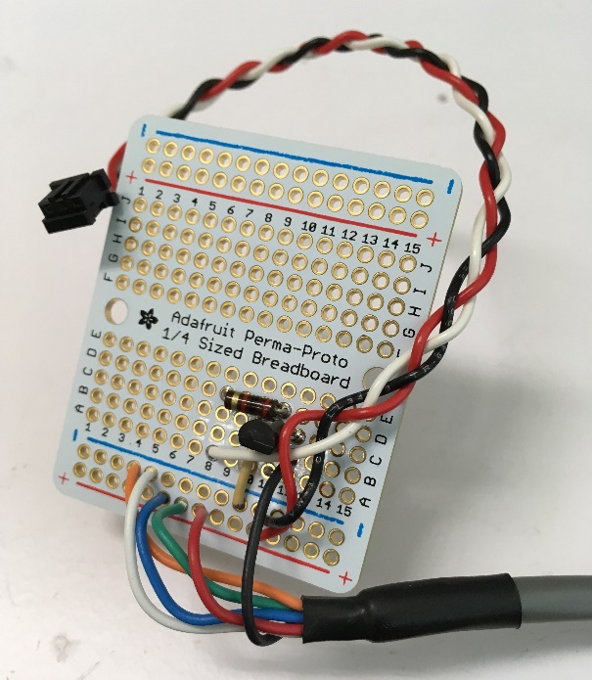

Figure Completed breadboard for audio cue system

* Add crimp terminals to the other end of each of the three wires
* Insert the crimp terminals into the 3-pin receptacle in the order shown in Figure 54.
* Add some dental acrylic to the back of the receptacle to secure the terminals in place.

### Solder the tone generator leads onto the breadboard

* Cut off any connectors at the end of the cable coming out of the tone generator, removing as little wire as possible, so there is plenty to work with.
* The blue, green, orange, and white wires can each be connected to ground or 5V to control the frequency of the tone generated. The combination described below should generate a 3.5 kHz tone. See the [ENV-223 manual for other combinations](https://www.med-associates.com/wp-content/uploads/2017/01/DOC-044-R1.2-ENV-223-MULTIPLE-TONE-GENERATOR.pdf).
* The wires are color coded. Solder them as follows:
  + Black wire onto row 12
  + Red, green, and blue wires onto positive bus row
  + Orange and white wires onto negative bus row
* See Figure 55 for the results of this step.

### Plug in the speaker

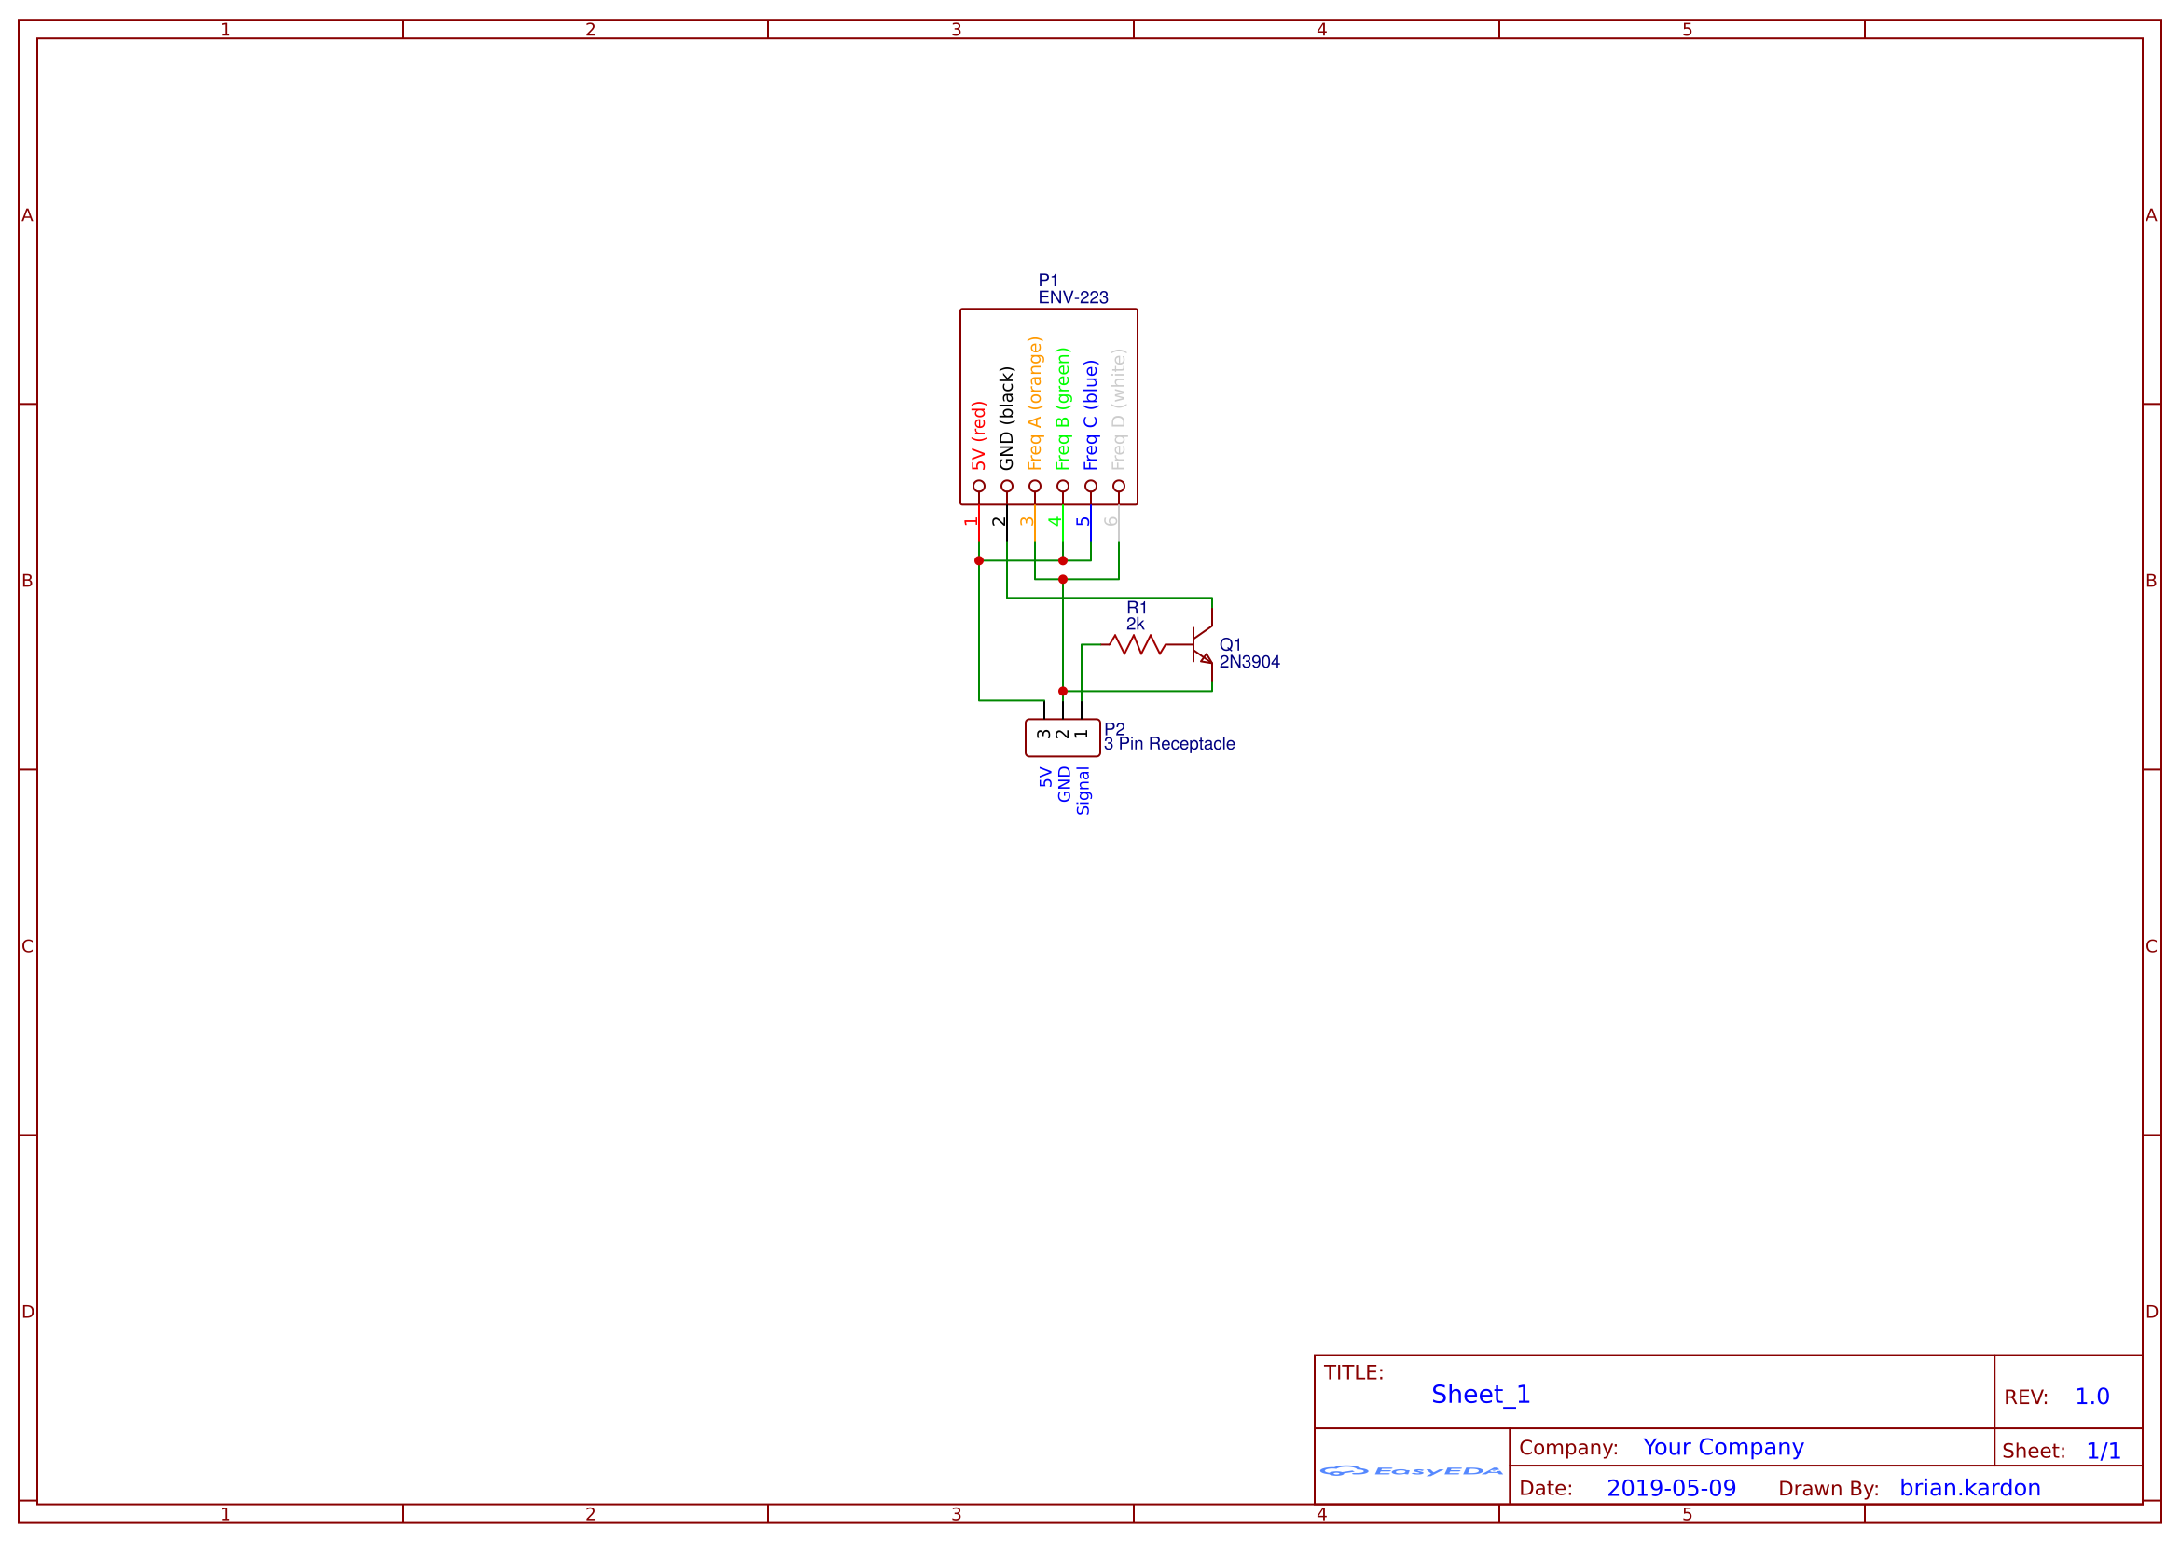

Figure Schematic for audio cue circuit

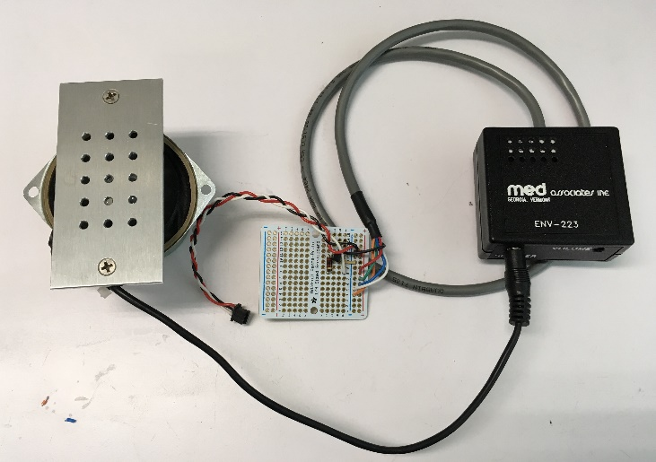

Figure Completed audio cue system

* The speaker has an audio plug – insert it into the audio jack on the tone generator
* Note that the volume can be adjusted with a small flathead screwdriver.
* See Figure 57 for the completed audio cue system.

# Building a joystick board

## Full list of Materials

| **#** | **Part Description** | **Manufacturer/**  **Supplier** | **Manufacturer/Supplier Part Number** | **Datasheet/Drawing/Modification** |
| --- | --- | --- | --- | --- |
|  | Joystick PCB | Custom made using Pad2Pad | N.A. (Custom made) |  |
|  | Capacitor, 10 pF, SMT x2 | Samsung/Digikey | 1276-2154-1-ND | <https://www.digikey.com/product-detail/en/samsung-electro-mechanics/CL10C100JB8NCNC/1276-2154-1-ND/3890240> |
|  | Capacitor, 1 nF, 0603 case x3 | Samsung/Digikey | 1276-1091-1-ND | <https://www.digikey.com/product-detail/en/samsung-electro-mechanics/CL10C102JB8NNNC/1276-1091-1-ND/3889177> |
|  | Capacitor, 10 nF, SMT x4 | Samsung/Digikey | 1276-1103-1-ND | <https://www.digikey.com/product-detail/en/samsung-electro-mechanics/CL10B103JB8NNNC/1276-1103-1-ND/3889189> |
|  | Capacitor, 0. 1 μF (100 nF), 0603 case | Samsung/Digikey | 1276-6998-1-ND | <https://www.digikey.com/product-detail/en/samsung-electro-mechanics/CL10B104KO8ZW6C/1276-6998-1-ND/7320640> |
|  | Capacitor, 0.22 μF, radial leads | Samsung/Digikey | 1276-1996-1-ND | <https://www.digikey.com/product-detail/en/samsung-electro-mechanics/CL10B223JB8NNNC/1276-1996-1-ND/3890082> |
|  | Capacitor, 0.47 μF, 0402 case x2 | Samsung/Digikey | 1276-2082-1-ND | <https://www.digikey.com/en/supplier-centers/s/samsung-electro-mechanics-america> |
|  | Resistor, 160 Ω, 0402 case | Vishay-Dale/Digikey | 541-160YCT | <https://www.digikey.com/product-detail/en/vishay-dale/CRCW0402160RFKEDHP/541-160YCT-ND/2825954> |
|  | Resistor, 1 kΩ, 0402 case x5 | Panasonic/Digikey | P1.00KLCT | <https://www.digikey.com/product-detail/en/panasonic-electronic-components/ERJ-2RKF1001X/P1.00KLCT-ND/97341> |
|  | Resistor, 2.6 kΩ, 0402 case | Panasonic/Digikey | P2.61KLCT | <https://www.digikey.com/product-detail/en/panasonic-electronic-components/ERJ-2RKF2611X/P2.61KLCT-ND/194243> |
|  | Resistor, 3.3 kΩ, 0402 case x2 | Rohm/Digikey | RHM3.3KCDCT | <http://www.digikey.com/product-detail/en/MCR01MRTF3301/RHM3.3KCDCT-ND/4083740> |
|  | Resistor, 9 kΩ, 0402 case | Panasonic/Digikey | P9.10KLCT | <https://www.digikey.com/product-detail/en/panasonic-electronic-components/ERJ-2RKF9101X/P9.10KLCT-ND/17467224> |
|  | Resistor, 22 kΩ, 0402 case | Panasonic/Digikey | P22KJCT | <http://www.digikey.com/product-detail/en/ERJ-2GEJ223X/P22KJCT-ND/146939> |
|  | Op Amp IC, SMT | TI/Digikey | LM358 | <https://www.digikey.com/product-detail/en/texas-instruments/LM358DR/296-1014-1-ND/404838> |
|  | Voltage regulator | STMicroelectronics/Digikey | L7805CV | <https://www.digikey.com/product-detail/en/stmicroelectronics/L7805CV/497-1443-5-ND/585964> |
|  | Touch sensor IC, SMT x2 | Atmel/Digikey | AT42QT1011 | <http://www.atmel.com/images/Atmel-9542-AT42-QTouch-BSW-AT42QT1011_Datasheet.pdf> |
|  | Transistor x2 | Micro Commercial Co/Digikey | 2N3904 | <https://www.digikey.com/product-detail/en/micro-commercial-co/2N3904-AP/2N3904-APCT-ND/950591?utm_adgroup=Semiconductor%20Modules&gclid=EAIaIQobChMIpO3hideR2gIVFFcNCh0mPwH6EAAYASAAEgIVBvD_BwE> |
|  | 2-pin header x4 | Hirose Electric/Digikey | DF3A-2P-2DSA | <http://www.digikey.com/product-detail/en/DF3A-2P-2DSA/H2094-ND/141512> |
|  | 3-pin header x2 | Hirose Electric/Digikey | DF3A-3P-2DSA | <http://www.digikey.com/product-detail/en/DF3A-3P-2DSA/H2095-ND/141515> |
|  | 4-pin header | Hirose Electric/Digikey | DF3A-4P-2DSA | <http://www.digikey.com/product-detail/en/DF3A-4P-2DSA/H2096-ND/141518> |
|  | DB-9 connector, male, through hole | Amphenol/Digikey | A34064-ND | <https://www.digikey.com/product-detail/en/te-connectivity-amp-connectors/5747871-2/A34064-ND/1123840> |
|  | DB-15 connector, female, RA through hole | Amphenol/Digikey | 17EBH-015-S-AM-0-10 | <https://www.digikey.com/product-detail/en/amphenol-commercial-products/17EBH-015-S-AM-0-10/17EBH-015-S-AM-0-10-ND/1242549> |
|  | Heat sink | Wakefield-Vette/Digikey | 345-1022 | <https://www.digikey.com/product-detail/en/wakefield-vette/273-AB/345-1022-ND/340320> |
|  | Heat sink compound, Silicone (type Z9) | GC Electronics | 10-8109 | <http://www.gcelectronics.com/order/DataSheets/10-8109%2010-8108%2010-8107-10%2010-8107-100%2010-8106%20Silicone%20(Z9).pdf> |
|  | Screw, 4-40x3/8” with nut |  |  |  |

## Building Instructions

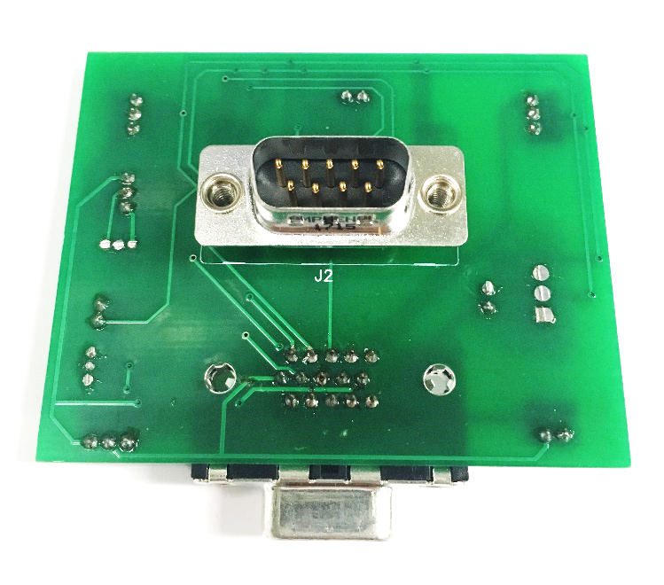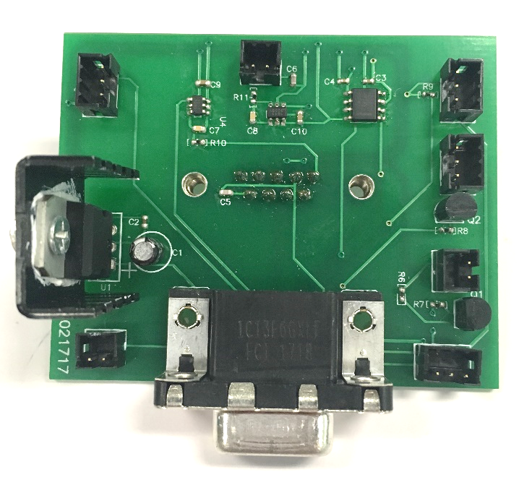

Figure Completed joystick board. Top: Front side. Bottom: Back side.

### General notes

The joystick board collects and conditions the signals from the various sensors, and passes the resulting signals to the DAQ. The board was developed for an experiment involving a rodent joystick, and although this setup does not involve a rodent joystick, most of the other sensors are the same, so the same board can be used.

If soldering, especially surface mount soldering, is new to you, there are many guides available on the internet.

Recommended tools: Soldering iron, helping hands

### Soldering the SMT components

* C2 = 0.1 uF
* C3 = 1 nF
* C4 = 1 nF
* C5 = 10 pF
* C6 = 10 pF
* C7 = 10 nF
* C8 = 10 nF
* C9 = 0.47 uF
* C10 = 0.47 uF
* R6 = 3.3 kΩ
* R7 = 1 kΩ
* R8 = 1 kΩ
* R10 = 1 kΩ
* R11 = 1 kΩ
* R9 = 22 kΩ
* U2 = Op amp IC – *note: the orientation is important here!*
* U4 = Touch sensor IC – *note: the orientation is important here!*
* U5 = Touch sensor IC – *note: the orientation is important here!*

### Soldering the through-hole components

* C1 = 0.22 uF – *note: the orientation is important here!*
* U1 = Voltage regulator – *note: the orientation is important here!*
* Q1 = Q2 = Transistor – *note: the orientation is important here!*
* J5 = J7 = J9 = 2-pin header
* J3 = J4 = J6 = J8 = 3-pin header
* J2 = DB-9 connector (solder on **back** of board)
* J1 = DB-15 connector

### Add heatsink

* Dab a small amount of heatsink compound onto the heatsink.
* Using a 4-40 screw and nut, firmly attach the heatsink to the voltage regulator using the hole on the regulator chassis.
* See Figure 58 for the completed joystick board.

# Building an adapter for the joystick board

## Full list of Materials

| **#** | **Part Description** | **Manufacturer/**  **Supplier** | **Manufacturer/Supplier Part Number** | **Datasheet/Drawing/Modification** |
| --- | --- | --- | --- | --- |
|  | DB-9 Female Receptacle Solder Cup | Norcomp/Digikey | 209FE-ND | <https://www.digikey.com/product-detail/en/norcomp-inc/171-009-203L001/209FE-ND/858108> |
|  | Heatshrink tubing |  |  |  |
|  | Stranded, insulated wire, ~26 AWG |  |  |  |
|  | 2-pin header | Hirose Electric/Digikey | DF3A-2P-2DSA | <http://www.digikey.com/product-detail/en/DF3A-2P-2DSA/H2094-ND/141512> |

## Building Instructions

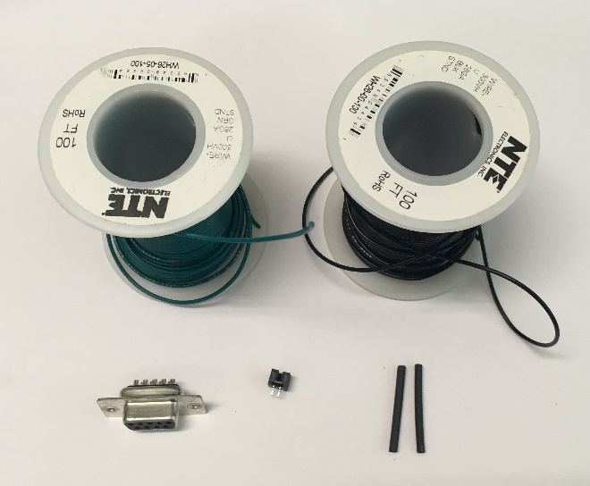

Figure Materials for joystick board adapter. Clockwise from top left: Wire, heatshrink tubing, 2-pin header, female to solder cup DB-9 connector

### General notes

Since the joystick board was originally designed to attach to a rodent joystick with a capacitive ball touch sensor, but this setup does not include a joystick, we will need a small adapter to connect the second capacitive ball electrode to the joystick board. The joystick board could be redesigned to accommodate two touch posts, which would obviate the need for this adapter.

Recommended tools: Soldering iron, heat gun, needlenose pliers, helping hands

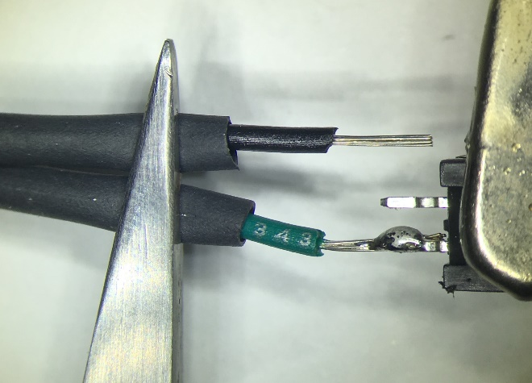

Figure Soldering wires to 2-pin header

### Prepare the leads

* Cut two wires about 6” long

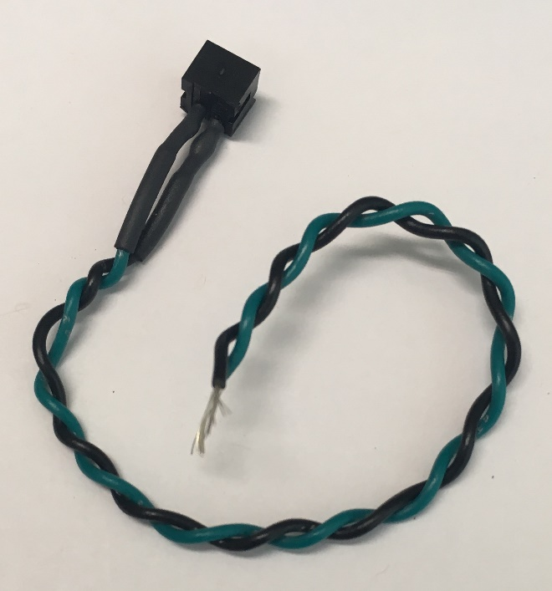

Figure Header connected to wire leads

* Twist them together and strip the ends, about 1/8” on both sides
* Slide a piece of heatshrink tubing onto each of the ends on one side of the wires in preparation for the next step

### Connect the header

* Solder the heatshrink-side of each of the wires onto each of the two header pins. *Note: the plastic housing the header pins tends to melt if exposed to soldering iron heat for extended periods of time.*
* Slide the heatshrink tubing over the solder joint and shrink with a heat gun.
* See Figure 60 for an illustration of this process

### Connect the DB9

* Add a piece of heatshrink tubing to the other end of each wire
* Fill the solder cups #1 and #9 on the DB9 connector (if you look closely, you can see pin numbers next to the cups)

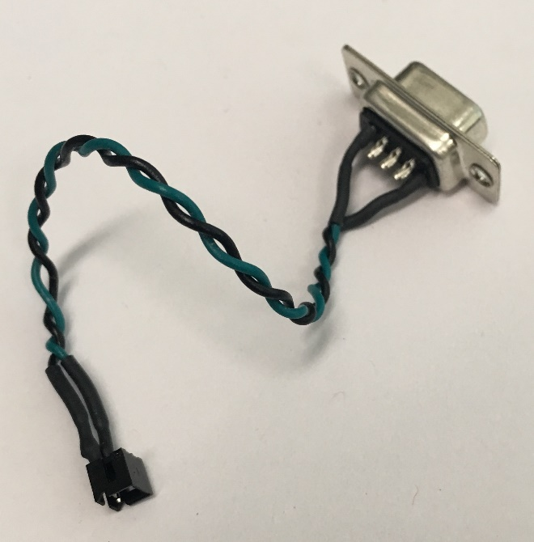

Figure Completed joystick board adapter for second touch post

* Remelt the solder and insert the two wires into solder cups #1 and #9
* Push the heatshrink tubing over the solder cup and shrink with a heat gun
* See Figure 62 for the finished adapter.

# Building restraint walls and back support

## Full list of Materials

| **#** | **Part Description** | **Manufacturer/**  **Supplier** | **Manufacturer/Supplier Part Number** | **Datasheet/Drawing/Modification** |
| --- | --- | --- | --- | --- |
|  | White fun foam 9" X 12" X 1/16" thick | Cleverbrand Inc./Amazon | 4336848947 / B01HIMLUGA | <https://www.amazon.com/WHITE-FUN-FOAM-THICK-PACK/dp/B01HIMLUGA/ref=asc_df_B01HIMLUGA/> |
|  | Acrylic wall panels x2 | Custom made with laser cutter (see Figure 66) | N/A (Custom made) | N/A |
|  | Metal rectangle | Custom made | N/A | N/A |
|  | Metal brackets x2 |  |  |  |
|  | 4-40x3/8” screws x2 |  |  |  |
|  | 4-40 nuts x2 |  |  |  |
|  | Superglue (Loctite 401) | Loctite | 401 | <http://www.loctite.sg/sea/content_data/93806_NEWCA401EN.pdf> |

## Building Instructions

Figure Materials for restraint walls and back support. Clockwise from top left: metal rectangle, brackets, side wall panels, 4-40x3/8” screws, 4-40 nuts, 8-32x3/8” screws, 8-32 nuts. Not pictured: Foam sheet

### General notes

To maintain the mouse’s body orientation during head-fixing, two side walls are mounted on top of the platform on either side of the mouse, and a back support fits between them.

Recommended tools: Screwdriver, adjustable crescent wrench, scissors

### Attach brackets to the side walls

* Attach the hole side (as opposed to slot side) of one of the brackets to the hole in one of the side walls. See Figure 65 for the correct orientation.
* Attach the other bracket to the other wall oriented in mirror image to the other wall.

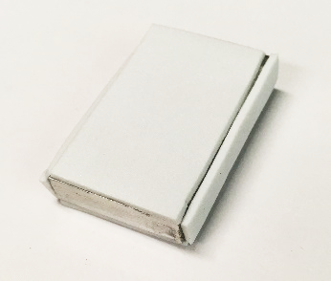

Figure Completed back support

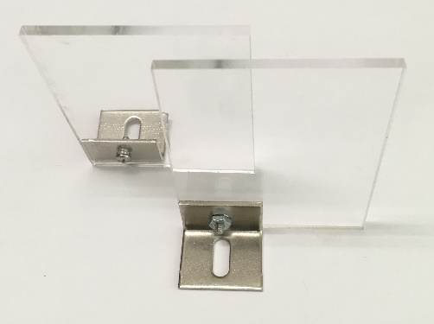

Figure Side walls with brackets attached. Note that the long dimension of the wall is vertical, that the slot side of the bracket is down, and that the two walls are mirror images of each other.

### Construct the back support

* Cut pieces of foam sheet the same size as the front, back, and two long edges of the back support rectangle.
* Use superglue to affix the foam to the rectangle.
* The foam makes the back support more comfortable for the mouse, and also makes it possible to wedge the back support firmly between the walls.
* See Figure 64 for the results of this step.

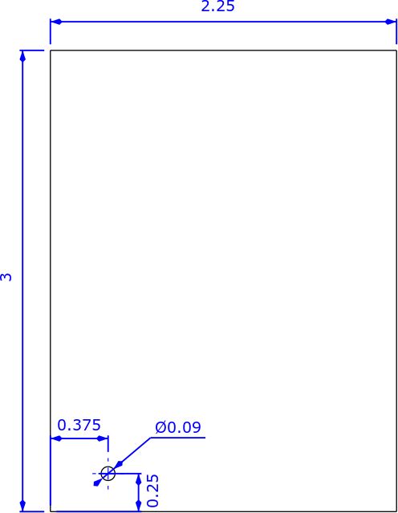

Figure Wall dimensions, in inches

# Final assembly of the rig

## Full list of Materials

| **#** | **Part Description** | **Manufacturer/**  **Supplier** | **Manufacturer/Supplier Part Number** | **Datasheet/Drawing/Modification** |
| --- | --- | --- | --- | --- |
|  | Head-fixed rig base |  |  | See Constructing the rig base |
|  | Head-fixing assemblies (left and right) |  |  | See Constructing the head-fixing assemblies |
|  | Touchposts and mirror mount |  |  | See Constructing the touchposts and mirror mount |
|  | Water reservoir |  |  | See Constructing the water reservoir |
|  | Lick spout, lick sensor, and solenoid valve |  |  | See Constructing the lick spout |
|  | Mirror with magnet mount |  |  |  |
|  | Masking light |  |  | See Building the masking light |
|  | Audio cue system |  |  | See Constructing the audio cue system |
|  | Joystick board |  |  | See Building a joystick board |
|  | Joystick board adapter for second touchpost |  |  | See Building an adapter for the joystick board |
|  | Side walls and back support |  |  | See Building restraint walls and back support |
|  | 1/2" Optical Post, SS, 8-32 Setscrew, 1/4"-20 Tap, L = 2" | Thorlabs | TR2 | <https://www.thorlabs.com/thorproduct.cfm?partnumber=TR2> |
|  | 8-32x3/8” screws x5 |  |  |  |
|  | 8-32 nuts x5 |  |  |  |
|  | 4-40x3/8” screws x2 |  |  |  |
|  | 4-40 nuts x2 |  |  |  |
|  | 1/4"-20x3/8” screw |  |  |  |
|  | Tape |  |  |  |

## Building Instructions

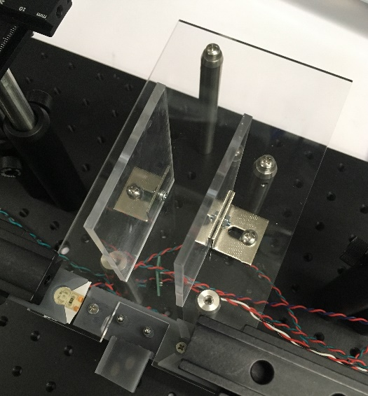

Figure Side walls installed on platform

### General notes

See Figure 72 for a diagram of where all the components plug into the joystick board.

### Mount restraint walls

* Set the two restraint walls with brackets so the bracket slots are over the two mounting holes in the platform and the brackets face outwards.
* Insert 8-32x3/8” screws into the bracket slots and the platform holes.
* Add 8-32 nuts loosely onto the 8-32x3/8” screws.
* Position the walls so they are centered on the platform, and the back support fits snugly between them, then tighten the 8-32 screws.
* The walls must be positioned so the back support can just be wedged between them.

### Mount touchposts and mirror mount on platform

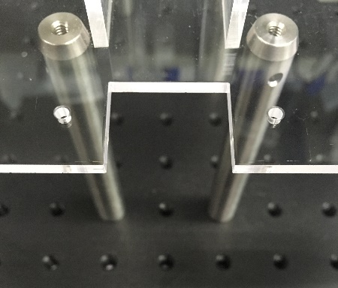

Figure Platform ready for touchposts and mirror mount platform

* Use 4-40x3/8” screws and nuts to mount the touchposts and mirror platform in the rectangular cutout in the front of the platform. The touchpost panel should be mounted **below** the platform.
* Plug the joystick board adapter into the DB-9 connector in the back of the board.
* Plug one of the touchposts into the adapter, and the other into the joystick board. See Figure 72 for the correct positions on the joystick board.
* See Figure 69 for the results of this step.

### Mount water reservoir

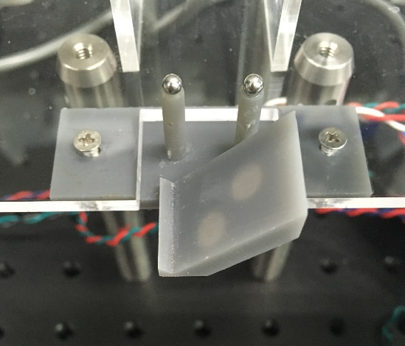

Figure Touchposts and mirror mount installed

* Remove the screw and backing for the water reservoir mounting mechanism that comes with the water bottle. They won’t be used.
* Insert an 8-32x3/8” screw into the water reservoir mount, and start an 8-32 nut on the screw, but leave it at the end of the screw – do not tighten it.
* Slide the nut into the front-facing slot on the construction rail.
* Position the mount at the top of the rail, and tighten the screw firmly to hold the mount in place.
* Insert the water reservoir into the mount and lock it in.
* See Figure 70 for the results of this step.

### Install and connect lick spout assembly

* Insert the end of the lick spout optical post into the 3” post holder on the rotation stage on the rig base. Use the thumbscrew to hold the post in place.

Figure Water reservoir mount attached to construction rail

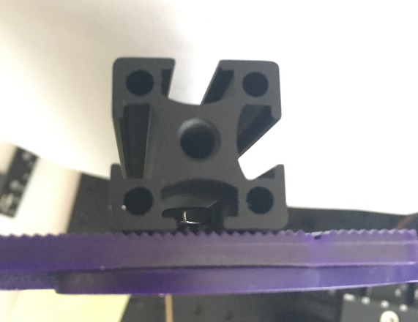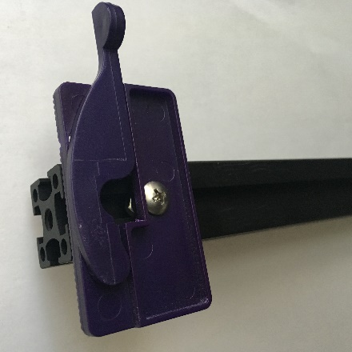

Nut in rail slot

* Plug the lick sensor connector cable into the joystick board. See Figure 72 for the correct position on the joystick board.

### Add audio system

* Place the speaker on the rig base breadboard near the platform. Put the tone generator and circuit board out of the way on the back area of the rig base, and run the connector cable around the back.
* Connect the connector cable to the joystick board. See Figure 72 for the correct position on the joystick board.

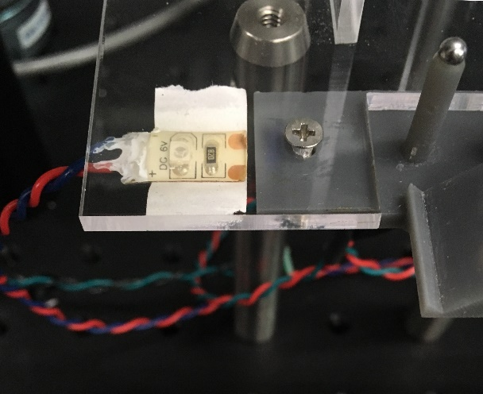

Figure Masking light installed

### Connect lick spout to water reservoir and joystick board

* Plug the solenoid connector cable into the joystick board. See Figure 72 for the correct position on the joystick board.
* Slide the unconnected end of the tube from the solenoid valve onto the bottom outlet of the water reservoir.

### Connect the masking light

* Tape the masking light onto the underside of the platform right next to the touchpost panel. The light needs to be easily visible from the mouse’s point of view.
* Plug the masking light cable into the joystick board. See Figure 72 for the correct position on the joystick board.

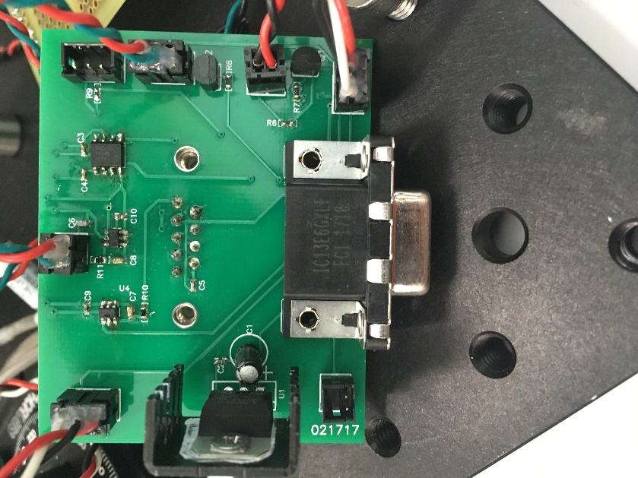

Lick sensor

Touch post

No connection

Solenoid valve

Masking light

Audio system

Figure Joystick board connections for the head-fixed rig. The second touchpost connects to the DB-9 adapter cable, which attaches in the back of the joystick board.

No connection

# Building the optogenetic system

## Full list of Materials

| **#** | **Part Description** | **Manufacturer/Supplier** | **Manufacturer/Supplier Part Number** | **Datasheet/Drawing/Modification** |
| --- | --- | --- | --- | --- |
|  | Doric Laser Diode Fiber Light Source, 2 channel, 450 nm | Doric | LDFLS_450/075_450/075 | <http://doriclenses.com/life-sciences/laser-diode-fiber-light-sources/910-laser-diode-fiber-light-source-2-channel-model.html#/ld_wavelengths-450_nm_75_mw/ld_wavelengths_2-450_nm_75_mw> |
|  | Fiber commutator | Doric | FRJ_1x2i_FC-2FC | <http://doriclenses.com/life-sciences/fiber-optic-rotary-joints/809-1x2-fiber-optic-rotary-joints-intensity-division.html> |
|  | Mounting plate for commutators | Custom made with laser cutter | N.A. (Custom made) |  |
|  | Fiber optic cable, male to male SMA | Thorlabs | FG200UCC 200um 0.22NA | <https://www.thorlabs.com/thorproduct.cfm?partnumber=FG200UCC> |
|  | Fiber optic cable, male SMA to ferrule insert |  |  |  |
|  | Commutator mounting bracket | Doric | Holder_FRJ_large | <http://doriclenses.com/life-sciences/holders-for-rotary-joints/819-holder-for-frj1x2-frj1x4-erj-aerj-hrj-oe-and-ledfrj-1ch.html> |
|  | 1/4”-20 x 1” screws |  |  |  |
|  | 1/4”-20 nuts |  |  |  |

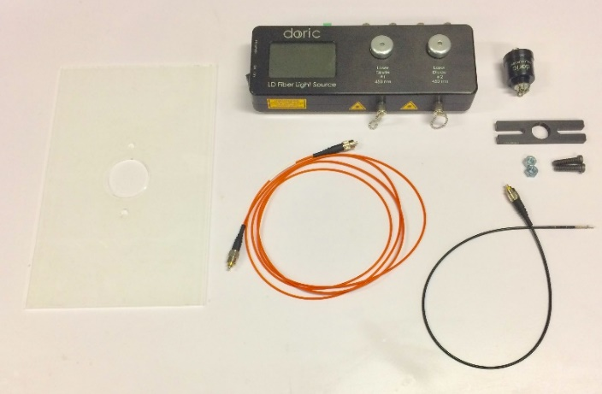

Figure Optogenetic system materials. Clockwise from top left: Custom mounting plate, laser light source, commutator, commutation mounting bracket, 1/4"x20 bolts and nuts, fiber optic cable (black, male SMA to ferrule), fiber optic cable (orange, male to male)

## Building Instructions

### General notes

The optogenetic system consists of a laser light source, optical fibers, and a commutator/splitter. The light is sent via fiber optic cable to one or two fiber optic cranial implants on a mouse. Although the mouse is head-fixed and does not need to be able to rotate, the commutator doubles as a laser light splitter, allowing us to illuminate two brain regions simultaneously; since we already use the commutators in freely moving experiments it’s easy for us to use them for head-fixed experiments as well. It would work just as well to use a cheaper light splitter instead of a commutator. The commutator mounts on a custom plate that sits in the rack above each homecage.

### Screw commutator into mounting bracket

* See Figure 74 for the results of this step.

### Bolt bracket to custom mounting plate

* Use the 1/4"x20 bolts and nuts to fix the commutator roughly in the middle of the opening in the plate.
* Note that the bracket should go on top, so in the unlikely event that the screws loosen and come out, the commutator will not fall.
* See Figure 75 for the results of this step.

### Connect the fiber optic cables.

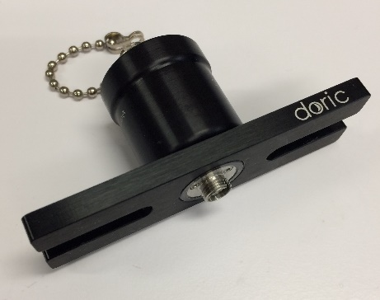

Figure Commutator screwed into bracket

* The male-male cable should go on top (the non-rotating port). The other end of this cable will connect to the laser light source.
* The male-ferrule cable should go on the bottom (the rotating port). The other end of this cable will connect to the implant.
* See Figure 77 for the results of this step.

### Use tape to hold excess cable in place

* Take the extra fiber optic cable that connects the laser to the commutator and coil it on the top of the mounting plate.

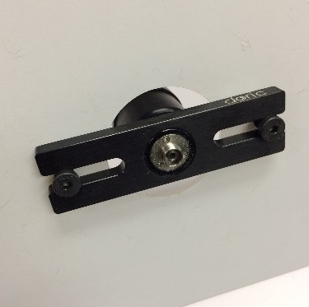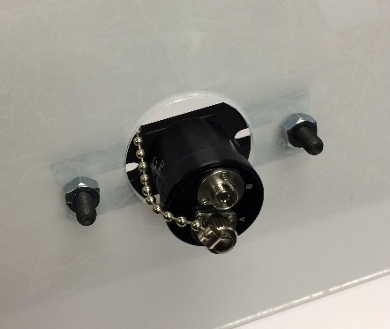

Figure Commutator and bracket mounted to custom plate. Left: View from top. Right: View from bottom

* Use tape to fix the coil in position so it won’t shift during the experiment.
* Note that changes in the radius of curvature of the fiber optic cable during the experiment will cause the light power level reaching the implant to change.
* See Figure 76 for the results of this step.

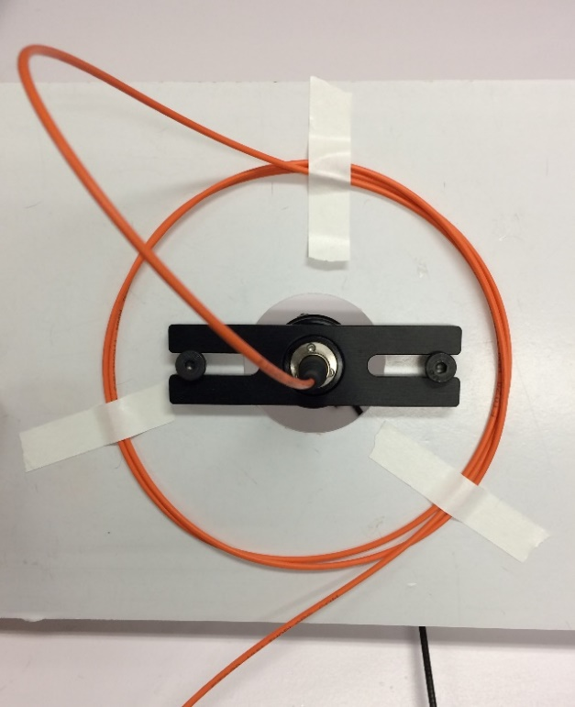

Figure Cable management

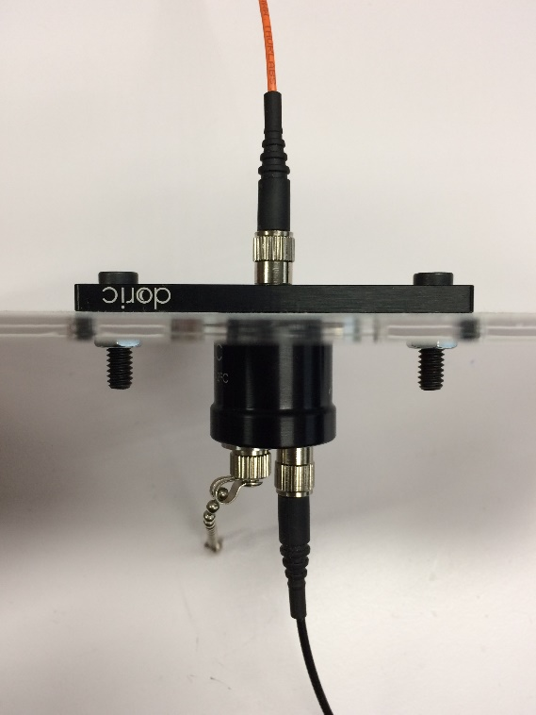

Figure Fiber optic cables connected

# Building the RIO breakout board

## Full list of Materials

| **#** | **Part Description** | **Manufacturer/Supplier** | **Manufacturer/Supplier Part Number** | **Datasheet/Drawing/Modification** |
| --- | --- | --- | --- | --- |
|  | RIO breakout board |  | N.A. (Custom Made) |  |
|  | 15 Position D-Sub, High Density Plug, Male Pins Connector x4 | Digikey | 181-215RME | <https://www.digikey.com/product-detail/en/norcomp-inc/181-015-113R561/181-215RME-ND/1767724> |
|  | BNC Connector Jack, Female Socket 50 Ohm Panel Mount, Through Hole, Right Angle Solder x4 | Digikey | ARF1065 | <https://www.digikey.com/product-detail/en/amphenol-rf-division/31-5431/ARF1065-ND/80179> |
|  | Thermistors, surface mount x28 | Digikey | PRF18BB471QB5RB | <https://www.digikey.com/product-detail/en/murata-electronics-north-america/PRF18BB471QB5RB/490-8499-1-ND/4380762> |
|  | Schottke Diodes, surface mount x28 | Digikey | TBAT54S | <https://www.digikey.com/product-detail/en/toshiba-semiconductor-and-storage/TBAT54SLM/TBAT54SLMCT-ND/6109133> |
|  | 50 pin ribbon cable header x2 |  |  |  |
|  | 20-22 AWG wires for power x2 |  |  |  |

## Building Instructions

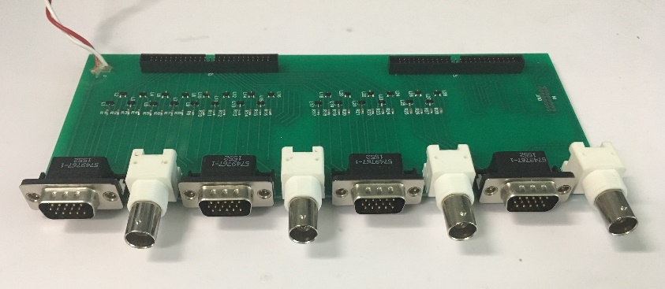

Figure Completed RIO breakout board

### General notes

The RIO breakout board is a component of the DAQ system. It plays two roles – protecting the analog and digital IO ports of the expensive sbRIO board, and routes the sbRIO IO channels into four groups and connects them to DB-15 and BNC receptacles so they can be easily connected to the homecages and laser light sources. Each RIO breakout board services a single sbRIO board, and supports up to four homecages.

### Solder the SMT components

### Solder the through-hole components

### Cut and strip power wires

* Cut and strip two wires, about 1 foot each.
* Color coding is recommended – color scheme used here: red=high, white=low
* Solder into power connection through holes in RIO breakout board.
* See Figure 78 for the completed breakout board.

# Building the data acquisition system (DAQ)

## Full list of Materials

| **#** | **Part Description** | **Manufacturer/Supplier** | **Manufacturer/Supplier Part Number** | **Datasheet/Drawing/Modification** |
| --- | --- | --- | --- | --- |
|  | Single board RIO |  | sbRIO-9636 | <http://sine.ni.com/nips/cds/view/p/lang/en/nid/210421> |
|  | Completed RIO breakout board |  | N.A. (Custom Made) |  |
|  | 50-pin IDC ribbon cables x2 | National Instruments |  |  |
|  | RIO power connector (NI Minfit Pigtail 2C 12 inches) |  | 152834A01 |  |
|  | Wire, 18-22 AWG |  |  |  |
|  | 4-40x3/8” screws x49 |  |  |  |
|  | 4-40x1/4” screws x3 |  |  |  |
|  | 4-40 nuts x8 |  |  |  |
|  | 4-40 x 1/2" spacers x3 |  |  |  |
|  | 4-40 x 1” spacers x3 |  |  |  |
|  | Heatshrink tubing |  |  |  |
|  | Enclosure (Rackmount Chassis 19" 2U 84HP 340MM) with custom front panel openings |  | 20860127 | <https://www.digikey.com/product-detail/en/schroff/20860127/1439-1130-ND/4209859> |
|  | Power supply |  | P37-15T | <http://www.polytrondevices.com/products/power-modules/linear-encapsulated-power-modules> |
|  | Universal power cord x2 |  | 03130 | <https://www.cablestogo.com/product/03130/6ft-18-awg-universal-power-cord-nema-5-15p-to-iec320c13-taa-compliant> |
|  | Panel mount power receptacle with switch |  | 76400003 | <http://www.qualtekusa.com/images/AC_Receptacles/pdfs/76400003.pdf> |
|  | Panel mount Ethernet receptacle |  |  |  |
|  | DB-15 cables, CNC Tech x4 |  | 731-10061-00200 | <https://www.digikey.com/product-detail/en/cnc-tech/731-10061-00200/1175-1157-ND/3064888> |
|  | Completed homecage x4 |  |  |  |
|  | Control & storage computer |  |  |  |
|  | Ethernet cable, ~1 foot |  |  |  |
|  | Ethernet cable, long enough to reach network access point |  |  |  |
|  | LabVIEW 2013 |  |  |  |
|  | Rodent VI LabVIEW software |  |  |  |

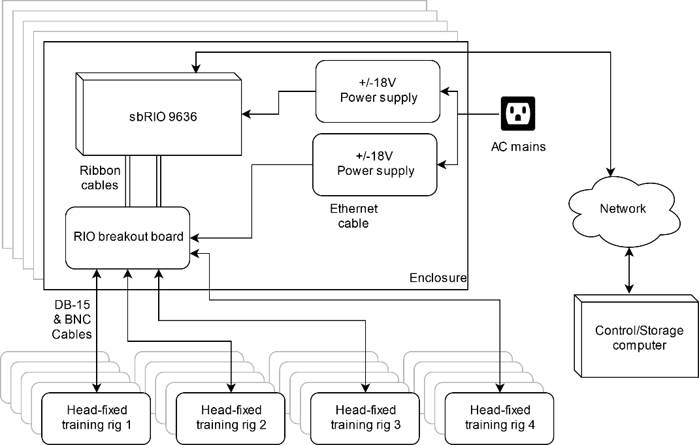

Figure DAQ system schematic for head-fixed training (not video) rigs, showing half of what can fit in one enclosure

## Building Instructions

### General notes

The data acquisition system consists of a single-board RIO DAQ from National Instruments, which has a large array of digital and analog input/output (IO) channels, a custom PCB that protects and distributes those channels, an enclosure for the DAQ, DB-15 cables to connect the DAQ to each homecage, and a control/storage computer which controls the DAQ via LabVIEW software, and stores the sensor data it receives. Each DAQ system can host up to eight training head-fixed rigs, or two high speed video head-fixed rigs. See Figure 79 for the training rig schematic, and Figure 80 for the video rig schematic.

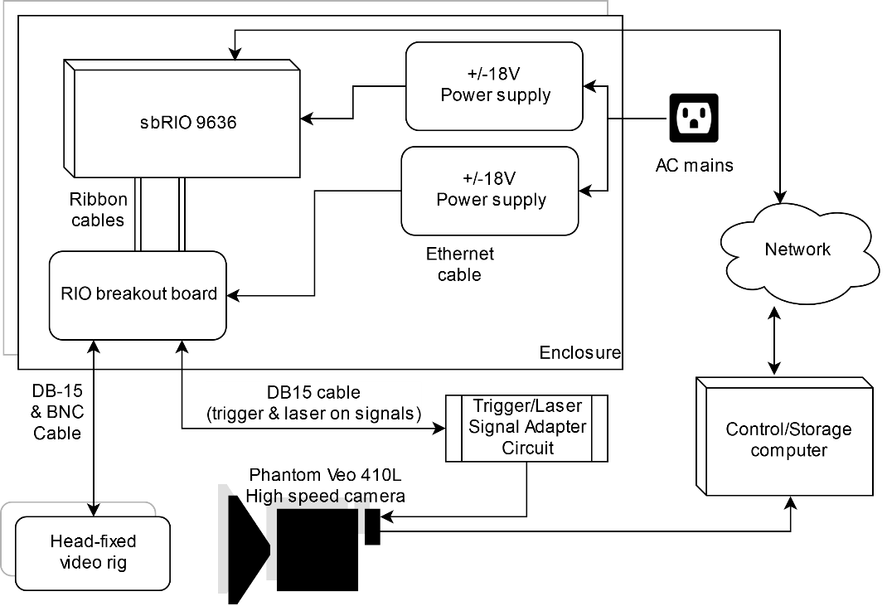

Figure DAQ system schematic for head-fixed video rig, showing half of what can fit in one enclosure

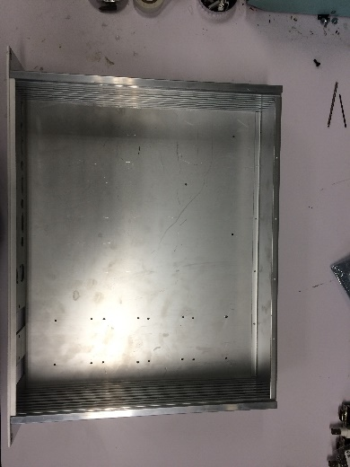

Figure Enclosure base plate with power supply mounting holes drilled

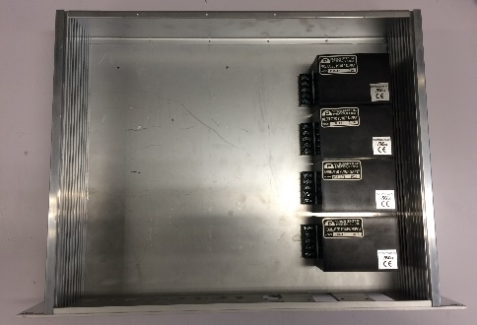

Figure Four power supplies mounted

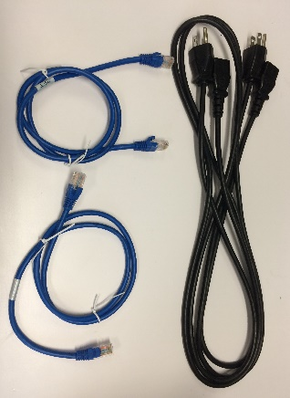

Figure Required cords: 2 short Ethernet cords, 2 power cords

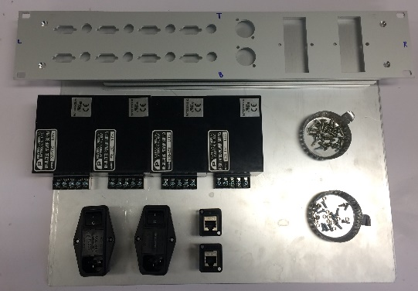

Figure Enclosure materials. Clockwise from top left: custom cut front, sides, and back panels, enclosure hardware, 4-40 screws and nuts, Ethernet jacks x2, power jacks x2, power supplies x4

### Assemble base and sides of enclosure

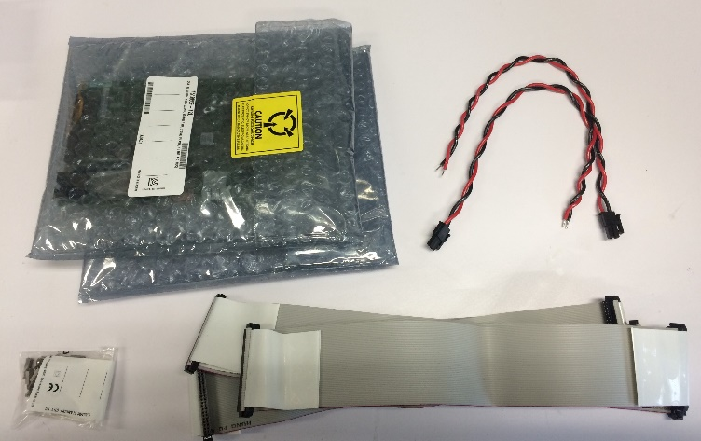

Figure sbRIO supplies. Clockwise from top left: sbRIO-9636 x2, NI Minifit Pigtail x2, NI 50 pin ribbon cable x2, mounting hardware (not used)

* See manufacturer instructions

### Mount power supplies on enclosure base

* Each power supply has four 4-40 mounting holes.
* Drill four mounting holes (1/8”) for each power supply along the right side of the base plate of the enclosure.
* Screw each power supply in using 4-40x1/4” screws.
* See Figure 81 and Figure 82 for the results of this step.

### Mount sbRIOs on enclosure base

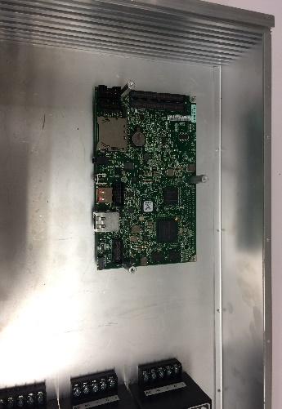

Figure 2nd layer of standoffs installed

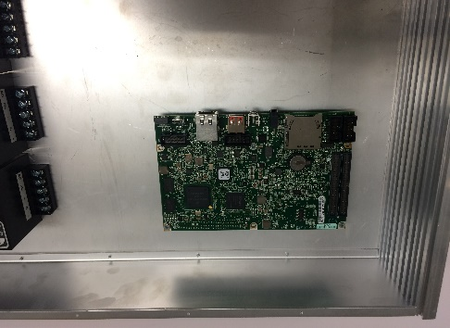

Figure sbRIO #1 installed on standoffs

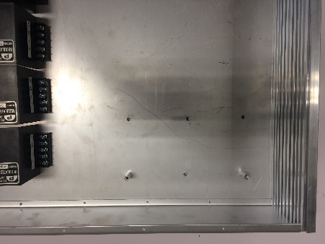

Figure Baseplate with three standoffs installed. Note that the image shows the other three holes drilled - these will be unused and unnecessary.

* Drill mounting holes (1/8”) for three of the six mounting holes in the sbRIO board. See Figure 88.
* Note that the mounting standoffs provided by National Instruments do not provide enough clearance for the ribbon cables when mounting two sbRIOs on top of each other.
* Note that unless you have male to female standoffs, you can only use three mounting holes for each sbRIO.
* Screw the shorter three standoffs into the enclosure base.
* Mount an sbRIO on top of the three standoffs. See Figure 87.
* Screw the longer three standoffs into the three unused mounting holes on the first sbRIO. See Figure 86.

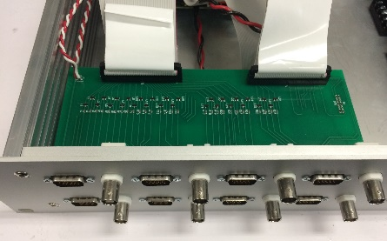

Figure Two RIO breakout boards installed with ribbon cables.

* Plug two ribbon cables into the two 50-pin headers on the sbRIO board. These cables carry the DIO and AIO channels to and from the sbRIO. Make sure the side of the ribbon marked red is on the side of the header with channel #1. See Figure 92.

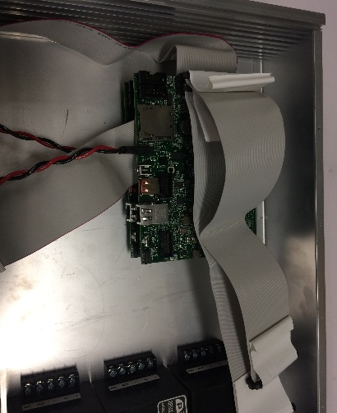

Figure sbRIO #2 ribbon cables plugged in

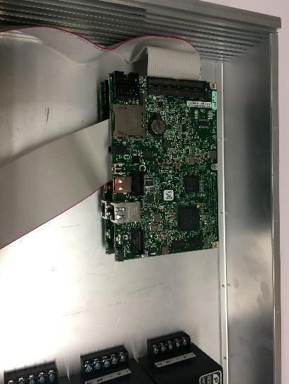

Figure sbRIO #2 installed

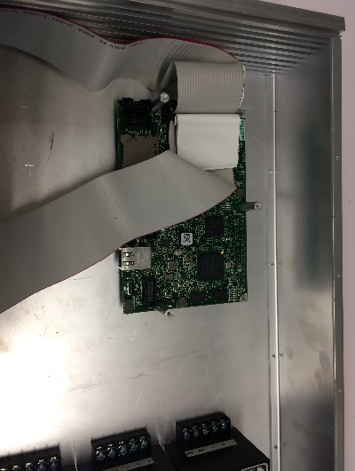

Figure sbRIO #1 installed with ribbon cables

* Screw the 2nd sbRIO onto the 2nd layer of standoffs. Take care that the ribbon cables from the first sbRIO are neatly exiting the space between the sbRIOs. See Figure 91.

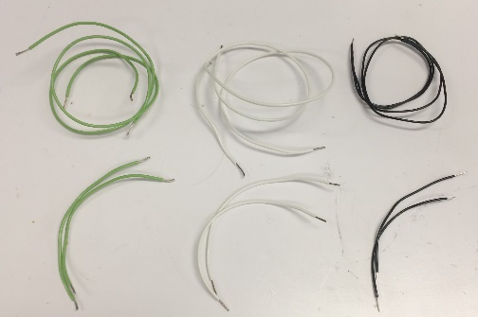

Figure Power supply wires, cut and stripped

* Plug the other two ribbon cables into sbRIO #2. Again take care that the orientation is correct. See Figure 90.

### Mount RIO breakout boards on enclosure faceplate

* Insert the RIO breakout board DB-9 and BNC ports into the faceplate cutouts.
* Secure the RIO breakout boards with 4-40x3/8” screws on either side of each DB-9 port.
* Plug the four ribbon cables into the RIO breakout boards. In the orientation shown, the left ribbon cables from the sbRIOs go into the left headers on the RIO breakout boards. Pin #1 goes on the right.

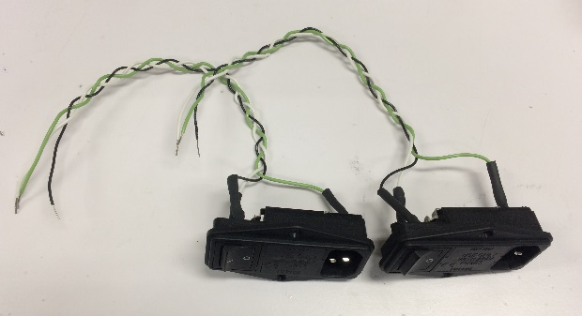

Figure AC power receptacles

* See Figure 89 for the results of this step.

### Cut and strip power wires

* Cut three pairs of 12” wires (two each for AC hot, neutral, and ground), and three pairs of 6” wires (two each for AC hot, neutral, and ground). Color coding is recommended – the color scheme used here is
  + AC hot = black
  + AC neutral = white
  + AC ground = green
* See Figure 93 for the results of this step.

### Solder wires onto power receptacles, and mount on faceplate

* Solder the longer wires onto the two power receptacles. Use heatshrink tubing to protect the solder joint.
* Use 4-40 screws and nuts to mount each receptacle on the faceplate.

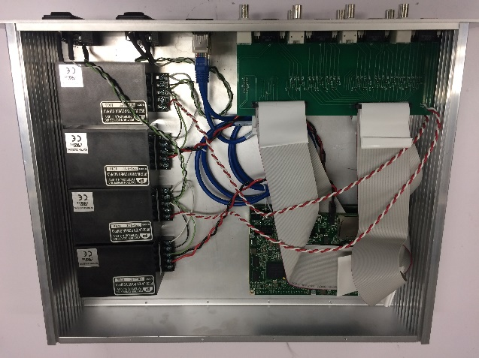

Figure Completed DAQ system

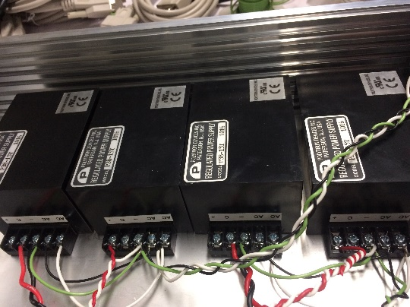

Figure Power supply connection photo

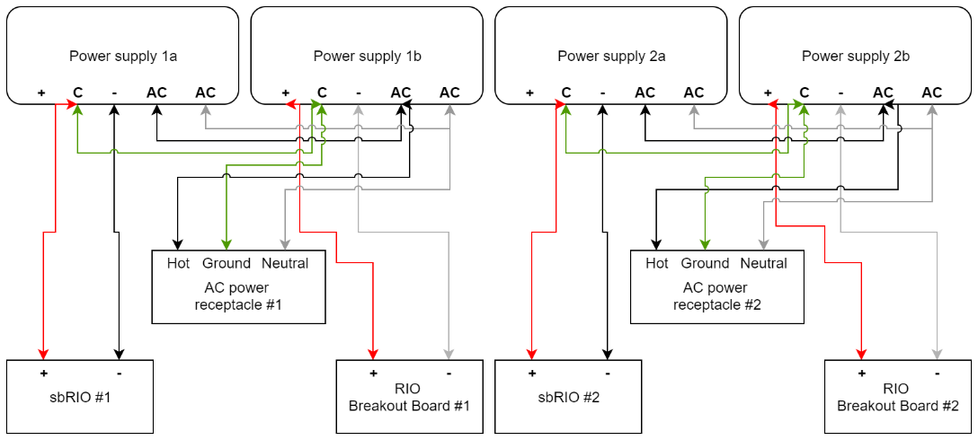

Figure Power supply connection schematic. Compare to corresponding photo.

* See Figure 94 for the results of this step.

### Connect power wires to power supplies.

* Connect the wires to the screw terminals on the power supplies as shown in Figure 97 and Figure 96.

### Connect sbRIO and RIO breakout board power cables

* Plug minfit power connectors into each sbRIO power jack.
* Connect bare wire ends of the sbRIO power cables and the RIO breakout board power cables to power supplies as shown in Figure 97 and Figure 96.

### Mount Ethernet jacks in enclosure, and connect to sbRIO boards

* Mount Ethernet jacks on faceplate with 4-40 screws and nuts.
* Connect each sbRIO Ethernet jack to the panel-mounted jack using the short Ethernet cables.

### Optional: close enclosure with lid.

### Connect to sbRIO using LabVIEW, and compile software onto FPGA.

# Building the camera trigger adapter

## Full list of Materials

| **#** | **Part Description** | **Manufacturer/**  **Supplier** | **Manufacturer/Supplier Part Number** | **Datasheet/Drawing/Modification** |
| --- | --- | --- | --- | --- |
|  | BNC female x solder cup connector x2 | Amphenol/Digikey | ARFX1905 | <https://www.digikey.com/product-detail/en/amphenol-rf-division/031-10-RFXG1/ARFX1905-ND/2643384> |
|  | DB-15 high density female x solder cup connector | Amphenol/Digikey | 609-4045 | <https://www.digikey.com/product-detail/en/amphenol-icc-fci/10090770-S154ALF/609-4045-ND/2350291> |
|  | 2N3904 transistor x2 | ON/Digikey | 2N3904TFCT | <https://www.digikey.com/product-detail/en/fairchild-on-semiconductor/2N3904TF/2N3904TFCT-ND/1626126> |
|  | Perma-proto board | Adafruit/Digikey | 1528-1101 | <https://www.digikey.com/product-detail/en/adafruit-industries-llc/1608/1528-1101-ND/5154676> |
|  | 1kΩ resistor x2 |  |  |  |
|  | Hookup wire |  |  |  |
|  | Heatshrink tubing |  |  |  |

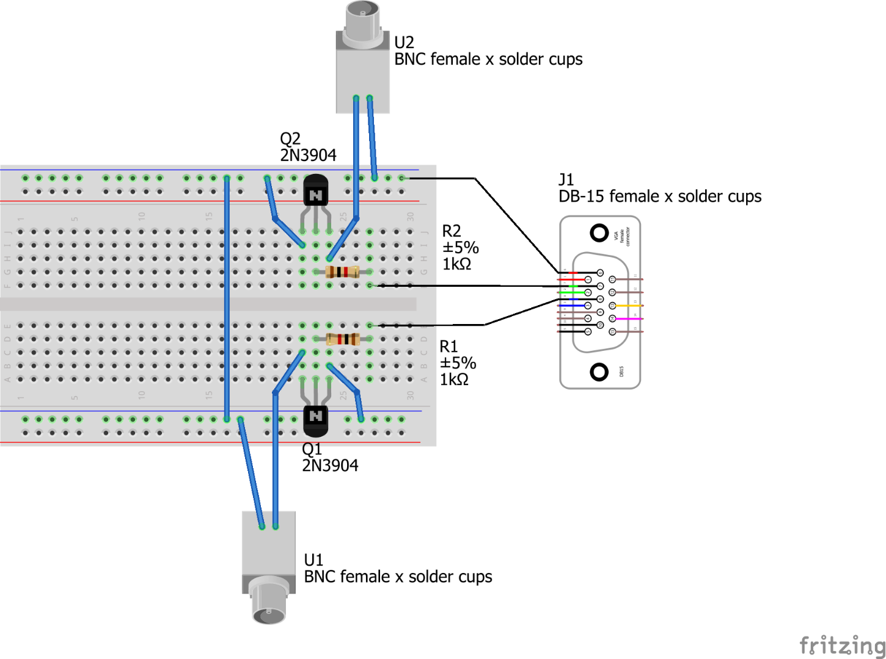

Figure Camera trigger adapter circuit diagram

## Building Instructions

### General notes

The high speed camera must be able to record only when the mouse is licking, otherwise the data stream generated for processing and storage would prohibitively large. This section describes how to build a simple adapter circuit that allows the DAQ to send a trigger pulse to the camera, telling it when to record.

This circuit also allows the DAQ to send a separate signal to the camera indicating that the optogenetic laser is active during a particular recording. This causes the camera to mark the recording metadata with this information so it can be used later for analysis.

Both of those two parts of the circuit are identical – when the DAQ sends a logical high voltage to one of the two halves of the circuit,

Recommended tools: Soldering iron, heat gun, flush cutters

### Cut and strip wire leads

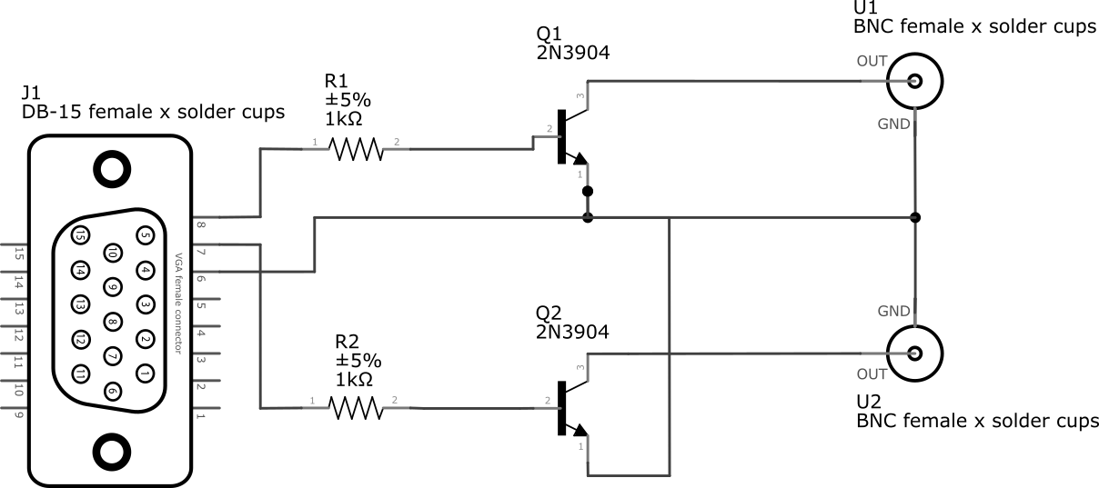

Figure Camera trigger adapter circuit schematic. The U1 connector transmits the signal to indicate whether the optogenetic laser is on. The U2 connector transmits the trigger signal to start recording.

* Cut seven wire leads and strip the ends.

### Solder wires into connectors

* Solder wires into both solder cups on each BNC connectors, and into the solder cups for pins 6, 7, and 8 on the DB-15 connector.
* Add a piece of heatshrink tubing over each solder joint and shrink with the heat gun.

### Solder components onto protoboard

* Solder the transistors, resistors, and connector leads onto the protoboard as shown in Figure 99 and Figure 98, and as also described in the net list below. See Figure 100 for the finished product.
* Part list:
  + U1, U2 = BNC female x solder cups connectors
  + Q1, Q2 = 2N3904 transistors
  + R1, R2 = 1 kΩ resistors
  + J1 = DB-15 female x solder cups connector
* Net list:
  + Ground net – U1 GND, U2 GND, Q1 pin 1, Q2 pin 1, DB-15 pin 6
  + Laser signal in net – DB-15 pin 8, R1 pin 1
  + Trigger signal in net – DB-15 pin 7, R2 pin 1
  + Laser base net – R1 pin 2, Q1 pin 2
  + Trigger base net – R2 pin 2, Q2 pin 2
  + Laser signal out net – Q1 pin 3, U1 OUT
  + Trigger signal out net – Q2 pin 3, U2 OUT

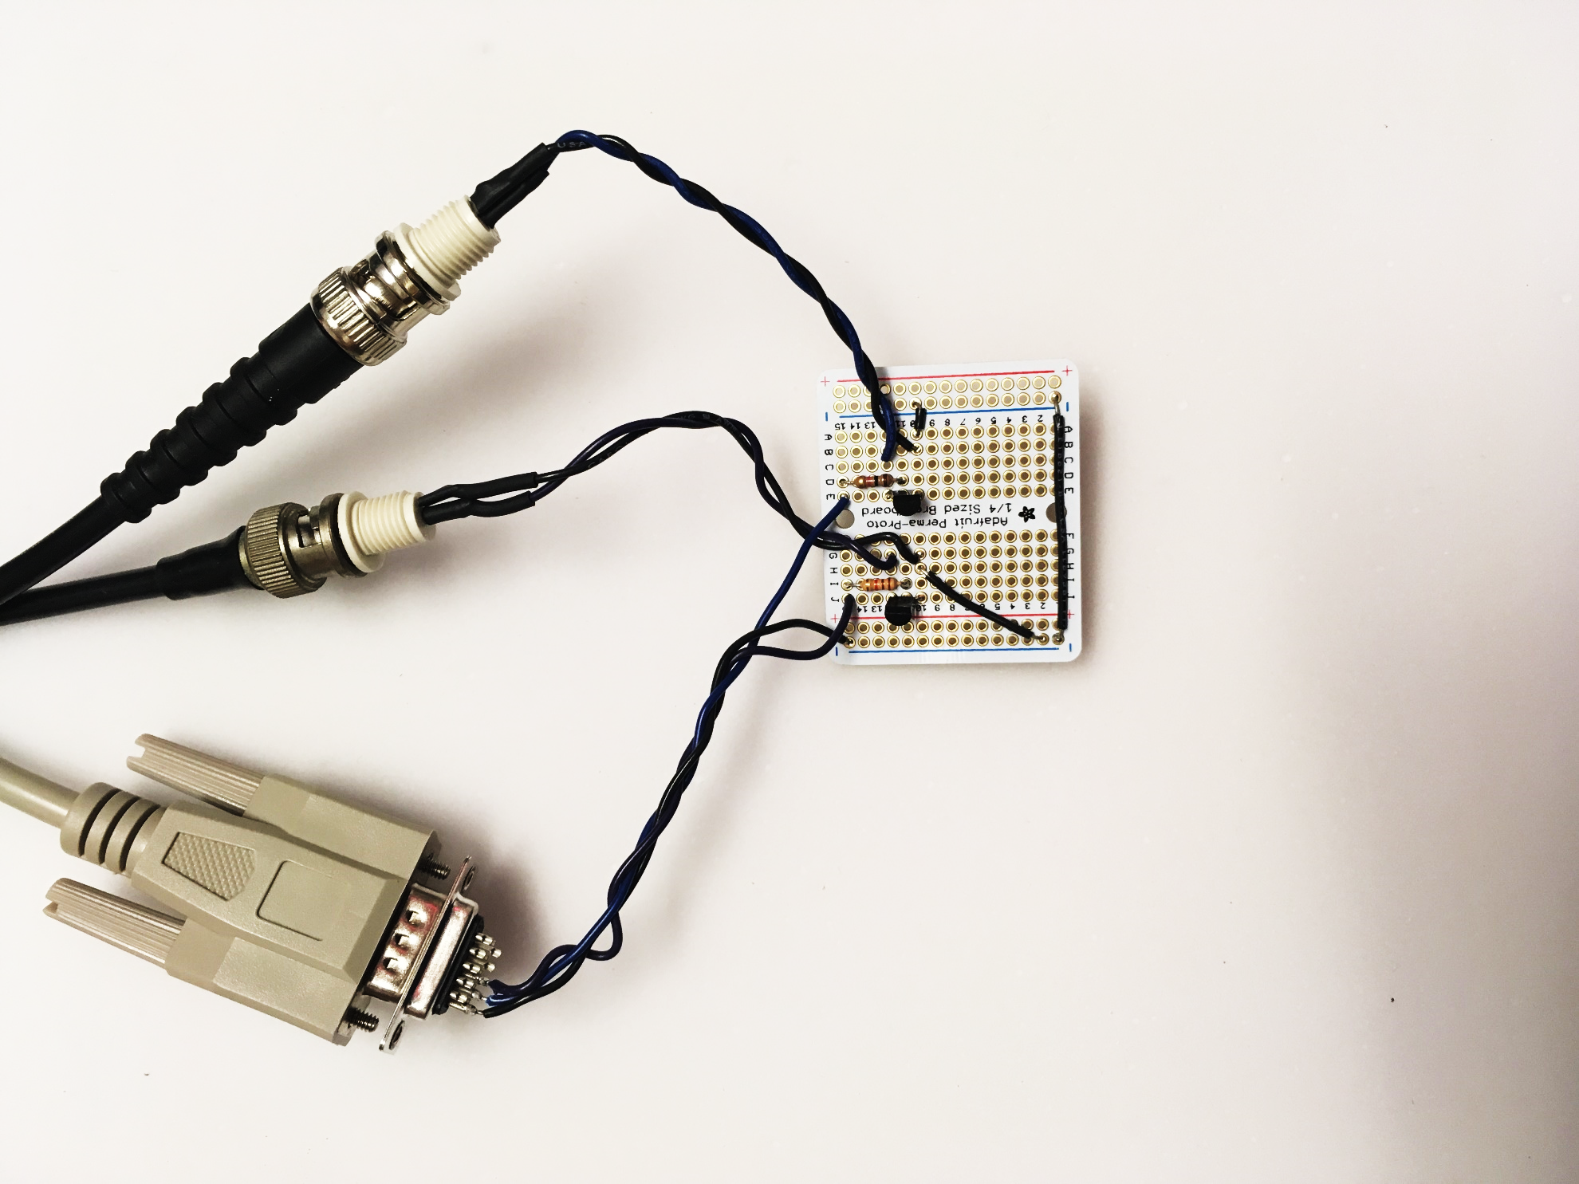

Figure Camera trigger adapter circuit, with cables attached

# Constructing the high speed camera box

## Full list of Materials

| **#** | **Part Description** | **Manufacturer/**  **Supplier** | **Manufacturer/Supplier Part Number** | **Datasheet/Drawing/Modification** |
| --- | --- | --- | --- | --- |
|  | Isolation box (Extra Tall Expanded PVC Sound Attenuation Cubicle) | Med Associates Inc. | ENV-018V | <https://www.med-associates.com/product/extra-tall-expanded-pvc-sound-attenuating-cubicle/> |
|  | Aluminum Breadboard 6" x 36" x 1/2" 1/4"-20 Taps | Thorlabs | MB636 | <https://www.thorlabs.com/thorproduct.cfm?partnumber=MB636> |
|  | Aluminum Breadboard 4" x 6" x 1/2", 1/4"-20 Taps, x2 | Thorlabs | MB4 | <https://www.thorlabs.com/thorproduct.cfm?partnumber=MB4> |
|  | Dovetail Rail Carrier, 2.00" x 1.00", 1/4" Counterbore, 8-32 Taps, x2 | Thorlabs | RC2 | <https://www.thorlabs.com/thorproduct.cfm?partnumber=RC2> |
|  | Dovetail Optical Rail, 3", Imperial | Thorlabs | RLA0300 | <https://www.thorlabs.com/thorproduct.cfm?partnumber=RLA0300> |
|  | Dovetail Optical Rail, 6", Imperial | Thorlabs | RLA0600 | <https://www.thorlabs.com/thorproduct.cfm?partnumber=RLA0600> |
|  | Ø1" Post Holder with Flexure Lock, 1/4"-20 Tap, L = 1.5", x2 | Thorlabs | RSHT1.5 | <https://www.thorlabs.com/thorproduct.cfm?partnumber=RSHT1.5> |
|  | 1/4"-20 Stainless Steel Cap Screw, 3/4" Long x4 | Thorlabs | SH25S075 | <https://www.thorlabs.com/thorproduct.cfm?partnumber=SH25S075> |
|  | 1/4"-20 Stainless Steel Socket Head Screw, 1-1/2" Long x2 | McMaster-Carr | 92196A706 | <https://www.mcmaster.com/92196a706> |
|  | 8-32 pan head screw, 3/4" long x4 | McMaster-Carr | 91772A197 | <https://www.mcmaster.com/91772a197> |
|  | 1/4"-20 Stainless Steel Setscrew, 1/2" Long x2 | Thorlabs | SS25S050 | <https://www.thorlabs.com/thorproduct.cfm?partnumber=SS25S050> |
|  | 8-32 pan head screw, 2” long | McMaster-Carr | 91772A205 | <https://www.mcmaster.com/91772a205> |
|  | 1/4"-20 nut x2 | McMaster-Carr | 92673A113 | <https://www.mcmaster.com/92673a113> |
|  | 8-32 nut | McMaster-Carr | 91841A009 | <https://www.mcmaster.com/91841a009> |
|  | 1/4" Washer, M6 Compatible, Stainless Steel x2 | Thorlabs | W25S050 | <https://www.thorlabs.com/thorproduct.cfm?partnumber=W25S050> |
|  | 8-32 oversized washer | McMaster-Carr | 90313A302 | <https://www.mcmaster.com/90313a302> |
|  | Sonex mini acoustic foam, 2’ x 4’ x 1.5” | Acoustical Solutions | FOMSONMIN242WHT | <https://acousticalsolutions.com/product/sonex-mini-acoustic-foam/> |

## Building Instructions

### General notes

The head-fixed rig is designed to be able to be accurately and quickly mounted within a high speed video box. This way, multiple head-fixed rigs can be used for training mice concurrently, and can be swapped in and out of the high speed video box when video is needed. The camera and the head-fixed rig are positioned relative to each other using a Thorlabs optical breadboard, which makes the video scene highly constant between video sessions, facilitating automatic segmentation of the video with a machine learning algorithm.

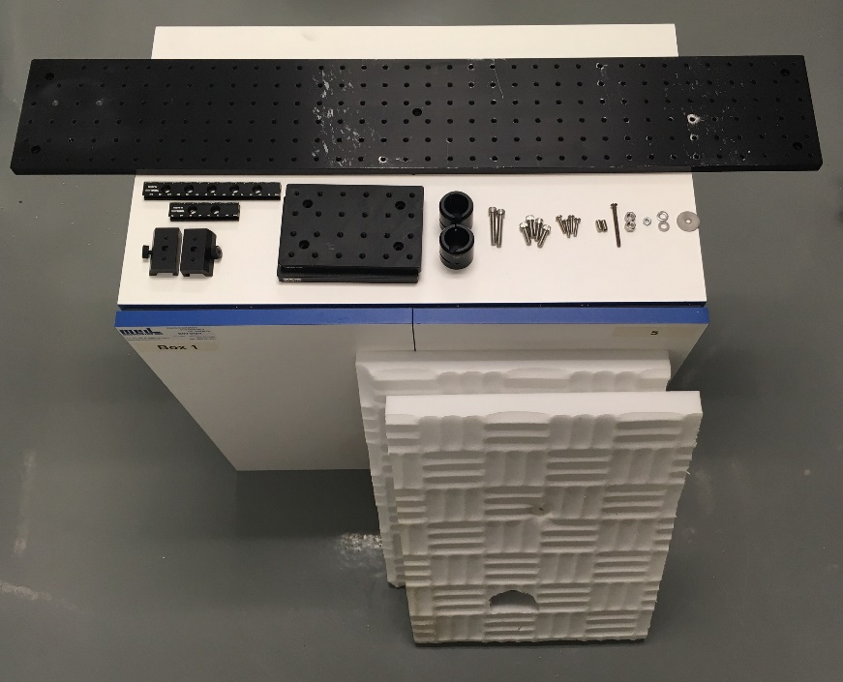

Figure Materials for constructing high speed camera box. Clockwise from top: 36" breadboard, 8-32 oversized washer, 1/4"-20 washers, 8-32 nut, 1/4"-20 nuts, 8-32x2” screw, 1/4"-20x1/2” setscrews, 8-32x3/4” screws, 1/4"-20x3/4” screws, 1/4"-20x1.5” screws, 1” post holders, 4”x6” breadboards, rail carriers, dovetail optical rails. Bottom: Med Associates Inc. Sound Attenuation Cubicle, acoustic foam

Both the training box and the video box consist of a modified “sound attenuation cubicle” from Med Associates Inc. The video box has hardware added to allow for mounting the camera and the head-fixed rig accurately. The training box does not require the camera mounting hardware, and the only modification needed is the top hole for optogenetic equipment; as there is no camera to position relative to, the head-fixed rig can sit directly on the floor of the box. The instructions below are for constructing the video box. The instructions for constructing a training box is a subset of these instructions.

Recommended tools: Jigsaw (or router if available), drill, hole saw bit, hex wrench set, screw driver, box cutter

## Part 1 – Modifying the box

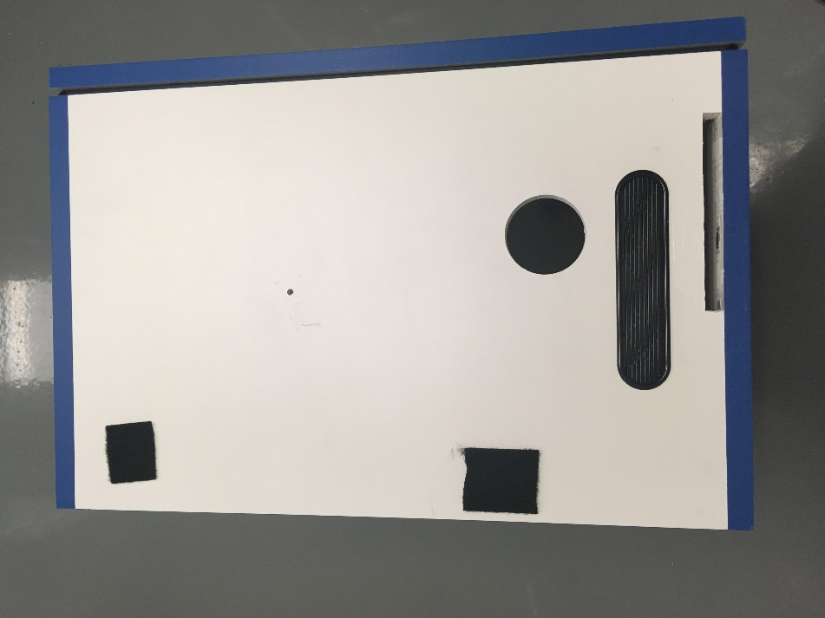

6.75”

0.75”

9.25”

6.125”

Approximately centered, 3/16” hole

6”

0.5”

2.5”

Figure Modifications to the side of the box for the camera, the mounting breadboard, and the foam anchor bolt.

### Cut rectangular slot in box for breadboard

* Turn the box so its left side is facing upwards.
* Measure and mark a rectangle 1/2" x 6” with its bottom left corner 6.75” from the back of the box and 0.75” from the bottom of the box.
* This step is only for the video box, not the training box.
* See Figure 102 for the results of this step.

### Cut side hole for camera view

* Using a 2.5” hole saw, cut a hole centered at 9.25” from the back of the box and 6.125” from the bottom.
* This step is only for the video box, not the training box.
* See Figure 102 for the results of this step.

### Add anchor holes for breadboard

* We will use the two countersunk holes on the right side of the camera mounting breadboard to anchor the breadboard to the box
* Turn the box back right side up.
* Slide the breadboard into the box.
* Position the two countersunk holes so that their centers are approximately 1.25” from the right wall of the box
* Mark the location of the two countersunk holes
* Remove the breadboard from the box

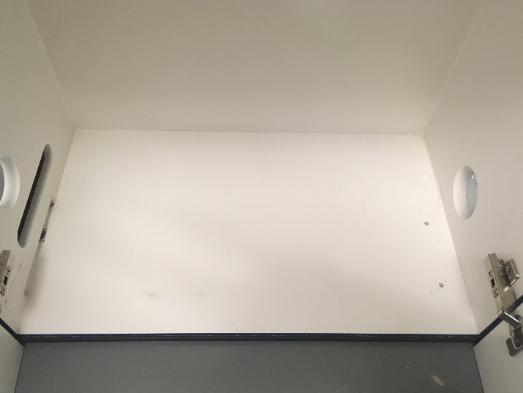

Figure Breadboard anchoring holes

* Drill a 1/4" through the bottom of the box at each mark
* This step is only for the video box, not the training box
* See Figure 103 for the results of this step.

### Cut top hole for optogenetics and strobe cables

* In the center of the top of the box, use a hole saw to drill a 2” hole
* This hole will allow the strobe trigger signal, power, and optogenetic cables to enter the box.
* See Figure 104 for the results of this step

### Drill side hole for anchoring acoustic foam (optional)

* The acoustic foam provides extra sound isolation to prevent sounds from interfering with the experiment, and to prevent the audio cue from the experiment from interfering with other concurrent experiments.
* To prevent the acoustic foam from shifting and blocking the camera, we will anchor the left-hand foam sheet to the side of the box with a bolt.
* Approximately in the center of the box side, drill a 3/16” hole for the foam anchoring bolt
* See Figure 102 for the results of this step

### Cut acoustic foam panels (optional)

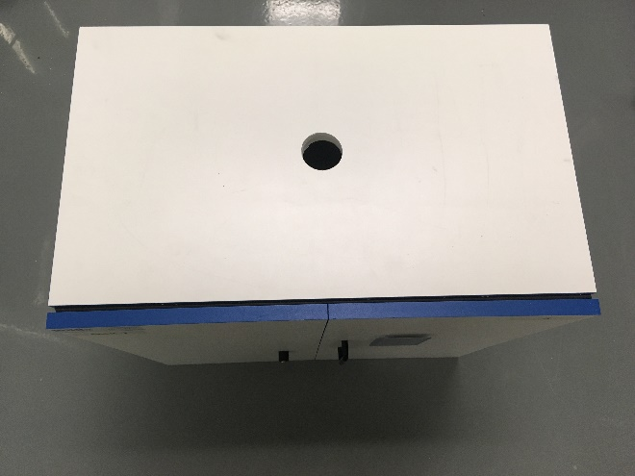

Figure Top hole for optogenetics and strobe cables

* Mark a 14”x21” rectangle, and a 14”x21.5” rectangle on the acoustic foam sheet.
* Cut out the rectangles with a box cutter.
* The longer rectangle goes on the right side of the box interior; the shorter rectangle goes on the left.
* Position the longer rectangle on the right side of the box 1/2" above the bottom, and make ad-hoc cuts so it fits around the door hinges and lays flat against the right side.
* Position the shorter rectangle on the left side of the box 1” above the bottom, and make ad-hoc cuts to fit around the hinges.
* Poke a hole that matches the acoustic foam anchoring hole.
* Cut a slit in the right side foam piece where the lower factory-cut hole is; this is how the DB-15 cable will enter the box.
* Insert the 8-32 x 2” screw with a washer into the foam hole, into the side of the box, and out. Use the nut on the outside to secure the screw and foam.

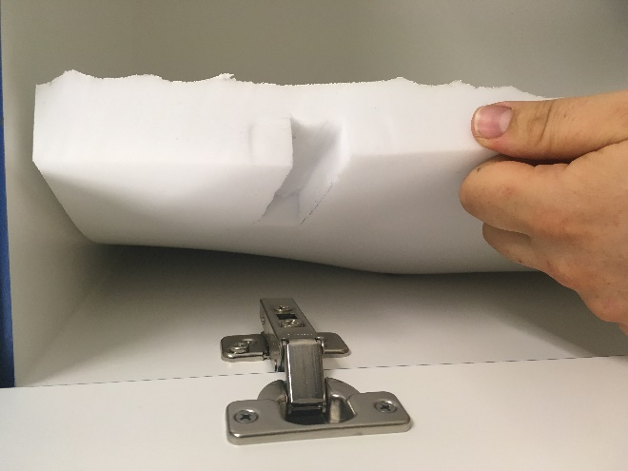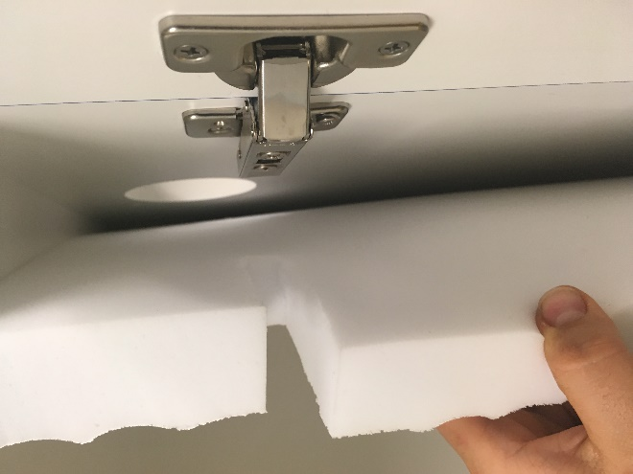

Figure Foam with example cutouts to fit around hinges

* From the left outside of the box, trace the camera hole outline on the foam.
* Remove the foam and cut out the camera hole outline with a box cutter
* Re-install the foam.

## Part II – Building and installing camera mount

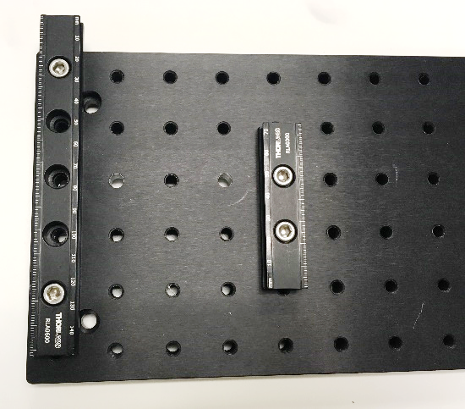

Figure Camera positioning rails installed

The camera mount consists of a long breadboard that fixes the relative position of the camera and the head-fixed rig, allowing for repeatable video framing.

### Add positioning rails

* Mount the 6” and 3” dovetail optical rails using the 1/4"-20x3/4" long bolts. The bolts should go in positions (0, 1), (0, 5), (4, 3), and (4, 4). See Figure 1 for a description of the coordinate system.
* See Figure 106 for the results of this step.

### Add rail carriers

* Slide a rail carrier on each optical rail with the locking thumbscrews pointing outwards.

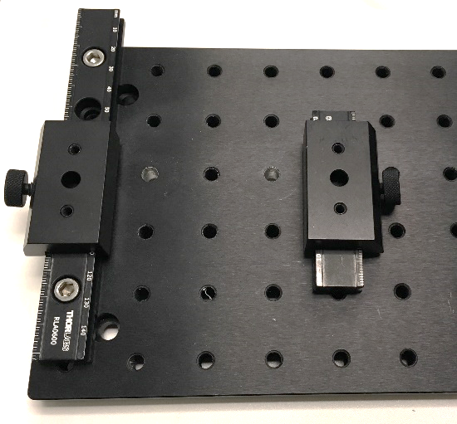

Figure Rail carriers installed

* Line up the carriers with each other on their dovetail rails
* See Figure 107 for the results of this step.

### Add camera platform

* Place the 4”x6” breadboard (the camera platform) on top of the two rail carriers.
* In the coordinate system of the 4”x6” breadboard, align holes (1, 1), (1, 2), (5, 1), and (5,2) with the two 8-32 holes on top of the rail carriers.
* Use the 8-32x3/4” screws to fasten the camera platform breadboard to the rail carriers using the holes at the above coordinates.
* See Figure 108 for the results of this step

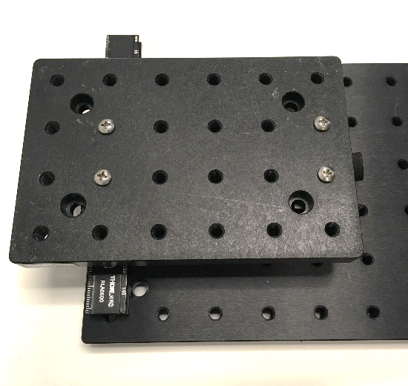

Figure Camera platform installed

### Add camera mounting feet receptacles

* Screw two 1/4"-20x1/2” setscrews halfway into the camera platform at positions (2, 2) and (4, 2).
* See Figure 109 for the results of this step.
* Screw the two 1” post holders down onto the setscrews.
* Check if the setscrews are protruding up above the inside bottom of the post holders. If they are, correct it with a hex wrench until they do not.

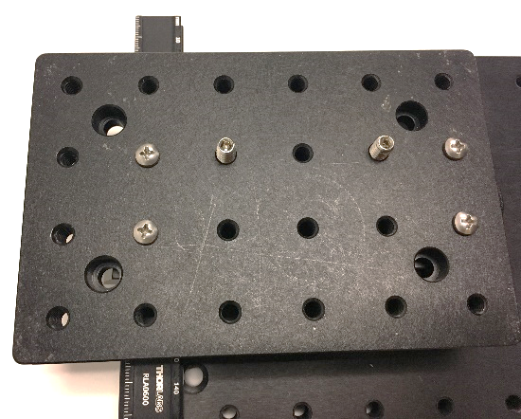

Figure Camera mounting feet receptacle setscrews installed

* See Figure 110 for a depiction of the setscrew correction
* See Figure 111 for the finished camera platform.

### Insert camera mount into box

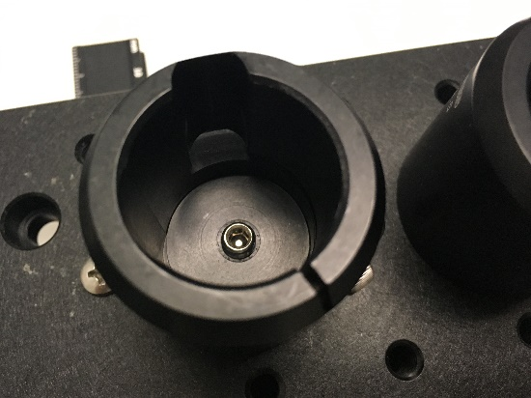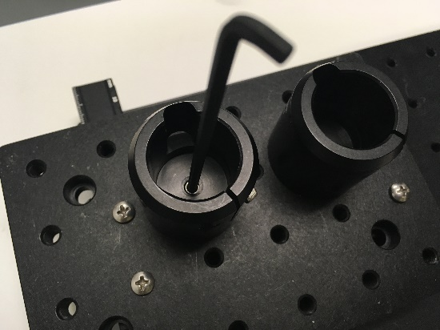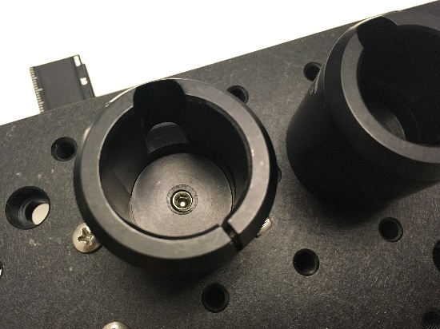

Figure Adjusting the set screws so they don't protrude into the space where the camera feet need to sit. Left: protruding setscrew. Middle: fixing protruding setscrew with hex wrench. Right: correctly positioned setscrew

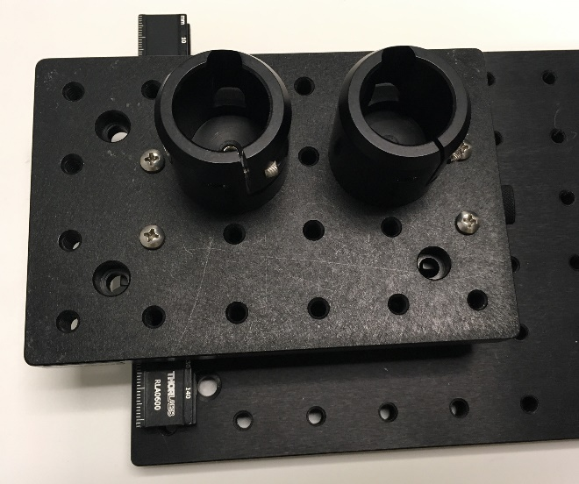

Figure Finished camera platform

* Place the camera box up onto a wire rack shelf.
* Slide the entire camera mount into the rectangular slot cut into the left side of the camera box
* Line up the countersunk holes on the right side of the camera mount with the holes cut into the bottom of the camera box.
* Insert 1/4"-20x1.5” screws into the two countersunk holes on the right side of the camera mount breadboard, and through the holes in the bottom of the box.
* Use washers and nuts to secure the screws to the bottom of the box. See Figure 113 for the installed mounting screws
* Place the other 4”x6” breadboard in the box behind the camera mount. It can just sit on the bottom, and does not need to be mounted. This will provide support for the back of the head-fixed rig.

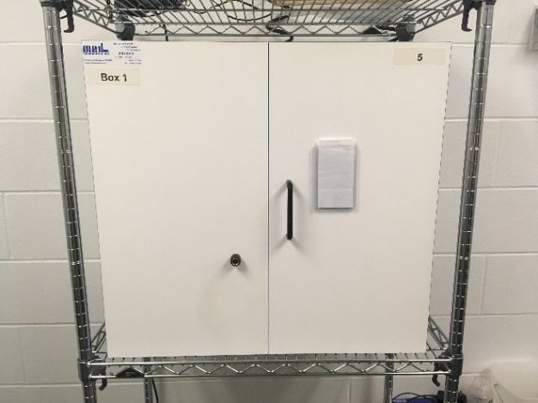

Figure Box on a wire rack

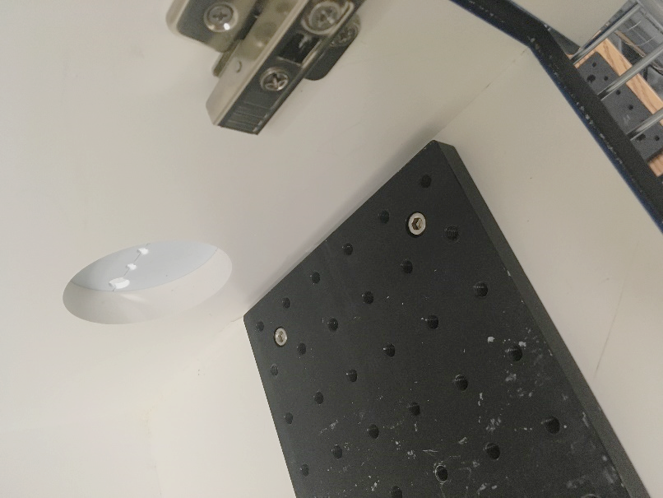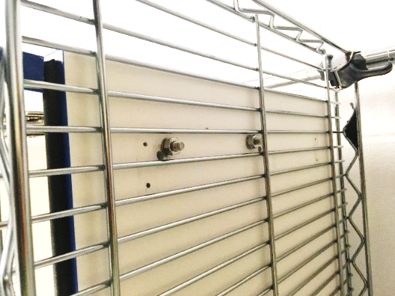

Figure Screws fixing the camera mount to the box seen from the top (left) and from the bottom (right)

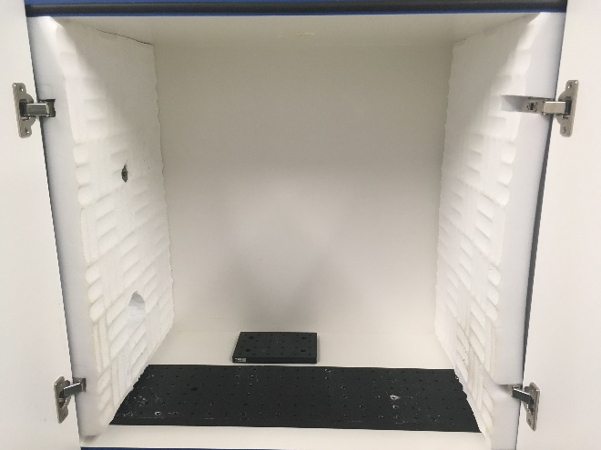

Figure Camera mounting system installed in box with foam and rear head-fixed rig support breadboard.

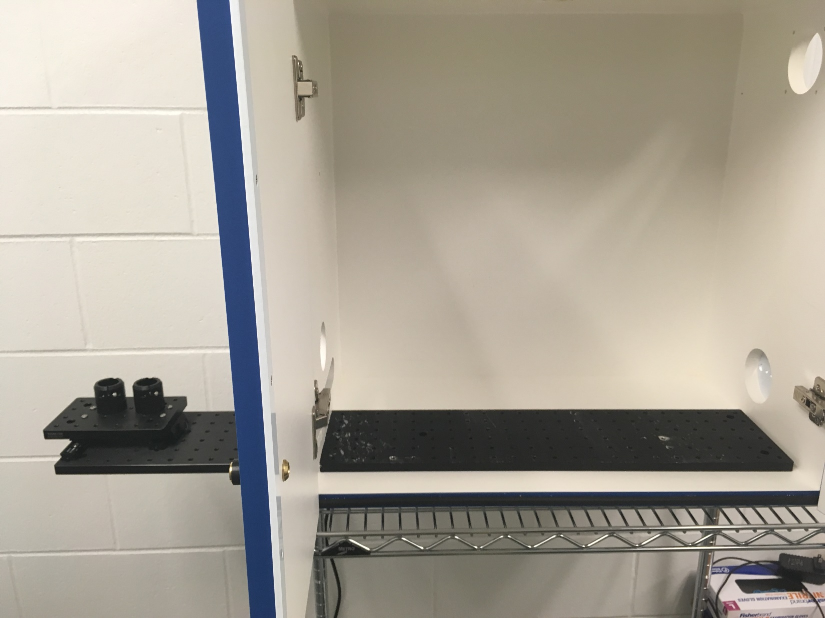

Figure Camera mounting system installed in the box (without foam or the rear head-fixed rig support breadboard)

# Assembling entire system

## Full list of Materials

| **#** | **Part Description** | **Manufacturer/**  **Supplier** | **Manufacturer/Supplier Part Number** | **Datasheet/Drawing/Modification** |
| --- | --- | --- | --- | --- |
|  | Phantom VEO 410L High speed camera | Vision Research | Phantom VEO 410L | <https://www.phantomhighspeed.com/products/cameras/veo/veo410> |
|  | Completed high speed camera box with camera mount |  | Custom made |  |
|  | Completed optogenetic system |  | Custom made |  |
|  | Completed DAQ |  | Custom made |  |
|  | Completed camera trigger adapter circuit |  | Custom made |  |
|  | Completed head-fixed rig |  | Custom made |  |
|  | Control/storage server |  |  |  |
|  | Labview 2017 |  |  |  |
|  | Labview control software |  |  |  |
|  | Phantom Camera Control (PCC) software |  | Vision Research Inc. | <https://www.phantomhighspeed.com/resourcesandsupport/phantomresources/pccsoftware> |
|  | 1" Pillar Posts, 0.75" long x2 | Thorlabs | RS075 | <https://www.thorlabs.com/thorproduct.cfm?partnumber=RS075> |
|  | 1" Pillar Posts, 0.5" long x2 | Thorlabs | RS05 | <https://www.thorlabs.com/thorproduct.cfm?partnumber=RS05> |
|  | Ø25 mm Post Spacer, Thickness = 1 mm x2 | Thorlabs | RS1M | <https://www.thorlabs.com/thorproduct.cfm?partnumber=RS1M> |
|  | 1/4"-20 Stainless Steel Setscrew, 3/4" Long x5 | Thorlabs | SS25S075 | <https://www.thorlabs.com/thorproduct.cfm?partnumber=SS25S075> |
|  | IR LED strobe light | AOS Technologies | StroboLED II - 880 nm  (Discontinued by manufacturer) | <https://www.aostechnologies.com/fileadmin/user_upload/PDFs/Process_Monitoring/StroboLED_ProductLeaflet_en.pdf> |
|  | 1/2" Optical Post, SS, 8-32 Setscrew, 1/4"-20 Tap, L = 2" | Thorlabs | PH1 | <https://www.thorlabs.com/thorproduct.cfm?partnumber=TR2> |
|  | BNC cables x |  |  |  |
|  | DB-15 cables x2 |  |  |  |
|  | Ethernet cable x2 |  |  |  |

## Building Instructions

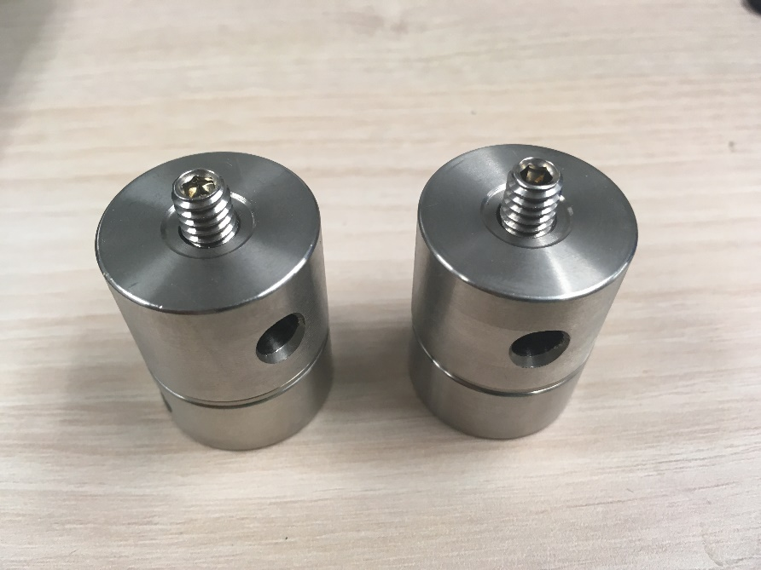

Figure Two completed camera mounting feet. From bottom to top: 1/2" pillar post, 1mm spacer, 3/4" pillar post, protruding setscrew.

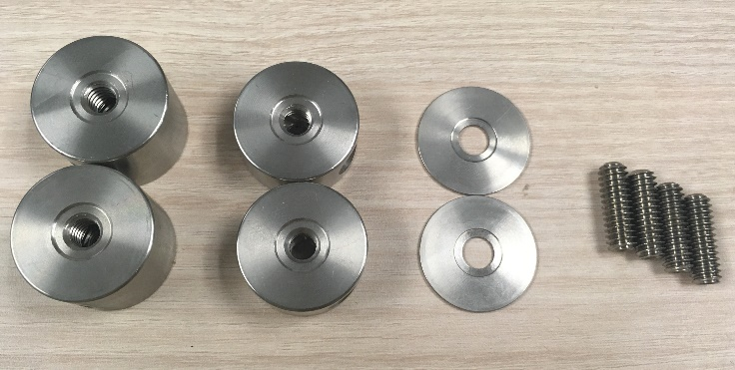

Figure Camera mounting feet parts

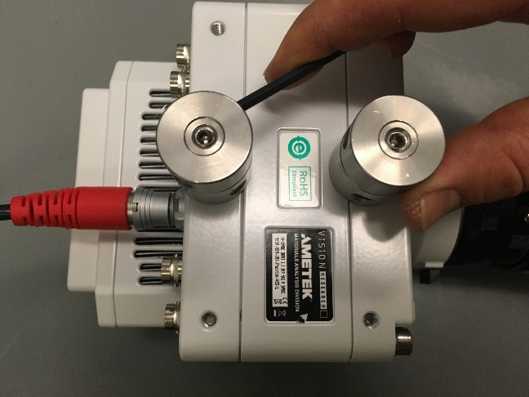

Figure Camera mounting feet installed on the bottom of the Phantom VEO 410L, showing the process of tightening them on with a hex wrench.

### General notes

It may be helpful to refer to Figure 2 to visualize the connections needed.

### Assemble camera mounting feet

* Screw a 1/4"-20x3/4" setscrew into the 0.5” long pillar post so it only protrudes from one end. Stack the 1mm post spacer onto the protruding setscrew, and screw the 0.75” long pillar on top of the spacer. Make sure the setscrew does NOT stick out the bottom of the camera foot, or the camera will not mount properly.
* Screw another setscrew into the 0.75” long pillar so it does protrude out.
* Repeat the above steps to make a second mounting foot
* Screw the two mounting feet into two bottom mounting holes on the Phantom VEO 410L camera. Use a hex wrench in the side holes of the pillar posts to tighten it securely on.
* See Figure 116 for the completed feet, and Figure 118 for the feet installed on the camera bottom.

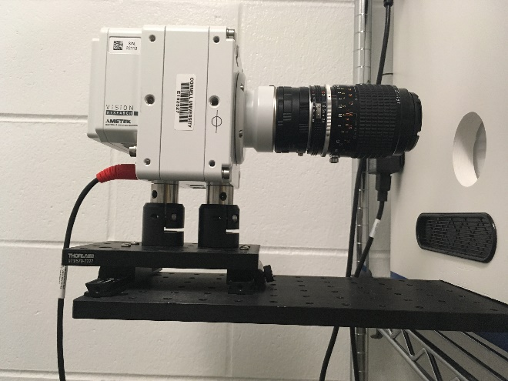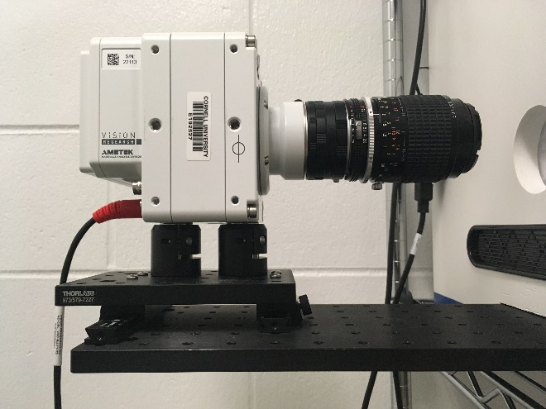

Not all the way down

Figure Installing the camera on the camera mounting platform. Left: Camera not completely seated. Right: Camera correctly seated.

### Mounting the camera

* Gently, carefully insert the camera mounting feet into the post holders on the camera mounting platform. Make sure the mounting feet slide all the way down to the bottom of the post holders.
* See Figure 119 for the camera mounting process.

### Install head-fixed rig

* Slide completed head-fixed rig into the back left corner of the box
* There should be two screws in the head-fixed rig base at (3, 0) and (17, 2). Turn the screws so they stick out slightly on the bottom, and align them with the nearest hole in the breadboard below the head-fixed rig. Screw them in further to connect the head-fixed rig breadboard to the camera mount breadboard. You may not be able to screw them all the way in, but they are only to ensure alignment, so that isn’t a problem.

### Install strobe light

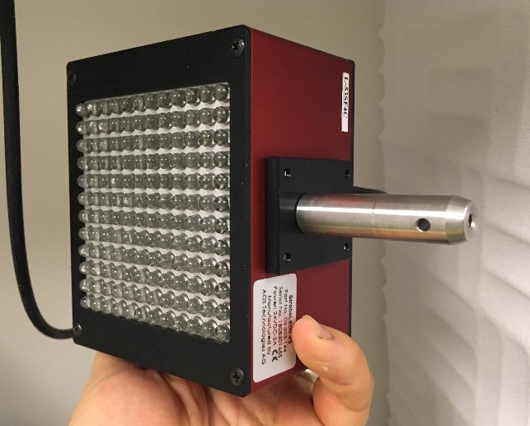

Figure Strobe light with mounting post on the bottom.

* Using a 1/4"-20x3/4” setscrew and a 2” optical post, add a mounting post to the strobe light.
* Slide the strobe light mounting post into the 1” post holder.
* The strobe can be positioned using the locking thumbscrew later for optimum illumination.
* Connect a BNC cable to the trigger BNC port on the back
* Connect the power adapter to the power port on the back of the strobe light (or prepare to – leaving it plugged in when not in use is not recommended)
* Run both the BNC and power adapter cables up through the top hole in the box. Use tape if necessary to keep the cables from dangling into the camera’s field of view.
* Plug the other end of the power adapter into a power outlet
* Plug the other end of the BNC cable into the port on the back of the camera marked “5 I/O”. This will transmit the sync signal from the camera to the strobe that will make the strobe flash in sync with the camera shutter.

### Install optogenetic system

* Set the laser diode module on top of the wire rack above the rack. Plug in its power cord.
* Set the commutator in the hole on top of the box so the two optical connectors face downwards.
* Optional – add a cushion of acoustic foam under the commutator mounting panel to improve sound isolation
* Connect an optical fiber from the top of the commutator to one of the outputs of the laser diode module.

### Install camera trigger adapter circuit

* The trigger adapter circuit has two BNC outputs, and one DB-15 input. The BNC output associated with the DB-15 pin 7 (U2 in Figure 99) transmits the trigger signal to the camera. The BNC output associated with the DB-15 pin 8 (U1 in Figure 99) transmits the laser on signal to the camera.
* Use a BNC cable to connect U2 in the adapter to the BNC port on the back of the camera marked “1 TRIGGER”
* Use a BNC cable to connect U1 in the adapter to the BNC port on the back of the camera marked “3 I/O”
* Use a DB-15 cable to connect the DB-15 connector (J1) to the Box 3 DB-15 port on the RIO

### Set up control/storage server

* The control server that runs the Labview code and the server that receives and stores the video data can be separate, or the same server, as long as the server has the resources to both store high throughput data and run the Labview code at the same time.
* The Phantom VEO 410L is available with an optional 10 Gb Ethernet connection. This can allow for recordings that are larger or more frequent, as it allows data to offload from the camera RAM to the storage server more quickly. This also requires a 10 Gb Ethernet card in the storage server.
* The control server needs Labview 2017 or later, and the custom Labview control software.
* The storage server needs the free Vision Research camera capture software “Phantom Camera Control” (PCC).

### Make RIO connections

* Run a BNC cable from the Box 1 (leftmost) BNC port on the RIO to the BNC port on the laser diode corresponding to the optical fiber output that is connected to the commutator
* Run a DB-15 cable from the Box 1 DB-15 port on the RIO through the right side factory-cut hole in the box, through the slit in the acoustic foam, to the DB-15 connector on the joystick board.
* Run an Ethernet cable from the Ethernet port on the RIO to the Ethernet port on the control server.

# Table of Figures

Figure 1 The coordinate system used throughout the documentation 7

Figure 2 Overall system diagram 7

Figure 3 Materials for head-fixed rig base. Clockwise from top left: Construction rail, setscrews, 1/4"-20 screws (3/4” and 5/8”), 8-32 screws, PH4, PH3, PH1, acrylic platform, TR4, RP01. The components are sitting on the optical breadboard. 9

Figure 4 Removing the 8-32 setscrews from the optical posts 9

Figure 5 RP01 rotation stage. 9

Figure 6 Completed head-fixed rig base 10

Figure 7 Head-fixing assembly materials (one side only - another set is needed for the other side) 11

Figure 8 Head-fixing assembly dovetail rails connected together 12

Figure 9 Rail carrier with clamp 12

Figure 10 Dovetail rails with carrier installed 12

Figure 11 Base with left head-fixing assembly complete and installed 13

Figure 13 Materials for constructing the touchposts and mirror mount. Clockwise from top left: Solid wire, two colors of stranded wire, epoxy, dental acrylic, heatshrink tubing, receptacles, crimp terminals, touchpost & mirror mount. Not pictured: magnets 14

Figure 14 Steps for connecting a wire lead to the ball electrode: a) clamp the ball in place with hole accessible b) add a dab of flux onto the hole in the ball c) melt solder into the hole in the ball d) remelt solder and insert wire 15

Figure 15 Completed ball electrodes with wire leads 15

Figure 16 Four connecting wires in two twisted pairs, showing the eight ends appropriately stripped 15

Figure 17 Process for attaching wires to receptacles: a) crimp middle tabs onto stripped wire, back tabs onto insulation b) repeat for other wire c) insert into receptacle in the orientation shown d) push in until catch pokes out into hole 16

Figure 18 Soldering connecting wires to the electrode leads. Left, one pair of connecting wires is soldered on. Right, both pairs soldered with heatshrink tubing applied. 16

Figure 19 Two pairs of magnets inserted into magnet holes 16

Figure 20 Reservoir materials. Clockwise from top left: Water bottle, FxF Luer lock connectors x3, Luer lock caps x3, epoxy 17

Figure 21 Reservoir cap disassembled. The metal spout can be discarded. 17

Figure 22 Process of making bottom water outlet. A) Mix epoxy and slather generous amounts on one side of male adapter B) Insert male adapter into the wide end of the rubber seal up to the flange C) Wipe excess epoxy away D) allow to harden, and insert in cap 18

Figure 23 Adapter and seal installed in cap. Outside view, left, inside view, right. 18

Figure 24 Completed water reservoir 18

Figure 25 Luer lock fill and drain ports inserted and epoxied 18

Figure 26 Materials for lick spout. Clockwise from top left: heatshrink tubing, steel tube, wire, lick sensor PCB, crimp terminals, headers and receptacles, 1/16" plug, solenoid valve. Not pictured: lick spout mount, rail carrier, screw, nut, and washer. 20

Figure 27 Lick spout PCB connector cable. Left: Completed cable. Right: close-up of receptacle wire order (same for both ends) 20

Figure 28 Lick spout end under a microscope. Left: before filing off burs and sharp edges. Right: After filing 21

Figure 29 Attaching the spout tube to the mount. a) mark tube at 1.5" b) fill triangular area with dental acrylic, insert tube at 1.5", and cover with tape c) cure and remove tape d) add extra dental acrylic and cure 21

Figure 30 Attaching the electrode leads to the water spout. a) twist stripped ends of leads around spout b) using flux, solder wires onto spout c) add dental acrylic to solder joint 21

Figure 31 Finished mounted water spout 22

Figure 32 Adding leads to solenoid valve. a) solder b) slide on heatshrink c) shrink heatshrink d) insert receptacle - note which receptacle slot is empty 23

Figure 33 Solenoid valve with completed leads 23

Figure 34 Tube connecting solenoid valve and lick spout. Top: Close-up of tube/spout connection 24

Figure 35 Lick sensor PCB with components soldered on. 24

Figure 36 Completed lick spout, capacitive lick sensor, and solenoid valve, all connected. (male Luer x 1/16” hose barb not shown) 25

Figure 37 Lick spout mounting rail 25

Figure 38 Spout mount with spout attached 27

Figure 39 Motor mount with optical post attached 27

Figure 40 Motor mount with guide rail installed. Left: Top view. Right: Bottom view. 27

Figure 41 Motor mount with motor installed. 28

Figure 42 Spout mount attached to guide rail carriage 28

Figure 43 Carriage installed on guide rail and attached to motor shaft 28

Figure 44 Top to bottom: Flexboard adapter top view, bottom view, and motor controller connections 29

Figure 45 Completed mirror, showing the back side with the magnetic foil applied. 30

Figure 46 Mirror placed on mirror mount on head-fixed rig 30

Figure 47 Materials for masking light. Clockwise from top left: wire, heatshrink tubing, crimp terminals, 2-pin receptacle, LED light strip 31

Figure 48 LED with wires soldered onto terminals. Note that the terminals are marked "+" and "-" to indicate 5V and GND. 32

Figure 49 LED unit cut from strip, with terminals exposed 32

Figure 50 LED with terminals coated 32

Figure 51 Receptacle for LED 32

Figure 52 Completed masking light 32

Figure 53 Breadboard with resistor, transistor, and jumper wire soldered 34

Figure 54 Connector cable end. Note the order of the wires in the receptacle. 34

Figure 55 Completed breadboard for audio cue system 34

Figure 56 Schematic for audio cue circuit 35

Figure 57 Completed audio cue system 35

Figure 58 Completed joystick board. Top: Front side. Bottom: Back side. 38

Figure 59 Materials for joystick board adapter. Clockwise from top left: Wire, heatshrink tubing, 2-pin header, female to solder cup DB-9 connector 40

Figure 60 Soldering wires to 2-pin header 40

Figure 61 Header connected to wire leads 41

Figure 62 Completed joystick board adapter for second touch post 41

Figure 63 Materials for restraint walls and back support. Clockwise from top left: metal rectangle, brackets, side wall panels, 4-40x3/8” screws, 4-40 nuts, 8-32x3/8” screws, 8-32 nuts. Not pictured: Foam sheet 42

Figure 64 Completed back support 42

Figure 65 Side walls with brackets attached. Note that the long dimension of the wall is vertical, that the slot side of the bracket is down, and that the two walls are mirror images of each other. 42

Figure 66 Wall dimensions, in inches 43

Figure 67 Side walls installed on platform 44

Figure 68 Platform ready for touchposts and mirror mount platform 45

Figure 69 Touchposts and mirror mount installed 45

Figure 70 Water reservoir mount attached to construction rail 45

Figure 71 Masking light installed 46

Figure 72 Joystick board connections for the head-fixed rig. The second touchpost connects to the DB-9 adapter cable, which attaches in the back of the joystick board. 46

Figure 73 Optogenetic system materials. Clockwise from top left: Custom mounting plate, laser light source, commutator, commutation mounting bracket, 1/4"x20 bolts and nuts, fiber optic cable (black, male SMA to ferrule), fiber optic cable (orange, male to male) 47

Figure 74 Commutator screwed into bracket 48

Figure 75 Commutator and bracket mounted to custom plate. Left: View from top. Right: View from bottom 48

Figure 76 Cable management 48

Figure 77 Fiber optic cables connected 48

Figure 78 Completed RIO breakout board 49

Figure 79 DAQ system schematic for head-fixed training (not video) rigs, showing half of what can fit in one enclosure 51

Figure 80 DAQ system schematic for head-fixed video rig, showing half of what can fit in one enclosure 51

Figure 81 Enclosure base plate with power supply mounting holes drilled 52

Figure 82 Four power supplies mounted 52

Figure 83 Required cords: 2 short Ethernet cords, 2 power cords 52

Figure 84 Enclosure materials. Clockwise from top left: custom cut front, sides, and back panels, enclosure hardware, 4-40 screws and nuts, Ethernet jacks x2, power jacks x2, power supplies x4 52

Figure 85 sbRIO supplies. Clockwise from top left: sbRIO-9636 x2, NI Minifit Pigtail x2, NI 50 pin ribbon cable x2, mounting hardware (not used) 52

Figure 86 2nd layer of standoffs installed 52

Figure 87 sbRIO #1 installed on standoffs 52

Figure 88 Baseplate with three standoffs installed. Note that the image shows the other three holes drilled - these will be unused and unnecessary. 52

Figure 89 Two RIO breakout boards installed with ribbon cables. 53

Figure 90 sbRIO #2 ribbon cables plugged in 53

Figure 91 sbRIO #2 installed 53

Figure 92 sbRIO #1 installed with ribbon cables 53

Figure 93 Power supply wires, cut and stripped 53

Figure 94 AC power receptacles 53

Figure 95 Completed DAQ system 54

Figure 96 Power supply connection photo 54

Figure 97 Power supply connection schematic. Compare to corresponding photo. 54

Figure 98 Camera trigger adapter circuit diagram 55

Figure 99 Camera trigger adapter circuit schematic. The U1 connector transmits the signal to indicate whether the optogenetic laser is on. The U2 connector transmits the trigger signal to start recording. 56

Figure 100 Camera trigger adapter circuit, with cables attached 57

Figure 101 Materials for constructing high speed camera box. Clockwise from top: 36" breadboard, 8-32 oversized washer, 1/4"-20 washers, 8-32 nut, 1/4"-20 nuts, 8-32x2” screw, 1/4"-20x1/2” setscrews, 8-32x3/4” screws, 1/4"-20x3/4” screws, 1/4"-20x1.5” screws, 1” post holders, 4”x6” breadboards, rail carriers, dovetail optical rails. Bottom: Med Associates Inc. Sound Attenuation Cubicle, acoustic foam 59

Figure 102 Modifications to the side of the box for the camera, the mounting breadboard, and the foam anchor bolt. 60

Figure 103 Breadboard anchoring holes 60

Figure 104 Top hole for optogenetics and strobe cables 61

Figure 105 Foam with example cutouts to fit around hinges 61

Figure 106 Camera positioning rails installed 62

Figure 107 Rail carriers installed 62

Figure 108 Camera platform installed 62

Figure 109 Camera mounting feet receptacle setscrews installed 62

Figure 110 Adjusting the set screws so they don't protrude into the space where the camera feet need to sit. Left: protruding setscrew. Middle: fixing protruding setscrew with hex wrench. Right: correctly positioned setscrew 63

Figure 111 Finished camera platform 63

Figure 112 Box on a wire rack 63

Figure 113 Screws fixing the camera mount to the box seen from the top (left) and from the bottom (right) 63

Figure 114 Camera mounting system installed in box with foam and rear head-fixed rig support breadboard. 64

Figure 115 Camera mounting system installed in the box (without foam or the rear head-fixed rig support breadboard) 64

Figure 116 Two completed camera mounting feet. From bottom to top: 1/2" pillar post, 1mm spacer, 3/4" pillar post, protruding setscrew. 66

Figure 117 Camera mounting feet parts 66

Figure 118 Camera mounting feet installed on the bottom of the Phantom VEO 410L, showing the process of tightening them on with a hex wrench. 66

Figure 119 Installing the camera on the camera mounting platform. Left: Camera not completely seated. Right: Camera correctly seated. 66

Figure 120 Strobe light with mounting post on the bottom. 67